E
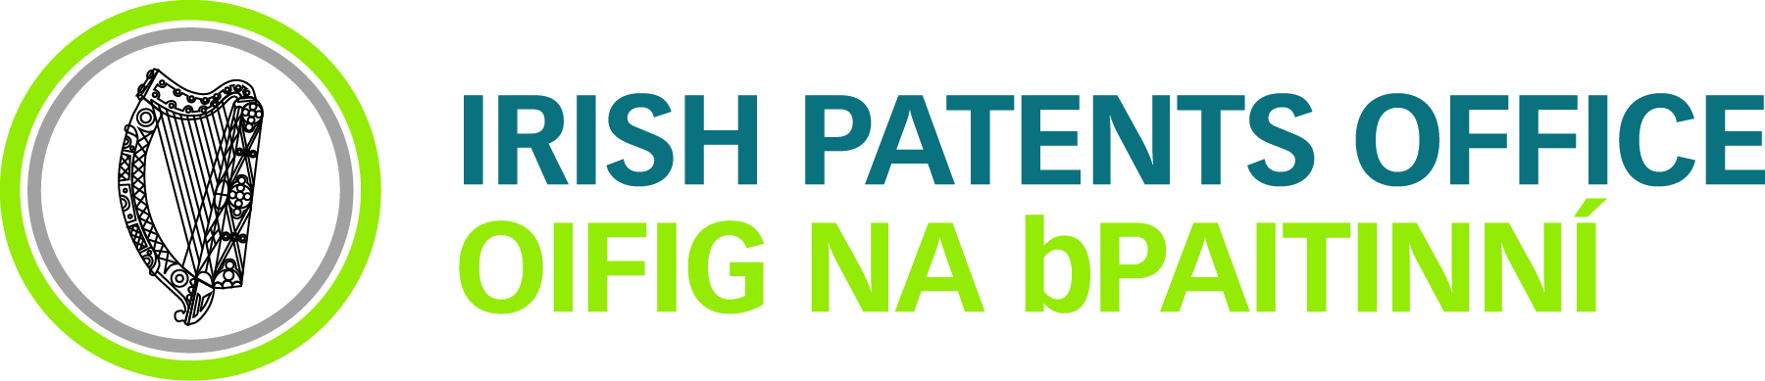 | 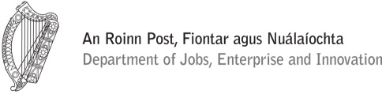
SEMINAR
WIPO/IP/IE/14/inf/2 prov
ORIGINAL: english
DATE: June 2, 2014

World Intellectual Property Organization –
Services and Initiatives to Help Grow Global Businesses through Innovation

organized by
the World Intellectual Property Organization (WIPO)

in cooperation with the Department of Jobs,
Enterprise & Innovation and the Irish Patents Office

Limerick, Ireland, June 18, 2014

Provisional program

prepared by the Secretariat of WIPO
and the Department of Jobs, Enterprise & Innovation

Wednesday, June 18, 2014

9.20 a.m. to 9.40 a.m. Opening Session

Welcome addresses by:
- Ms. Anne Coleman-Dunne, Director of IP, Department of Jobs, Enterprise and Innovation, Dublin
- Mr. Yoshiyuki Takagi, Assistant Director General, Global Infrastructure Sector (GIS), World Intellectual Property Organization (WIPO)
- Mr. Paul Dillionhill, Director of the Technology Transfer Office (UL)

9.40 a.m. to 10.10 a.m. Topic 1: Introduction to WIPO:
Development of the International Legal Framework;
Major Intellectual Property (IP) Economic Studies

Speaker: Mr. Christopher Ruggerio, Senior Legal Officer, Section for the Coordination of Developed Countries, Transition and Developed Countries Division (TDC), WIPO

10.10 a.m. to 10.35 a.m. Topic 2: The Patent Cooperation Treaty (PCT):
Introduction and Future Developments

Speaker: Mr. Matthew Bryan, Director, PCT Legal Division, Innovation and Technology Sector, WIPO

10.35 a.m. to 11.15 a.m. Topic 3: In-House Innovation: Capturing Creativity through Intellectual Asset Management and IP Portfolio Management (IP Audits, Confidentiality, Trade Secrets)

Speaker: Mr. Joe Doyle, IP Manager, Enterprise Ireland

11.15 a.m. to 11.30 a.m. Coffee break

11.30 a.m. to 11.50 a.m. Topic 4: Global IP Systems: The Madrid System for the International Registration of Marks

Speaker: Ms. Debbie Roenning, Director, Legal Division, Madrid Registry, Brands and Designs Sector, WIPO

11.50 a.m. to 12.20 p.m. Topic 5: Global IP Systems: Practice and experiences of the Madrid System for the International Registration of Marks

Speaker: Mr. Niamh Hall, Partner, FR Kelly & CO, Patent and Trade Mark Agents

12.20 p.m. to 1.00 p.m. Topic 6: Collaborative Innovation with Industry: Technology Transfer and Access to Higher Education IP and Know-How

Speaker: Ms. Alison Campbell, Director, Knowledge Transfer Ireland

1.00 p.m. to 2.00 p.m. Lunch break

2.00 p.m. to 2.30 p.m. Topic 7:

(a) WIPO Arbitration and Mediation Center (ADR):
Alternative Dispute Resolution

Speaker: Mr. Matthew Bryan

2.30 p.m. to 2.55 p.m. (b) Using Mediation to Reduce Cost in IP Enforcement:
Possible Case Study

Speaker: Ms. Yvonne McNamara, Barrister at Law

2.55 p.m. to 3.15 p.m. (c) The Unified Patent Court: A new Court System for Defending European patents

Speaker: Ms. Anne Coleman-Dunne

3.15 p.m. to 3.45 p.m. Topic 8: Global Databases for IP Platforms and Tools for the Connected Knowledge Economy

Speakers: Mr. Yoshiyuki Takagi
Mr. Fergal Brady, Patent Examiner, Patents Office (TCD),
Ms. Karen Ryan, Patent Examiner, Patents Office (UL),

3.45 p.m. to 4.15 p.m. Questions and Answers

CLOSING SESSION

[End of document]

