E
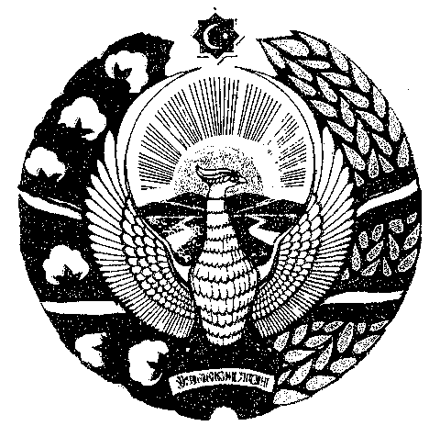
Agency on INtellectual PROPERTY
of the REpublic of Uzbekistan
Seminars
WIPO/IP/UNI/UZ/14/INF/1.prov
ORIGINAL: english
DATE: may 2014

Intellectual Property Policies in Universities and Research Institutions

organized by

the World Intellectual Property Organization (WIPO)

and

the Agency on Intellectual Property of the Republic of Uzbekistan

Tashkent, Samarkand and Urgench, May 20 to 23, 2014

Provisional Program

prepared by the International Bureau of WIPO

Tashkent, Tuesday, May 20, 2014

09.00 – 09.45 Registration

09.45 – 10.00 OPENING SESSION

Welcome addresses by:

    - Representative of the Agency on Intellectual Property of the Republic of Uzbekistan – to be confirmed
    - Representative of Universities/Research Institutions of Uzbekistan – to be confirmed
    - Mr. Michal Svantner, Director, Department for Transition and Developed Countries, World Intellectual Property Organization (WIPO), Geneva

10.00 – 10.15 Topic 1 WIPO Capacity Building Activities in Countries in Transition

Speaker: Mr. Michal Svantner

10.15 – 11.45 Topic 2 Current Role and Use of IPRs by Universities and Research Institutions in Spain and CIS countries.

Speakers: Ms. Patricia Garcia-Escudero Marquez, Director General, Spanish Patent and Trademark Office

Mr. Evgeniy Sesitsky, Consultant,
Department for Transition and
Developed Countries (TDC),
WIPO, Geneva

11.45 – 12.00 Coffee Break

12.00 – 12.30 Topic 3 Current Role and Use of IPRs by Universities and Research Institutions in Uzbekistan

Speakers: Mr. Mavlon Mukhitdinov, IP Expert, Chamber of Commerce and Industry of Uzbekistan, Tashkent

12.30 – 14.00 Lunch

14.00 – 14.30 Topic 4 WIPO Model Intellectual Property Policy for
Universities and Research Institutions

Speaker: Michal Svantner

14.30 – 15.00 Topic 5 Transfer of IPRs. Technology Transfer in Research
and Development Context

Speaker: Mr. Evgeniy Sesitsky

15.00 – 16.30 Topic 6 Panel Discussion: Current Situation Regarding IP Policies at Universities and Research Institutions in the Region

Moderator: Mr. Evgeniy Sesitsky

Speakers: Representatives of Universities and Research Institutions of Uzbekistan

WIPO-financed international participants

16.30 – 16.45 Coffee Break

16.45 – 17.00 Conclusions and Closing Ceremony

Representative of the Agency on Intellectual Property of the Republic of Uzbekistan – to be confirmed

Representative of Universities and Research Institutions of Uzbekistan –
to be confirmed

Mr. Michal Svantner

17.00 – 18.30 University and Research Institutions IP Policy Development Session

On the Spot Counseling:

Mr. Michal Svantner

Mr. Evgeniy Sesitsky

Representative of the Agency on Intellectual Property of the Republic of
Uzbekistan – to be confirmed

Representative of Universities and Research Institutions of Uzbekistan –
to be confirmed

Samarkand, Thursday, May 22, 2014

09.00 – 09.30 Registration

09.30 – 09.45 Opening Ceremony

Welcome addresses by:

    - Representative of the Agency on Intellectual Property of the Republic of Uzbekistan – to be confirmed
    - Representative of Universities in Uzbekistan – to be confirmed
    - Mr. Michal Svantner, Director, Department for Transition and Developed Countries, World Intellectual Property Organization (WIPO), Geneva

09.45 – 10.15 Topic 1 WIPO Model Intellectual Property Policy for
Universities and Research Institutions

Speaker: Mr. Michal Svantner

10.15 – 11.00 Topic 2 Current Role and Use of IPRs by Universities and Research Institutions in Spain and CIS countries.

Speakers: Ms. Patricia Garcia-Escudero Marquez

Mr. Evgeniy Sesitsky

11.00 – 11.15 Coffee Break

11.15 – 11.45 Topic 3 Transfer of IPRs. Technology Transfer in Research
and Development Context

Speakers: Mr. Evgeniy Sesitsky

11.45 – 12.00 Conclusions and Closing

Representative of the Agency on Intellectual Property of the Republic of
Uzbekistan – to be confirmed

Representative of Universities and Research Institutions of Uzbekistan –
to be confirmed

Mr. Michal Svantner

12.00 – 13.30 University and Research Institutions IP Policy Development Session

On the Spot Counseling:

Mr. Michal Svantner

Mr. Evgeniy Sesitsky

Representative of the Agency on Intellectual Property of the Republic of
Uzbekistan – to be confirmed

Representative of Universities and Research Institutions in Uzbekistan –
to be confirmed

Urgench, Friday, May 23, 2014

09.00 – 09.45 Registration

09.45 – 10.00 Opening Ceremony

Welcome addresses by:

    - Representative of the Agency on Intellectual Property of the Republic of Uzbekistan – to be confirmed
    - Representative of Universities in Uzbekistan – to be confirmed
    - Mr. Michal Svantner, Director, Department for Transition and Developed Countries, World Intellectual Property Organization (WIPO), Geneva

10.00 – 10.15 Topic 1 WIPO Capacity Building Activities in Countries in Transition

Speaker: Mr. Michal Svantner

10.15 – 11.00 Topic 2 Intellectual Property in Uzbekistan

Speaker: Representative of the Agency on Intellectual Property of the Republic of Uzbekistan – to be confirmed

11.00 – 11.15 Coffee Break

11.15 – 12.15 Topic 3 Current Role and Use of IPRs by Universities and Research Institutions in CIS countries

Speakers: Mr. Evgeniy Sesitsky

The Representative of Universities and Research Institutions in Uzbekistan - to be confirmed

12.15 – 14.00 Lunch

14.00 – 14.20 Topic 4 WIPO Model Intellectual Property Policy for
Universities and Research Institutions

Speaker: Michal Svantner

14.20– 15.30 Topic 5 Panel Discussion: Current Situation Regarding IP Policies at Universities and Research Institutions in the Region

Moderator: Mr. Evgeniy Sesitsky

Speakers: Representatives of Universities and Research Institutions of Uzbekistan

15.30 – 15.45 Coffee Break

15.45 – 16.15 Conclusions and Closing Ceremony

Representative of the Agency on Intellectual Property of the Republic of
Uzbekistan – to be confirmed

Representative of Universities and Research Institutions in Uzbekistan –
to be confirmed

Mr. Michal Svantner

16.15 – 17.00 University and Research Institutions IP Policy Development Session

On the Spot Counseling:

Mr. Michal Svantner

Mr. Evgeniy Sesitsky

Representative of the Agency on Intellectual Property of the Republic of
Uzbekistan – to be confirmed

Representative of Universities and Research Institutions in Uzbekistan –
to be confirmed

