 | 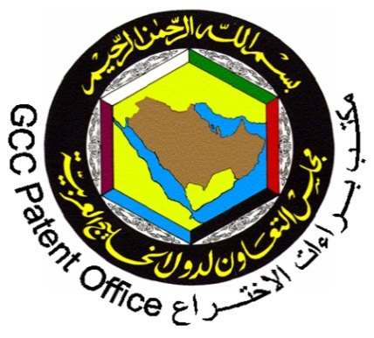  The GCC Patent Office  Riyadh, Saudi Arabia | E
wipo/PCT/RYD/2/16/1 prov. 1
original: english
Date: MAY 9, 2016
dA

WIPO Awareness-Raising Seminar for the GCC Patent Office on the Patent Cooperation Treaty (PCT): The System for Worldwide Filing of Patent Applications

organized by
the World Intellectual Property Organization (WIPO)

in cooperation with
the GCC Patent Office

Riyadh, Saudi Arabia, May 25 to 26, 2016

PROVISIONAL PROGRAM

prepared by the International Bureau of WIPO

Wednesday, May 25, 2016

09.00 – 09.30 Registration

09.30 – 10.00 Opening Ceremony

Mr. Abdullah Ibrahim Almoqhim, Director General, Patent Office of the Cooperation Council for the Arab States of the Gulf (GCCPO), Riyadh

Mr. Ali Jazairy, Senior Counsellor, PCT International Cooperation Division, Patents and Technology Sector, World Intellectual Property Organization (WIPO), Geneva, Switzerland

10.00 – 10.45 Patenting in the GCC Gulf States: Current Status, PCT Membership of the GCC States, and Cooperation with WIPO

Speaker: Mr. Abdallah Al Mazroa, Patent Consultant, Patent Office of the Cooperation Council for the Arab States of the Gulf (GCCPO), Riyadh

10.45 – 12.00 Introduction: Basics, Contracting States, Statistics, Main Advantages of the Patent Cooperation Treaty (PCT)

Speaker: Mr. Ali Jazairy, Senior Counsellor, PCT International Cooperation Division, Patents and Technology Sector, WIPO

12.00 – 12.30 Coffee Break

12.30 – 13.30 The PCT International Phase and National Phase

Speaker: Mr. Ali Jazairy, Senior Counsellor, PCT International Cooperation Division, Patents and Technology Sector, WIPO

13.30 – 14.00 The PCT Administrative Procedures

Speaker: Mr. Ali Jazairy, Senior Counsellor, PCT International Cooperation Division, Patents and Technology Sector, WIPO

Thursday, May 26, 2016

10.00 – 12.00 The ePCT System: Presentation and Live Demonstration

Speaker: Mr. Ali Jazairy, Senior Counsellor, PCT International Cooperation Division, Patents and Technology Sector, WIPO

12.00 – 12.30 Coffee Break

12.30 – 13.30 The Use of the PCT System as an Engine for Technology Transfer

Speakers: Mr. Ali Jazairy, Senior Counsellor, PCT International Cooperation Division, Patents and Technology Sector, WIPO

13.30 – 14.00 Summary and Closing Address

Mr. Abdallah Al Mazroa, Patent Consultant, Patent Office of the Cooperation Council for the Arab States of the Gulf (GCCPO), Riyadh

Mr. Ali Jazairy, Senior Counsellor, PCT International Cooperation Division, Patents and Technology Sector, World Intellectual Property Organization (WIPO), Geneva, Switzerland

[End of document]

