E
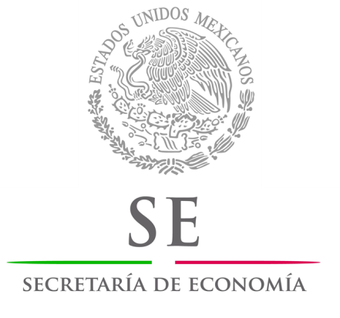 | 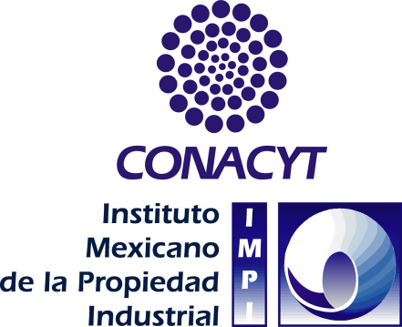 | 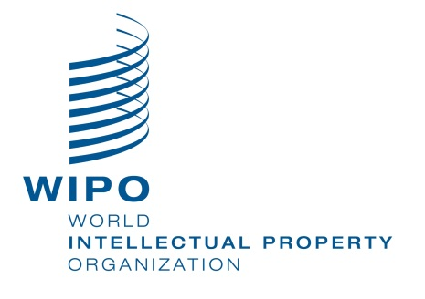
regional consultation meeting
WIPO/REG/IP/MTY/13/1 PROV. 2
ORIGINAL: english
DATE: august 2013

Fifth WIPO Regional Consultation Meeting on Technology Transfer:
The Development Agenda Project on Intellectual Property and Technology Transfer: Common Challenges – Building Solutions
organized by
the World Intellectual Property Organization (WIPO)

in cooperation with
the Ministry of Economy

in partnership with
the National Council for Science and Technology (CONACYT)
and the Mexican Institute for Industrial Property (IMPI)

Monterrey, December 5 and 6, 2013

provisional program

prepared by the International Bureau of WIPO
Thursday, December 5, 2013

9.00 – 9.30 | Registration
9.30 – 10.00 | Opening Ceremony
 | Welcome addresses by:
Mr. Miguel Ángel Margáin González, Director General, Mexican Institute for Industrial Property (IMPI)

Dr. Enrique Cabrero Mendoza, Director General, National Council for Science and Technology (CONACYT)
Mr. Juan Antonio Toledo, Senior Director, Regional Bureau for Latin America and the Caribbean, World Intellectual Property Organization (WIPO), Geneva

His Excellency Mr. Ildefonso Guajardo Villarreal, Minister, Ministry of Economy
10.00 – 10.15 | Coffee Break
THEME I: | TECHNOLOGY TRANSFER AND WIPO’S DEVELOPMENT AGENDA
10.15 – 10.45 | Topic 1 | The Development Agenda Thematic Project on Intellectual Property and Technology Transfer: Common Challenges – Building Solutions (Recs. 19, 25, 26 and 28)
 |  | Speaker: Dr. Ali Jazairy, Senior Counsellor, PCT International Cooperation Division, Innovation and Technology Sector, WIPO
10.45 – 11.15 | Topic 2 | From United Nations Conference on Trade and Development (UNCTAD)’s Code of Conduct to the World Trade Organization (WTO)’s Trade-Related Aspects of Intellectual Property Rights (TRIPS) Agreement: Global Efforts for Technology Transfer
 |  | Speaker: Mr. Pedro Roffe, Senior Associate, International Centre for Trade and Sustainable Development (ICTSD), Geneva, Switzerland
11.15 – 11.45 | Topic 3 | New Trends in International Technology Transfer and WIPO’s Efforts for the Promotion of Innovation and Technology Transfer
 |  | Speaker: Dr. Ali Jazairy
11.45 – 13.00 | Lunch Break
THEME II: | BEST PRACTICES AND CASE STUDIES OF TECHNOLOGY TRANSFER IN THE LATIN AMERICAN AND CARIBBEAN REGION
13.00 – 13.30 | Topic 4 | The Innovation Ecosystem in Mexico
Keynote
Speaker: Dr. Enrique Cabrero Mendoza, Director General, National Council for Science and Technology (CONACYT)
13.30 – 14.00 | Topic 5 | Mexico’s High-Tech Park: Examples of Successful Technology Transfer
 |  | Speaker: Dr. Jaime Parada Ávila, Director General, Institute for Innovation and Technology Transfer, Monterrey High-Tech Park, Monterrey, Nuevo León, Mexico
14.00 – 14.30 | Topic 6 | How to Jumpstart Technology Transfer in Mexico
 |  | Speaker: Mr. Maurizio Santillán, President, Visionaria, Mexico City, Mexico
14.30 – 15.00 | Topic 7 | Innovation and Technology Transfer in Brazil
 |  | Speaker: Dr. Hercules Neves, Senior Life Sciences Business Line Manager, Six Semiconductors, Rio de Janeiro, Brazil
15.00 – 15.30 | Topic 8 | Innovation and Intellectual Property Policy in Brazil
 |  | Speaker: Mrs. Iovanna Gico Roller, Analyst in Science, Technology and Innovation and Deputy Coordinator on Intellectual Property, Ministry of Science, Technology and Innovation, Brasilia, Brazil
15.30 – 15.45 | Coffee Break
15.45 – 16.15 | Topic 9 | International Technology Transfer in Chile: Case Studies
 |  | Speaker: Mr. Marcos Kulka, General Manager, Fundacion Chile, Santiago, Chile
16.15 – 16.45 | Topic 10 | International Technology Transfer in Cuba: Case Studies
 |  | Speaker: Mrs. Josepha Lombardero, Center for Genetic Engineering and Biotechnology, Havana, Cuba
16.45 – 17.15 | Topic 11 | Success Stories of Technology Transfer in the Caribbean
 |  | Speaker: Mr. Malcolm Spence, Senior Coordinator on Intellectual Property, Science and Technology Issues, CARICOM Secretariat, Barbados
17.15 – 18.30 | Topic 12 | National Experiences and Technology Transfer Systems in the Latin American and Caribbean Economies (Presentations of Participating Countries):  Presentations of SWOT Matrices for Individual Countries
 |  | Moderator: Mr. Miguel Ángel Margáin González
 |  | Reporter: Mr. Juan Antonio Toledo
18.30 | End of Session

Friday, December 6, 2013

9.00 – 9.45 | Topic 13 | Review of SWOT Matrices and Summary of Best Practices for International Technology Transfer in the Latin American and Caribbean Region
 |  | Speaker: Dr. Hercules Neves
9.45 – 10.30 | Topic 14 | Introduction to the WIPO Tools, Capacity Building and Technical Assistance in Technology Transfer
 |  | Speaker: Mr. Juan Antonio Toledo
10.30 – 10.45 | Coffee Break
THEME III: | TOOLS and Platforms for Effective Technology Transfer and Diffusion
10.45 – 11.30 | Topic 15 | Enabling Infrastructure for Innovation and Technology Transfer – Applying Knowledge in Development
 |  | Speaker: Dr. Jonathan Soderstrom, Managing Director, Office of Cooperative Research, Yale University, New Haven, Connecticut, United States of America
11.30 – 13.00 | Roundtable 1 | Technology Transfer – Common Challenges
 |  | Moderator: Mr. Juan Antonio Toledo
Panelists: Mr. Pedro Roffe
Dr. Jaime Parada Ávila
Mr. Maurizio Santillán
Mr. Miguel Ángel Margáin González
Dr. Hercules Neves
Mrs. Iovanna Gico Roller
Mr. Marcos Kulka
Mr. Malcolm Spence
Dr. Jonathan Soderstrom
 |  | Reporter: Dr. Ali Jazairy
13.00 – 14.00 | Lunch Break
14.00 – 16.30 | Roundtable 2 | Building Solutions: Intellectual Property-Related Mechanisms and Initiatives for Promoting Technology Transfer in the Latin American and Caribbean Region
 |  | Moderator: Mr. Pedro Roffe
Panelists: Dr. Jaime Parada Ávila
Mr. Maurizio Santillán
Mr. Miguel Ángel Margáin González
Dr. Hercules Neves
Mrs. Iovanna Gico Roller
Mr. Marcos Kulka
Mr. Malcolm Spence
Dr. Jonathan Soderstrom
 |  | Reporter: Mr. Juan Antonio Toledo
16.30 – 16.45 | Coffee Break
16.45 – 17.30 | Roundtable 3 | Regional Consultation Recommendations for the Latin American and Caribbean Region
 |  | Moderator: Mr. Miguel Ángel Margáin González
Panelists: Mr. Juan Antonio Toledo
Mr. Pedro Roffe
Dr. Jaime Parada Ávila
Mr. Maurizio Santillán
Dr. Hercules Neves
Mrs. Iovanna Gico Roller
Mr. Marcos Kulka
Mr. Malcolm Spence
Dr. Jonathan Soderstrom
 |  | Reporter: Dr. Ali Jazairy
17.30 – 18.00 | Evaluation and Closing Ceremony

[End of document]

