E
PCT/CTC/30/10
ORIGINAL: English
DATE: March 16, 2017

Patent Cooperation Treaty (PCT)
Committee for Technical Cooperation

Thirtieth Session
Geneva, May 8 to 12, 2017

Extension of Appointment of the European Patent Office as an International Searching and Preliminary Examining Authority Under the PCT

Document prepared by the International Bureau

- All of the existing International Authorities were appointed by the PCT Assembly for a period ending on December 31, 2017. In 2017, the Assembly will therefore need to make a decision on the extension of the appointment of each existing International Authority that wishes to seek an extension of its appointment, having first sought the advice of this Committee (see PCT Articles 16(3)(e) and 32(3)). Information concerning this process and the role of the Committee is set out in document PCT/CTC/30/INF/1.
- On March 2, 2017, the European Patent Office submitted its application to extend its appointment as an International Searching Authority and International Preliminary Examining Authority under the PCT. This application is reproduced in the Annex to this document.
- The Committee is invited to give its advice on this matter.

[Annex follows]
Application of the European Patent Office for Extension of Appointment
as an International Searching and Preliminary Examining Authority Under the PCT

1 – General
Name of national Office or intergovernmental organization: European Patent Office (EPO)

Date on which application for appointment was received by the Director General: March 2, 2017

Session of the Assembly at which appointment is to be sought: 2017

Date at which operation as ISA/IPEA commenced: the EPO started operating as ISA and IPEA in 1978.

Existing ISA/IPEA(s) assisting in assessment of extent to which criteria met: n/a

2 – Substantive Criteria: Minimum Requirements for Appointment

2.1– Search and Examination Capacity
Rules 36.1(i) and 63.1(i): The national Office or intergovernmental organization must have at least 100 full-time employees with sufficient technical qualifications to carry out searches and examinations.

Employees qualified to carry out search and examination (end of 2015):

Technical field | N. examiners | Number (in full-time equivalent)* | Average experience as examiners (years)
Mechanical | 1,724 | 1,499 | 12.5
Electrical/electronic | 1,467 | 1,238 | 12.0
Chemistry | 822 | 683 | 13.8
Biotech | 213 | 177 | 15.2
Total | 4,226 | 3,596 | 12.7
(*FTE= SEOtime/200d)

Training Programs

The EPO has an extensive programme of training courses, both in the form of classroom training, workshops and e-Learning modules.

For new examiners there is a mandatory training schedule with 39 days of classroom training spread over the first two year period. The training covers all aspects of search, examination and classification. In addition, each new examiner is provided with two highly experienced examiners as coaches during the first two years.

For experienced examiners, there is an extensive programme of more advanced training covering specialised topics (e.g. searching in specific external databases), other roles which examiners take on at a later stage (e.g. opposition work) as well as courses focusing on specific aspects of search and/or examination. These courses are provided as required for the examiners to fulfil the necessary functions to the best of their abilities. In addition, technical areas also arrange peer-to-peer training adapted to the technical area’s specificities.

Rules 36.1(ii) and 63.1(ii): That Office or organization must have in its possession, or have access to, at least the minimum documentation referred to in Rule 34, properly arranged for search purposes, on paper, in microform or stored on electronic media.

Access to the minimum documentation for search purposes:
(X) Full access

Search systems:

The EPO uses its proprietary EPOQUE search system to search the Patent and Non-Patent Literature parts of the PCT Minimum Documentation. In addition we have an in-house Electronic Virtual Library providing online access to over 10,000 Scientific and technical Journals, as well as online access to specialized databases for searching genetic sequence listings and chemical compound structures.

Rules 36.1(iii) and 63.1(iii): That Office or organization must have a staff which is capable of searching and examining the required technical fields and which has the language facilities to understand at least those languages in which the minimum documentation referred to in Rule 34 is written or is translated.

Language(s) in which regional applications may be filed and processed:
English, French, German, and Dutch (only for applications filed in Belgium and the Netherlands)

In addition to its regional searches under the European Patent Convention, the European Patent Office prepares national search reports with written opinions in English, French or German for the following States: Belgium, Cyprus, France, Greece, Italy, Latvia, Lithuania, Luxembourg, Malta, Monaco, Netherlands, San Marino. Besides, the European Patent Office prepares international-type search reports without written opinions for the following States: Denmark, Finland, Norway, Switzerland; and international-type search reports with written opinions for the following States: Belgium, Netherlands.

Other languages in which large numbers of examiners are proficient:

Taking into account 50 or more employees at the EPO at the end of December 2015 (some may be non-examining staff):
Italian, Dutch, Spanish, Greek, Romanian, Swedish, Portuguese, Polish, Danish.

Services available to assist search or understanding of prior art in other languages:

– Patent Translate offers on-the-fly-translation of patent documents for 28 official languages of the EPO's 38 member states, plus Chinese, Japanese, Korean and Russian.
Detailed list: Albanian, Bulgarian, Croatian, Czech, Danish, Dutch, Estonian, Finnish, French, German, Greek, Hungarian, Icelandic, Italian, Latvian, Lithuanian, Macedonian, Norwegian, Polish, Portuguese, Romanian, Russian, Serbian, Slovak, Slovenian, Spanish, Swedish, Turkish

– Translation on the Fly (TFLY) is a browser-based application that handles translation requests from the Viewer used by examiners. TFLY provides machine translation of either any fulltext or any patent document facsimile into many languages using the Google Translate engine. In case only a facsimile is present, an OCR (Optical Character Recognition) will be performed on the document first, and followed by a translation. This new powerful OCR functionality allows the translation of most of the patent documents in EPODOC.

– In addition to the TFLY application, other tools and services may be used in order to translate patent and non-patent documentation originally in Asian or other languages such as Russian or Spanish: machine translation from other patent offices, human-enhanced machine translation (available in 2-3 days).

– Full human translation and translation performed by colleagues are also available to examiners.

EPO Examiners have access to ca. 25 million records which have been machine translated into English, and can search these in a seamless manner. The content of the fulltext translated patent databases are fed with a machine translation as provided by external providers (such as Thomson Reuters, SciPat). They cover large numbers of Chinese published/granted patent applications and utility models (13.7 million English translations), Japanese published/granted patent applications (9.2 million English translations), and Korean published/granted patent applications (1.8 million English translations).

The EPO Bulk Translation Project aims to translate, using Patent Translate (as in Tfly), patent publications into English before making them available to examiners in the patent literature (PL) full-text collections. More than 317,000 Spanish, Portuguese and Lithuanian documents from 1970-2016, and more than 103,000 Russian, Chinese, Japanese and Korean documents from 2014-2016 are now stored in our prior-art collections and therefore readily searchable. The English machine translations become accessible in ANSERA and in EPOQUE (as of 20.09.2016). The translated collections will be complemented progressively, on a daily basis, with CN, JP, KR and RU publications from 1993-2013 and the corresponding EPOQUE database will be completed.

2.2 – Quality Management
Rules 36.1(iv) and 63.1(iv): That Office or organization must have in place a quality management system and internal review arrangements in accordance with the common rules of international search,

National quality management system:

See published report

3 – Intended Scope of Operation
Language(s) in which services would be offered:
English, French, German

State(s) or receiving Office(s) for which Authority would offer to be competent:
The EPO acts as ISA for any RO which selects it.

The EPO acts as IPEA if the EPO or a European ISA acted as ISA.

Limitations on scope of operation:
As ISA: the subject matter specified in items (i) to (vi) of PCT Rule 39.1 with the exception of all subject matter which is searched under the European patent grant procedure.

As IPEA: the subject matter specified in items (i) to (vi) of PCT Rule 67.1 with the exception of all subject matter which is examined under the European patent grant procedure.

4 – Statement of Motivation
The EPO has been deeply involved in the harmonisation process from the outset, leading to the adoption of the PCT. It has always strongly believed that such system brings enormous benefits to the users. Following the entry into force of the PCT, the EPO has continued to actively cooperate with the other Offices and the International Bureau to further improve the implemented system by i.a. introducing new services, proposing changes to the legal framework aimed at increasing legal certainty, addressing diverging practices to ensure consistency.

The EPO started offering its services as ISA and IPEA in 1978 and it is now selected by the majority of the ROs. The EPO searches in the international phase are global in scope and are performed applying the same high standard as for the European searches and using the same tools. Highly skilled examiners working in teams of three search and examine patent applications using the world’s most complete databases. The EPO gives great importance to the quality of its searches and assessments being aware that they have far-reaching consequences on users’ decisions concerning the future of the patent application. Despite the high volume of ISRs established (81,131 in 2015), the EPO has moreover succeeded in the course of the years to considerably improve its timeliness to meet users’ need. Since 2010, the EPO has also been acting as SISA and is actively engaged in making such service more attractive for users.

The international route is widely used by applicants who are interested in a global protection and that prefer to postpone major decisions and costs. In 2015, 61.4 per cent of the applications received by the EPO in the regional phase were indeed Euro-PCT applications. The percentage of applications which entered the European phase after the international phase has incredibly increased over the years. The activity of the EPO as ISA and IPEA allows applicants interested in entering the European phase to understand the value of their patent at an early stage, and, in case of positive feedback, to get their patent quickly granted in the regional phase and at a minor cost.

The EPO would therefore be pleased to continue providing users with its services as International Authority and to further contribute to the maintenance and the improvement of PCT system in the international framework.

5 – Applicant State(s)
Regional location
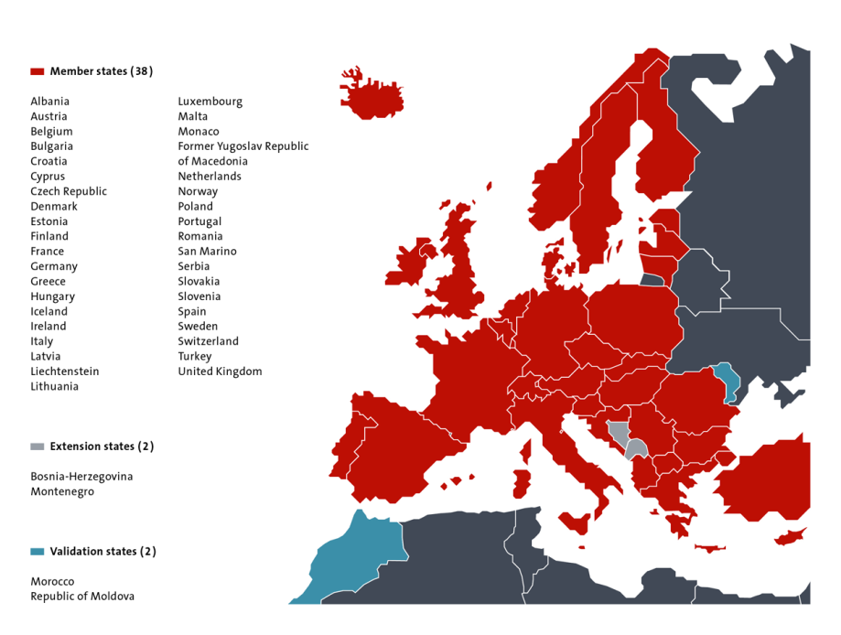
Map showing State(s) and neighboring States

6 – Profile of Patent Applications
Number of national applications received – by technical field
Year  Technical Field | 2011 | 2012 | 2013 | 2014 | 2015
Mechanical | 29,942 | 33,075 | 32,801 | 33,380 | 36,016
Electrical/electronic | 39,000 | 42,422 | 41,974 | 44,040 | 45,434
Chemistry | 35,971 | 38,651 | 37,117 | 38,454 | 39,572
Instruments | 23,207 | 23,943 | 23,963 | 25,405 | 27,464
Other fields (including not yet classified) | 14,722 | 10,403 | 12,014 | 10,974 | 11,536
Total | 142,842 | 148,494 | 147,869 | 152,703 | 160,022

Number of national applications received – by route
Year  Route | 2011 | 2012 | 2013 | 2014 | 2015
First filing | 20,879 | 21,345 | 22,373 | 23,437 | 23,390
Paris priority | 41,679 | 41,821 | 38,283 | 36,609 | 38,335
PCT regional phase entry | 80,264 | 85,396 | 87,377 | 92,657 | 98,297

Number of international applications received as RO
Year  Technical Field | 2011 | 2012 | 2013 | 2014 | 2015
Mechanical | 8,437 | 8,735 | 8,566 | 8,904 | 8,586
Electrical/electronic | 6,938 | 7,382 | 7,241 | 7,249 | 6,293
Chemistry | 8,608 | 9,131 | 8,826 | 8,773 | 8,623
Instrument | 4,152 | 4,484 | 4,643 | 5,152 | 4,771
Other fields (including not yet classified) | 2,758 | 2,698 | 2,760 | 2,824 | 5,878
Total | 30,893 | 32,430 | 32,036 | 32,902 | 34,151

Average time taken for national patent processing
Indicator | Measured from | Time (months) in 2015
To search | filing date | 5.7
To first examination
To grant | Formal check of examination request | 28.9

National workload
Measure | Number of applications
All pending applications | 684,004 in 2015 (WIPO intellectual Property Indicators, 2016 - WIPO statistics database)
Applications awaiting search (where relevant fees paid) | -
Applications awaiting first examination (where relevant fees paid) | -

[End of Annex and of document]

Available from the WIPO website at http://www.wipo.int/pct/en/quality/authorities.html.

