E
PCT/CTC/30/12
ORIGINAL: English
DATE: March 16, 2017

Patent Cooperation Treaty (PCT)
Committee for Technical Cooperation

Thirtieth Session
Geneva, May 8 to 12, 2017

Extension of Appointment of the Finnish Patent and Registration Office as an International Searching and Preliminary Examining Authority Under the PCT

Document prepared by the International Bureau

- All of the existing International Authorities were appointed by the PCT Assembly for a period ending on December 31, 2017. In 2017, the Assembly will therefore need to make a decision on the extension of the appointment of each existing International Authority that wishes to seek an extension of its appointment, having first sought the advice of this Committee (see PCT Articles 16(3)(e) and 32(3)). Information concerning this process and the role of the Committee is set out in document PCT/CTC/30/INF/1.
- On March 7, 2017, the Finnish Patent and Registration Office submitted its application to extend its appointment as an International Searching Authority and International Preliminary Examining Authority under the PCT. This application is reproduced in the Annex to this document.
- The Committee is invited to give its advice on this matter.

[Annex follows]
Application of the Finnish Patent and Registration Office for Extension of Appointment
as an International Searching and Preliminary Examining Authority Under the PCT

1 – General
Name of national Office or intergovernmental organization:

Finnish Patent and Registration Office

Date on which application for appointment was received by the Director General:

March 7, 2017

Session of the Assembly at which appointment is to be sought:

49th Session of the PCT Assembly

Expected date at which operation as ISA/IPEA could commence:

January 1, 2018, when the extension of the existing appointment as an International Searching and Preliminary Examining Authority would enter into force.

Existing ISA/IPEA(s) assisting in assessment of extent to which criteria met:

n/a

2 – Substantive Criteria: Minimum Requirements for Appointment

2.1 – Search and Examination Capacity
Rules 36.1(i) and 63.1(i): The national Office or intergovernmental organization must have at least 100 full-time employees with sufficient technical qualifications to carry out searches and examinations.

Employees qualified to carry out search and examination: (status 31 December 2016)

Technical field | Number (in full-time equivalent) | Average experience as examiners (years) | Breakdown of qualifications  MSc/PhD, DSc
Mechanical | 31 | 13 | 28/3
Electrical/electronic | 41 | 13 | 13/28
Chemistry | 23 | 15 | 14/9
Biotech | 8 | 15 | 4/4
Total | 103 | 13 | 59/44

Training Programs

Training programs for new examiners

The new examiners undergo 18 months of training to develop their patent search and examination skills. The training program consists of classroom lectures, project exercises and on-the-job training.

The on-the-job training is carried out under the guidance of a tutor. Each new examiner has a personal tutor. The tutors are senior patent examiners having a working experience of at least five years. The tutor gives practical education and teaches the basics of patents. The tutor explains how to work with patent applications and helps the new examiner when needed. On-the-job training means that each new examiner works with actual patent applications and the tutor reviews all the written opinions and decisions.

The classroom lectures for new examiners are given by senior examiners. The classroom lectures include 18 different themes. The lectures are classic presentations, discussions, project exercises, or computer exercises. The total time spent on the classroom lectures is 16 working days. Each new examiner participates in classroom lecture sessions during the first working year.

TOPIC (LECTURES FOR NEW EXAMINERS) | DURATION (HOURS)
Patent application and claims | 7
Classification systems | 16
Searching information, part I | 6
Searching information, part II | 6
Novelty search | 2
Patentability | 13
Opinion on patentability and search report | 16
Search service (commercial service) | 2
Decisions during the patent application procedure | 3
Rejection of application | 6
Special technical problems | 3
Utility model | 2
Unity of invention | 2
PCT system | 3
PCT procedure ISA | 16
PCT procedure IPEA | 3
Special cases during the patent application procedure | 3

In addition to internal training, all new examiners participate in external training at the Aalto University (Helsinki). The training program “Patents – Industry – Technology” is organised annually by the Aalto University in co-operation with the Finnish Patent and Registration Office. The aim of the training program is to familiarise participants with international patent systems as well as provide the participants with a basic knowledge of intellectual property rights, in particular, industrial property rights, and of the patenting processes in Finland and some other countries. The training program is targeted not only for new examiners but also for patent attorneys, patent engineers and other IPR professionals. The training includes lectures, drafting a patent application, three exams and a project work. The time spent on the training is 20 working days (see the table below). Moreover, four training days are held in EPO (Munich, Germany).

MODULE (PATENTS – INDUSTRY – TECHNOLOGY) | DURATION (DAYS)
Industrial property rights (IPR) in entrepreneurship | 2
Industrial property rights, forms of protection | 2
Patenting in Finland | 2
Processing of a patent application | 2
International patent application systems | 2
Special characteristics of national patent systems | 2
Seminar about the activities of the European Patent Office (held in Munich, EPO) | 4
Patents and competitors | 2
Utilizing industrial property rights | 2

At the end of the 18-month period, an oral exam is held for all new examiners. After passing the exam, the new examiner may work independently.

Training activities for existing examiners

The existing experienced examiners participate in courses and seminars offered by the European Patent Academy (EPO). The taken courses are advanced or expert level courses. They also participate in distance learning courses. The examiners taking part in education in the European Patent Academy have an obligation to train afterwards other examiners in the Finnish Patent and Registration Office. Typically, over 10 examiners attend annually different courses and seminars organized by the European Patent Academy (EPO).

The existing examiners also participate in IPR-related education and seminars provided by other organisations, for example, the European Patent Institute (EPI) or the IPR University Center (an institute established jointly by five Finnish universities).

The existing examiners take part in domestic and international scientific seminars and conferences in order to improve their technical expertise.

The Finnish Patent and Registration Office provides internal training activities for existing examiners on topical issues.

Training courses for tutors are organised regularly. The duration of a course is five days.
Language training is offered for examiners (English for office actions, Swedish, French and German).

Traditionally there has been bilateral co-operation with other patent offices. For example, seminars with the USPTO have been arranged. In addition, short-time exchanges of examiners have been carried out with the SIPO.

Rules 36.1(ii) and 63.1(ii): That Office or organization must have in its possession, or have access to, at least the minimum documentation referred to in Rule 34, properly arranged for search purposes, on paper, in microform or stored on electronic media.

Access to the minimum documentation for search purposes:
(x) Full access

Search systems:

The patent examiners at the Finnish Patent and Registration Office have all the necessary equipment (hardware and software) for performing efficient searches and examinations.

The examiners have access to EPOQUENET and several other databases and search tools in order to meet the requirement for the minimum documentation referred to in PCT Rule 34.

The EPOQUENET application provides the examiners with access to all the patent databases in conformity with the PCT minimum documentation requirement. The examiners also have access to translation databases including the biggest Asian countries (China, Japan and Korea). Commercial patent database WPI (Derwent World Patent Index) and non-patent literature databases such as EMBASE, IEEE, INSPEC and MEDLINE are also used through the EPOQUENET application.

The STN application is also available for the examiners. STN, containing databases such as CAS registry, USGENE and DGene, is used for searching mostly in the fields of chemistry and biotechnology. Through EPOQUENET and other search tools and portals, the examiners have access to a wide range of journals and other non-patent literature. Journals are available from several publishers (e.g. EBSCO, Elsevier, Springer and Wiley).

The above-mentioned tools give the examiners access to, at least, the minimum documentation referred to in the PCT Rule 34.

Rules 36.1(iii) and 63.1(iii): That Office or organization must have a staff which is capable of searching and examining the required technical fields and which has the language facilities to understand at least those languages in which the minimum documentation referred to in Rule 34 is written or is translated.

Language(s) in which national applications may be filed and processed:

Finnish, Swedish, English

Other languages in which large numbers of examiners are proficient:

German, French

Services available to assist search or understanding of prior art in other languages:

In-house translators, machine translation services

2.2 – Quality Management
Rules 36.1(iv) and 63.1(iv): That Office or organization must have in place a quality management system and internal review arrangements in accordance with the common rules of international search.

National quality management system:

The Finnish Patent and Registration Office obtained the first ISO 9001:2000 certificate for its PCT process (RO, ISA and IPEA) in 2006. In 2007, the certification was expanded to cover also the national patent application process.

The latest certification was conducted by the certification body in autumn 2016 according to the revised standard ISO 9001:2015. The certificate now covers the processing of utility models, the processing of national patent applications, and the processing of international applications under the PCT.

The Finnish Patent and Registration Office submitted the latest report on its quality management system to the International Bureau in accordance with Chapter 21 of the PCT International Search and Preliminary Examination Guidelines on November 30, 2016. It is available on the WIPO website at: http://www.wipo.int/pct/en/quality/authorities.html.

3 – Intended Scope of Operation
Language(s) in which services would be offered:

English, Finnish and Swedish

State(s) or receiving Office(s) for which Authority would offer to be competent:

Any Contracting State in accordance with the obligations of the Authority within the framework of the European Patent Organisation.

Limitations on scope of operation:

n/a

4 – Statement of Motivation
The Finnish Patent and Registration Office has a long history as an examining patent authority. The first Finnish patent was granted in 1842, 175 years ago. The independent central office – the Finnish Patent and Registration Office – started in 1942, 75 years ago.

The Finnish Patent and Registration Office has been acting as an International Searching and Preliminary Examining Authority for international applications under the PCT since 2005. The office is highly motivated in continuing this work. One of our governmental priorities is to ensure the status of ISA/IPEA of the office also in the future.

Finland is known for its high-tech industries, and we want to guarantee a good service, with local contact and in the local languages, to our clients, including the inventors, small- and medium-sized companies and large-scale industry.

Over the years, Finland has been ranked high in the statistics on the number of patent applications filed annually in relation to the population. In the Global Innovation Index 2016 rankings, Finland was the fifth among the top-ranked innovation nations.

The Finnish industry, and our clients as a whole, have been satisfied with the quality of our examination work and have expressed their wish to ensure that the Finnish Patent and Registration Office continues its work as an International Searching and Preliminary Examining Authority under the PCT. According to the recent statistics, in more than half of the PCT applications filed with the Finnish Patent and Registration Office, the applicant selects the Finnish Patent and Registration Office as the International Searching Authority from among three alternatives available (many of the applicants already have a Finnish national priority application). This shows a great trust in our work. The applicants evidently appreciate the fact that the search and examination of the PCT applications are carried out by another examiner than the one who handled the priority application.

The number of PCT applications has been growing steadily. We have a highly educated, qualified and experienced staff and all the necessary material resources. Based on these facts, the Finnish Patent and Registration Office is ready to share the burden of the PCT system, not only for international applications from Finnish applicants, but also from other sources, subject to the obligations within the framework of the European Patent Organisation.

5 – Applicant State
Regional location

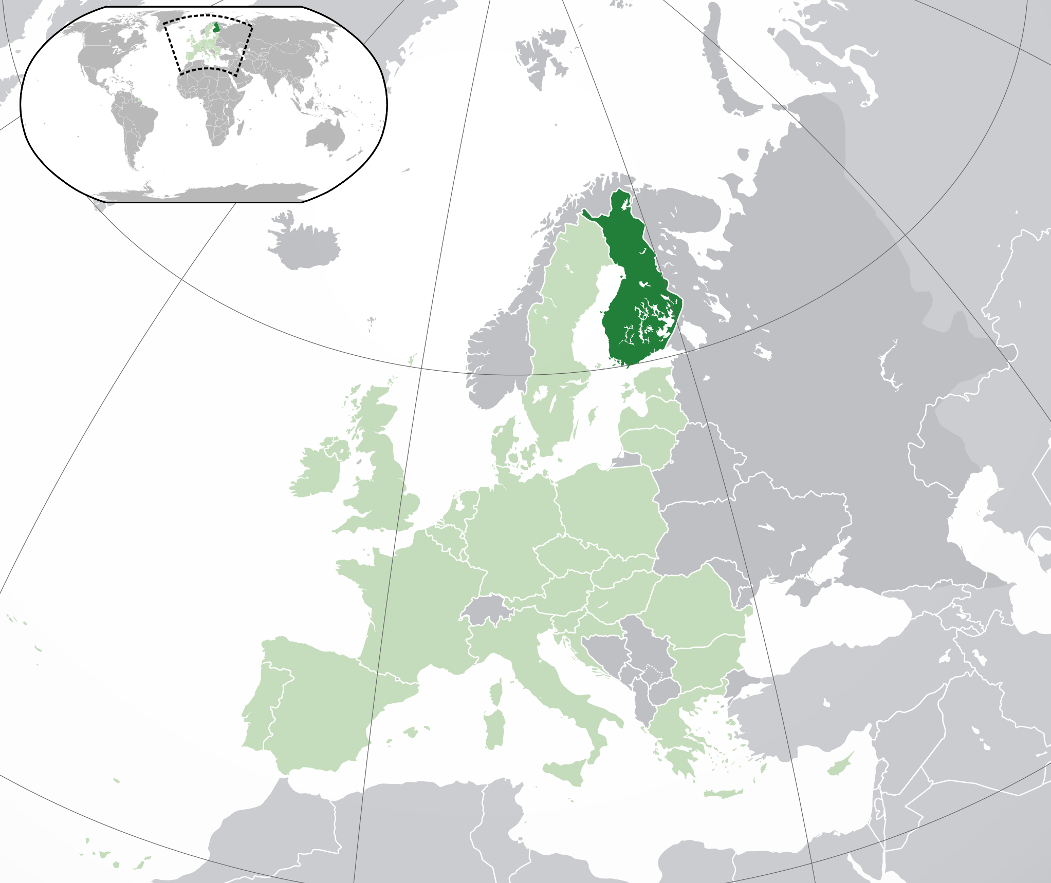

(Dark-Green) Finland. (Light-Green) The rest of the European Union (EU). (Dark-grey) The rest of Europe. (Light-grey) The surrounding region

Regional organization memberships:

European Union
European Union Intellectual Property Office (EUIPO)
European Patent Organisation (EPO)

Population:

5.5 million

GDP per capita:

39,164 euros

Estimated national R&D expenditure (% of GDP):

3 per cent of GDP

Number of research universities:

14

Summary of national patent information network (for example patent libraries, technology and innovation support centers):

The Finnish Funding Agency for Innovation (Tekes) is a publicly funded expert organisation for financing research, development and innovation in Finland. Tekes’s experts in different parts of Finland run regional teams, the members of which are persons specialising in invention development and commercialisation.

The Centres for Economic Development, Transport and the Environment (ELY Centres) are located around the country and are responsible for the implementation and development tasks of the central government.

Major universities have their own innovation support centres. In addition, the IPR University Center, which is an institute established jointly by five Finnish universities, co-ordinates and promotes education in and research into issues of intellectual and industrial property rights.

The Patent Library located in the Finnish Patent and Registration Office maintains a public book and journal collection on IP-related matters. It also co-operates with other PatLib Centres and offers free access to patent databases.

Major local industries:

Chemical industry products, forest industry products, metal and metal products, machinery and equipment, food products, electric and electronics industry products

Major trading partner States:

Germany, Sweden, Russia, Netherlands, China, United States

Other key information:

A decision on a national strategy concerning intellectual property rights (IPR strategy) was issued by a Government Resolution on 26 March 2009. In the 2011 Government Program, a decision was made to continue with the implementation of the IPR strategy, and to reform the action plan included in the strategy on the basis of the changes that had taken place in the operating environment and Government priorities.

In April 2014, a Government Resolution on a policy programme (2014-2020) on intangible value creation was published. It brings together central updated policy measures of the national strategy concerning intellectual property rights, key policy measures promoting business and entrepreneurship in the creative industries, and the updated national design programme.

The objective of the policy programme for intangible value creation is to enhance the prerequisites for intangible investments, strengthen the expertise related to the utilisation of intellectual capital and intangible value creation, and to promote the development of innovation-based business in Finland.

The policy programme for intangible value creation will be used to guide the work of government organisations within the framework of the budgets of the branches within the administration in question.

6 – Profile of Patent Applications
Number of national applications received – by technical field
Year  Technical Field | 2012 | 2013 | 2014 | 2015 | 2016
Mechanical | 841 | 731 | 706 | 674 | 623
Electrical/electronic | 409 | 444 | 371 | 318 | 346
Chemistry | 447 | 415 | 362 | 334 | 309
Biotech | 130 | 147 | 106 | 90 | 90
Total | 1,827 | 1,737 | 1,545 | 1,416 | 1,368

Number of national applications received – by route
Year  Route | 2012 | 2013 | 2014 | 2015 | 2016
National first filing/internal priority | 1,740 | 1,639 | 1,474 | 1,333 | 1,313
Paris priority | 87 | 98 | 71 | 83 | 55
PCT national phase entry | 47 | 38 | 41 | 43 | 27

Number of international applications received as RO
Year  Technical Field | 2012 | 2013 | 2014 | 2015 | 2016
Mechanical
Electrical/electronic
Chemistry
Biotech
Total | 1,358 | 1,265 | 1,112 | 1,005 | 969

Main Offices/States in which priority is claimed from national applications:

WO, EP, US, DE, CN, CA

Average time taken for national patent processing
Indicator | Measured from | Time (months)
To search | Filing | 6
To first examination | Filing | 6
To grant | Filing | 38

National backlogs
Measure | Number of applications
All pending applications | 3,300
Applications awaiting search (where relevant fees paid) | 555
Applications awaiting first examination (where relevant fees paid) | 555

7 – Support Required
N/A

8 – Other
N/A

9 – Assessment by other Authorities
N/A

[End of Annex and of document]

