E
PCT/CTC/30/19
ORIGINAL: English
DATE: March 16, 2017

Patent Cooperation Treaty (PCT)
Committee for Technical Cooperation

Thirtieth Session
Geneva, May 8 to 12, 2017

Extension of Appointment of the Intellectual Property Office of Singapore as an International Searching and Preliminary Examining Authority Under the PCT

Document prepared by the International Bureau

- All of the existing International Authorities were appointed by the PCT Assembly for a period ending on December 31, 2017. In 2017, the Assembly will therefore need to make a decision on the extension of the appointment of each existing International Authority that wishes to seek an extension of its appointment, having first sought the advice of this Committee (see PCT Articles 16(3)(e) and 32(3)). Information concerning this process and the role of the Committee is set out in document PCT/CTC/30/INF/1.
- On March 2, 2017, the Intellectual Property Office of Singapore submitted its application to extend its appointment as an International Searching Authority and International Preliminary Examining Authority under the PCT. This application is reproduced in the Annex to this document.
- The Committee is invited to give its advice on this matter.

[Annex follows]
Application of the Intellectual Property Office of singapore for Extension of Appointment
as an International Searching and Preliminary Examining Authority Under the PCT

1. General

1.1 Name of Office:
Intellectual Property Office of Singapore (IPOS)

1.2 Session of the Assembly at which appointment was sought:
Forty–Sixth Session (27th Extraordinary) Session, Geneva, September 22 to 30, 2014.

2. Substantive Criteria: Minimum Requirements for Appointment

2.1 Search and Examination Capacity:
In accordance with PCT Rules 36.1(i) and 63.1(i), the national Office or intergovernmental organization must have at least 100 full-time employees with sufficient technical qualifications to carry out searches and examinations.
As at November 2016, IPOS has 102 full-time patent examiners, with more than 90% having a PhD degree. They come from top global universities like National University of Singapore, Nanyang Technological University (Singapore), John Hopkins University (US), Imperial College London (UK), Technische Universität München (Germany), Monash University (Australia), Peking University (China), Tsinghua University (China) and Zhejiang University (China). Most have also authored works published in high-impact journals, and many are co-inventors on patent applications.
A breakdown of the profile of IPOS’ patent examiners according to technical fields is as below:
Technical field | Number (in full-time equivalent) | Average experience as examiners (years)
Engineering and physics | 23 | 4
Info communication technology | 16 | 4
Chemistry and materials | 36 | 4
Biotechnology and biomedical science | 27 | 4
Total | 102

IPOS has experienced patent examiners who had worked in established IP offices, like those of Australia, United Kingdom, Japan, Canada and China. Their areas of expertise and experience include search and examination (including the work of International Searching and Preliminary Examining Authority (ISA and IPEA)), training, hearings, quality management, strategic planning, policy and patent informatics.

2.2 Competency-based Training and Development:
IPOS has developed a competency framework for patent examiners, which defines the knowledge, skills, judgement and attributes that are required to perform the job effectively. Based on the competency framework, training and development strategies are built to support individual and organizational growth.
IPOS has partnered European Patent Office (EPO) and Japan Patent Office (JPO) to develop and run the training programs for our pioneer group of examiners. We also employed senior examiners with over 15 years of experience to complete the development of our examiners' competencies and to provide close supervision of their work. To ensure continuity of quality training, IPOS later partnered EPO and United States Patent and Trademark Office (USPTO) to develop in-house training capability. Examiners who had lecturing and teaching experience in universities were identified and given specialized training to be trainers. These in-house trainers, together with IPOS’ senior examiners and guest lecturers, have developed a structured training program to train new trainee examiners. Following the appointment of IPOS as ISA and IPEA, a special 4-day program was later developed to train the examiners on the PCT-specific procedures.
Continuous learning is also incorporated into our training strategy to ensure that examiners continue to gain experience and keep up-to-date with intellectual property and technological developments. Examiners are provided with numerous opportunities to attend training courses and conferences locally and overseas. A learning-and-development team was also established to help with sourcing workshops and training courses that are relevant for professional learning and growth.
IPOS also collaborates with other established offices in establishing examiner exchange program. Reciprocal visits allow examiners from both offices to share and compare the practices in their respective offices and learn from each other in terms of search and examination capabilities. We have had the privilege of hosting experienced examiners of diverse technical fields from EPO and JPO over a period of time ranging from one week to six months. Our examiners have also been sent to other offices (e.g. USPTO, JPO and Deutsches Patent- und Markenamt (DPMA)) to work on real patent applications and discuss the findings with their counterparts in other offices. IPOS also regularly organizes Community of Practice Workshops for patent examiners within Association of Southeast Asian Nations (ASEAN). The next workshop will held in Singapore in March 2017, where the patent examiners from ASEAN will be participating in a three-day workshop and to exchange practice experiences and discuss issues of common interest in our regional work-sharing platform, ASEAN Patent Examination Co-operation (ASPEC).
The table below provides the overview of the training program of an IPOS patent examiner.

Formal Training |  | Topic | Duration
 | 1 | Orientation | 1 week
 | 2 | Patent Law | 3 weeks
 | 3 | Patent Classification | 1 week
 | 4 | Patentability Criteria | 3 weeks
 | 5 | Search and Examination  - Claims construction  - Search strategy, platforms and databases  - Drafting opinions | 11 weeks
 | 6 | Search and Examination Practice | 2 weeks
 | Assessment via Written Examination |  | 1 week
 | Preparation for OJT, Team-forming |  | 2 weeks
 | PCT-specific procedures |  | 4 days
 | Total |  | 24 weeks  (6 months)
On-the-job Training | Competency-based training by experienced examiners and using practical work |  | Up to 12 months
Overall  Assessment | Based on the requirements as set up in the competency framework for patent examiners
Continuing training of examiners through various programs

2.3 Search Platforms and PCT Minimum Documentation:
According to PCT Rules 36.1(ii) and 63.1(ii) Office or organization must have in its possession, or have access to, at least the minimum documentation referred to in Rule 34, properly arranged for search purposes, on paper, in microform or stored on electronic media.
IPOS has implemented a comprehensive suite of search platforms with their respective plugs-in, covering both patent and non-patent literature. Together, they provide the examiners adequate access to the minimum documentation referred to in Rule 34 of the PCT Regulations and more.
The search platforms available to the examiners include:
a. the EPO’s search platform, EPOQUENet, incorporating access to Derwent World Patent Index (DWPI);
b. a broad coverage commercial search platform, Questel Orbit;
c. a dedicated commercial search platform for chemistry and biotechnology searches, STN; and
d. non-patent literature databases including China Academic Journals database by China National Knowledge Infrastructure (CNKI), IEEE Xplore by IEEE and Scopus by Elsevier.
These platforms are linked to the patent documentation of more than 80 countries and authorities (including World Intellectual Property Organization (WIPO), China, EPO, Germany, Japan, Korea, Russia, the UK, the US, and Singapore) and in many languages (including Chinese, English, French, German, Japanese, Korean, Russian, and Spanish).
IPOS regularly reviews the subscription-based search platforms and databases for their adequacy, relevance and efficiency. New resources are reviewed by IPOS Search Standards Office (SSO) and, where appropriate, added to the pool of patent resources available to the examiners for wider search coverage.
Full training to use the search platforms were provided to the examiners by the service providers. Refresher or advanced technical field-specific course is regularly provided to ensure that the examiners keep up-to-date on the usage of search platforms and databases.

2.4 Language(s) in which national applications may be filed and processed:
In accordance with Rules 36.1(iii) and 63.1(iii), that Office or organization must have a staff which is capable of searching and examining the required technical fields and which has the language facilities to understand at least those languages in which the minimum documentation referred to in Rule 34 is written or is translated.
IPOS began operating as ISA, IPEA and the Authority specified for supplementary search (SISA) under the PCT on September 1, 2015. The language accepted by IPOS as ISA and IPEA was solely English while the languages accepted by IPOS as SISA were English and Chinese. On October 1, 2016, IPOS as ISA and IPEA progressed to accept another language, Chinese, as a filing language.
All examiners are fluent in English as it is the official working language in Singapore. Among the examiners, more than 35 per cent have an excellent command of the Chinese language. IPOS is therefore able to perform searches in Chinese and review prior art documents in Chinese language. As the volume of such documents continues to trend upwards, the ability to do a full text search and examination in Chinese language will be a positive contribution to the comprehensiveness and accuracy of PCT search and examination work.

3. Quality Management
According to PCT Rules 36.1(iv) and 63.1(iv), that Office or organization must have in place a quality management system and internal review arrangements in accordance with the common rules of international search.
IPOS Patent Search and Examination Unit (S&E Unit) implemented ISO-compliant quality procedures for carrying out search and examination services since 2013. The certification according to the ISO 9001:2008 standards for search and examination services was formally attained in November 2014. Subsequently, the S&E Unit successfully passed external surveillance audit in 2015 and 2016 without any major findings. The Quality Management Office (QMO) is currently preparing to transit from the ISO 9001:2008 standards to the ISO 9001:2015 standards and aims to attain certification according to the new standard by end of October 2017.
In response to Circular C. PCT 1483 issued by International Bureau, IPOS recently submitted an annual report, which describes in detail IPOS’ quality management system (QMS) in accordance with Chapter 21 of the PCT International Search and Preliminary Examination Guidelines.
Our quality policy is to work together with our customers to provide high quality products and services which are delivered in an efficient and consistent manner. We are committed to continually improve our systems, practices and programs in order to provide robust IP rights that will foster a thriving and vibrant Singapore IP environment.
Our quality objectives are to provide high quality search and examination products, and services that are valid and reliable, delivered in an efficient and pragmatic manner.

3.1 Validity and Reliability of Search and Examination:
We regard a search to be valid when the search was conducted employing an appropriate search strategy, and using a comprehensive set of authoritative sources of information. A search is considered reliable when it is sufficiently documented to permit a reproducible and consistent search result.
An examination is valid when the law is correctly interpreted and logically applied to arrive at a sound decision, and where that decision and its basis are clearly communicated to the customer. An examination is reliable when examiners use a consistent approach based on an open and transparent set of guidelines and where considerations for arriving at a decision have been documented to show that guidelines have indeed been followed during the examination.
Before conducting search and examination for an international application, a search team consisting of three members (an examiner, a buddy examiner in the relevant technical field and a senior examiner) will be formed to discuss the search strategy and various substantive issues related to the application. It is mandatory for the examiner to document search strategy, search results, a short excerpt from the relevant prior art and considerations during examination in an internal document. The internal document will serve to facilitate the “3-pair of eyes” quality check (QC) process (see the figure below), which is mandatory for all the reports established under the PCT.
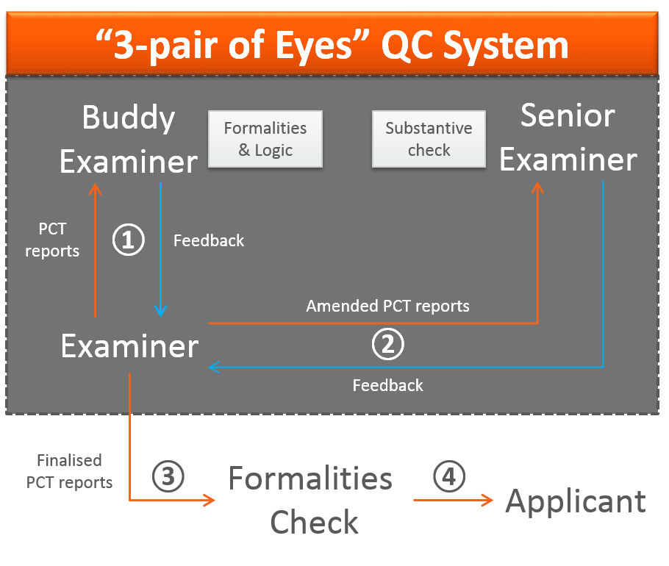
Upon completion of a draft of the reports, the examiner will send the draft to the buddy examiner for a check on the logic of the arguments and the formalities. The buddy examiner may make comments and track changes in the draft, prior to sending back to the examiner for consideration. Following which, the examiner may amend the draft based on the comments received, before submission to the senior examiner for final QC. The final QC process is iterative and will only be completed upon approval by the senior examiner. The finalized reports will then be subjected to a final round of formalities check before it is transmitted to the applicant.
The conformance level is assessed based on a set of metrics related to validity and reliability. Feedback related to the quality of work as well as update of guidelines and practice notices are regularly provided to ensure consistency and improvement of quality.

3.2 Efficient – Commitment to Timely Actions:
Products and services are delivered efficiently when they are delivered in a timely manner. Since turning operational as an ISA and IPEA in September 2015, we are committed to delivering all the reports within the time limits as set up in the Regulations under the PCT, and regularly review our processes to prevent late issuance of reports. IPOS has maintained a good timeliness record since operation. In 2015, IPOS ranked first among all ISAs with 100 per cent of our international search reports (ISRs) turned around within the prescribed 90-day timeline.
IPOS has a monitoring system that reports the pendency of all reports issued under the PCT. Reviews are conducted weekly to ensure that all reports will be issued within set time limits. Individual emails or notifications will be sent to the examiners to remind them of the time limits two weeks before any case is due.

3.3 Pragmatic:
IPOS expects the examiners to take a pragmatic and common-sense approach to deliver the products and services in the best way to the customers, as part of our commitment to provide quality services to applicants.

3.4 International Authority Implementation Office:
In 2014, IPOS set up an International Authority Implementation Office (IAIO) to make preparation for the appointment as ISA and IPEA. Following the appointment, the IAIO looked into mapping the work processes, preparing guidelines (administrative as well as search and examination), training on procedures, preparing to apply PCT templates, and preparing the IT infrastructure to implement the ePCT system. After turning operational as ISA and IPEA, the IAIO continues to look into streamlining and updating of work processes and guidelines according to changes in the PCT legislation and guidelines.

4. Scope of Operation
The languages accepted by IPOS as ISA, IPEA and SISA are English and Chinese.
The following receiving Offices have recognized IPOS to be their competent ISA/IPEA:
1) Cambodia: Department of Industrial Property of Cambodia
2) Indonesia: Directorate General of Intellectual Property (Indonesia)
3) Japan: Japan Patent Office
4) Mexico: Mexican Institute of Industrial Property
5) United States of America.: United States Patent and Trademark Office
6) Viet Nam: National Office of Intellectual Property of Viet Nam

5. National Innovation Strategies and Statement of Motivation
Singapore’s innovation journey has started since the early 1990s and this has formed the basic foundation of our research and development (R&D) sector. With a population density of 7,807 people per square kilometer, it is home to over 190,000 enterprises, ranging from small and medium-sized enterprises to multinational corporations which actively stage their innovation activities in Singapore. Singapore’s Gross Domestic Product (GDP) was worth 292.74 billion United States dollars (402.50 billion Singapore dollars) in 2015, representing 0.47 per cent of the world economy. This translated to 85,382.30 Singapore dollars GDP per capita. Total R&D expenditure was at 2.2 per cent of GDP, or 8.5 billion Singapore dollars, in 2014. R&D investments have created high-value jobs in Singapore and the number of R&D jobs created in Singapore was 42,100 in 2014. This comprises of research scientists and engineers, non-degree researchers, technicians and other supporting staffs. Moving forward to 2016, Singapore has unveiled a 19 billion Singapore dollars Research, Innovation and Enterprise (RIE) 2020 Plan to support our R&D efforts in the next five years. This is a 3 billion Singapore dollars increase from the RIE 2015 Plan which was released in 2011. The RIE 2020 plan seeks to promote innovation and technology recognition in enterprises, and drive economic growth through value creation. With our strong focus on R&D, Singapore is well-placed to support our intellectual property (IP) ecosystem.
Singapore government has recently released the Committee on the Future Economy (CFE) Report which highlights several recommendations to standardize IP protocol to streamline commercialization process for R&D. This demonstrated Singapore’s effort to increased recognition in IP and its pivotal role in supporting innovation as Singapore’s next engine of growth. The Singapore Government’s Budget Statement for Financial Year 2017 has also highlighted measures to improve access to IP in which collaborative efforts from IPOS and Intellectual Property Intermediary (IPI) will be directed to analyze and bundle complementary IP from Singapore and overseas. IP Development Incentives (IDI), which emphases on IP commercialization, has also been introduced to encourage innovation. This focus on innovation has underpinned the continuous growth in patenting activity, including PCT activity which a high share of applications originated from universities and; government and research institutions, measuring about 30 per cent in 2015.
Singapore has been a Contracting State of the PCT since 1995, with IPOS acting as the PCT receiving Office (RO) in Singapore. IPOS is familiar with PCT work as it handles a significant volume of PCT applications. Based on the WIPO’s latest PCT statistics, Singapore is ranked twelfth (in 2014) in terms of the number of PCT national phase entries and amongst the top 20 (in 2015) in terms of the number of PCT applications handled as an RO. Further, Singapore has been ranked amongst the top 10 ROs in timeliness in transmitting PCT applications to the International Bureau (IB) and to the ISAs. Singapore commenced operations as ISA and IPEA on September 1, 2015 and has since issued over 400 ISRs. As garnered from WIPO recent PCT statistics, Singapore has been ranked first in timeliness in transmitting ISRs to the IB in 2015 and is anticipated to rank amongst the top 3 in 2016. Combined with IPOS’ focus on building a strong patent search and examination capability, IPOS is confident of maintaining an active role in the PCT system as an ISA and IPEA.
In addition to our familiarity with the PCT system, IPOS as ISA and IPEA will be able to help meet the continued strong growth in demand for PCT search and preliminary examination work, particularly in South-East Asia. Over the past five years, the number of PCT applications has been increasing consecutively, achieving a new record of 218,000 PCT applications in 2015. On February 2, 2017, PCT marked a new milestone of publishing its 3 millionth published application in record time. This was driven largely by Asia which accounted for 43.5 per cent of all PCT applications filed in 2015. Asia recorded by far the sharpest growth in filings (+9 per cent in 2015), among the world’s six main geographical regions. With the establishment of ASEAN Economic Community in 2015 which marked a major milestone in regional economic integration, it is expected to drive regional economic growth and consequently, an increase in patenting activity in the region. Therefore, it is anticipated that the strong growth in PCT applications from ASEAN and Singapore is poised to continue. IPOS as an ISA and IPEA will continue to support Asia, and in particular ASEAN, as PCT activity continues to increase robustly, not only to provide search and examination services, but to also continue to work to increase awareness and use of the PCT system.
Furthermore, an ISA and IPEA role will also be synergistic with our efforts within the ASEAN region to reduce workload and increase the quality and efficiency in patent search and examination. In particular, such a role will complement our regional responsibilities under the ASPEC program to increase work-sharing and build a Community of Practice for patent examiners.

Map showing neighboring States

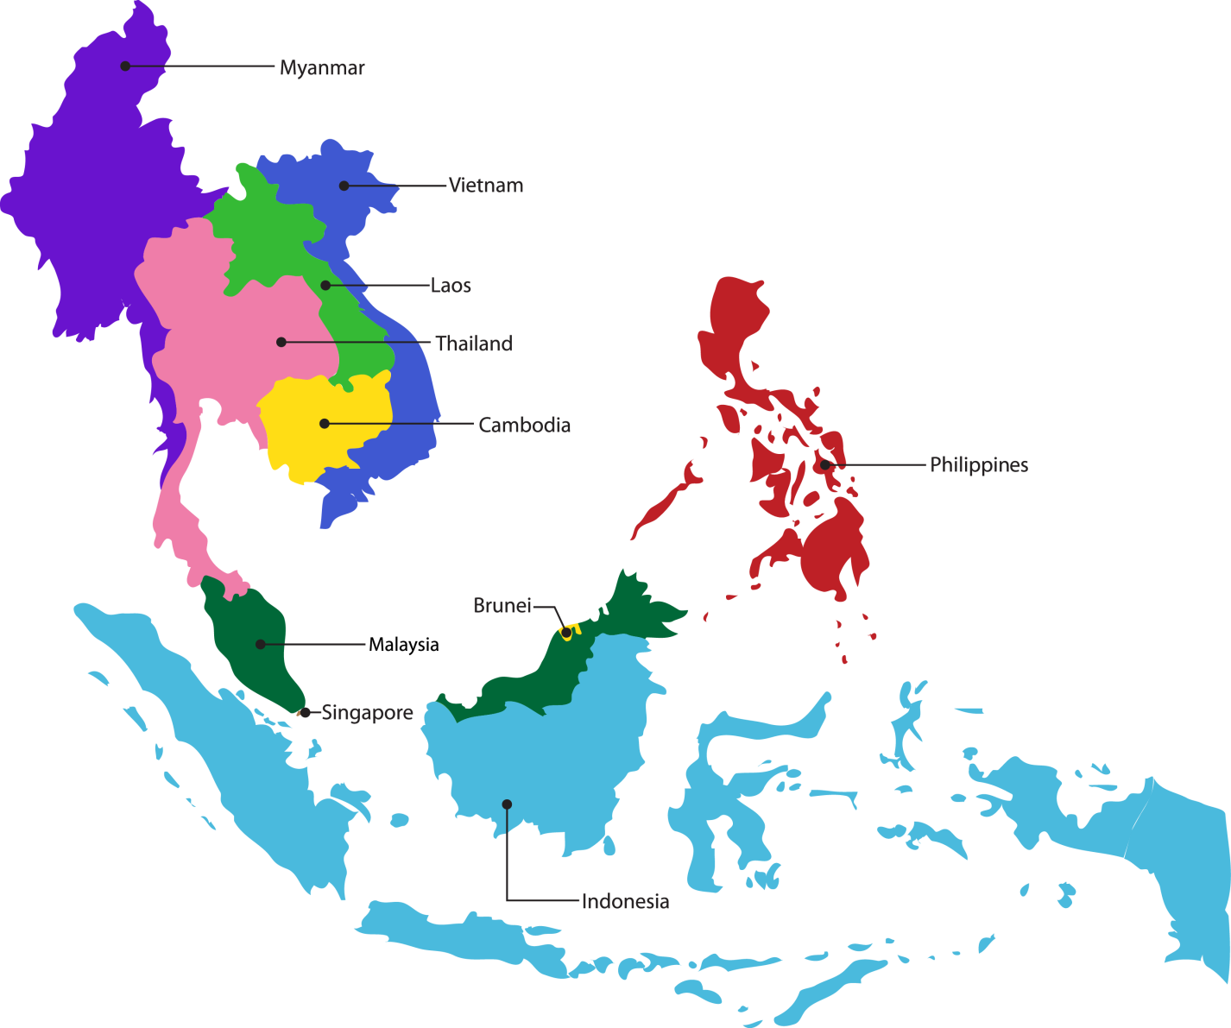

6. Profile of Patent Applications

6.1 Number of national applications received – by technical field:

Technical Field/ Year | 2012 | 2013 | 2014 | 2015 | 2016
Basic materials chemistry | N.A. | 1,270 | 1,224 | 1,197 | 1,328
Biotechnology |  | 1,508 | 1,497 | 1,648 | 1,577
Chemical engineering |  | 1,103 | 1,343 | 1,086 | 1,015
Environmental technology |  | 297 | 354 | 389 | 339
Food chemistry |  | 486 | 400 | 438 | 331
Macromolecular chemistry, polymers |  | 925 | 967 | 1,010 | 910
Materials, metallurgy |  | 418 | 450 | 435 | 403
Micro-structural and nano-technology |  | 60 | 68 | 58 | 65
Organic fine chemistry |  | 2,443 | 2,839 | 2,683 | 2,538
Pharmaceuticals |  | 3,760 | 4,123 | 4,490 | 4,096
Surface technology, coating |  | 532 | 481 | 468 | 466
Audio-visual technology |  | 440 | 483 | 386 | 293
Basic communication processes |  | 80 | 58 | 62 | 52
Computer technology |  | 755 | 601 | 840 | 944
Digital communication |  | 515 | 470 | 500 | 483
Electrical machinery, apparatus, energy |  | 637 | 541 | 593 | 550
IT methods for management |  | 308 | 287 | 303 | 324
Semiconductors |  | 871 | 786 | 731 | 845
Telecommunications |  | 441 | 509 | 399 | 215
Analysis of biological materials |  | 244 | 210 | 221 | 206
Control |  | 193 | 214 | 238 | 225
Measurement |  | 855 | 745 | 894 | 825
Medical technology |  | 813 | 753 | 874 | 761
Optics |  | 431 | 450 | 347 | 292
Engines, pumps, turbines |  | 241 | 471 | 308 | 210
Handling |  | 508 | 547 | 490 | 450
Machine tools |  | 341 | 348 | 262 | 331
Mechanical elements |  | 310 | 276 | 271 | 312
Other special machines |  | 478 | 471 | 451 | 468
Textile and paper machines |  | 161 | 115 | 96 | 107
Thermal processes and apparatus |  | 155 | 211 | 127 | 157
Transport |  | 329 | 338 | 405 | 393
Civil engineering |  | 784 | 644 | 788 | 782
Furniture, games |  | 216 | 254 | 193 | 165
Other consumer goods |  | 214 | 282 | 251 | 276
Extracted on 10/02/2017 based on lodgment date
* No of grants by technology cluster
* One application may have multiple IPC, hence there may be duplicate count in the groupings

6.2 Number of national applications received – by route:

Year  Route | 2012 | 2013 | 2014 | 2015 | 2016
National first filing/  internal priority | 627 | 641 | 837 | 1,056 | 1,180
Paris priority | 904 | 902 | 864 | 919 | 888
Divisionals | 1,484 | 1,621 | 1,489 | 1,575 | 1,872
PCT national phase entry | 6,672 | 6,558 | 7,123 | 7,264 | 7,040
Total | 9,687 | 9,722 | 10,313 | 10,814 | 10,980
Extracted based on lodgment date of application

6.3 Average time taken for national patent processing:
In average, each office action is issued within six months and the time to grant an application from the time the application is lodged is about 30 months. Nevertheless, IPOS offers an expedited scheme which enables applications which fulfil certain requirements, such as applications that are first filed in Singapore, to obtain a grant within a year. Applications under this expedited scheme will generally receive a first office action within 60 days.

6.4 National Workload:
In Singapore, applicant may file for search and examination based on different approaches, depending on the applicant’s need. They include:

- Request for Search using Patent Form 10
  - An applicant may request for search only and decide whether an examination needs to be carried out after reviewing the search report.

- Request for Search and Examination using Patent Form 11
  - An applicant may request for search and examination at the same time.

- Request for Examination using Patent Form 12
  - An applicant may decide to proceed with examination after reviewing the search report.
- Request for Supplementary examination using Patent Form 12A
  - An applicant may rely on a set of foreign positive report or granted patent to request for a top-up examination.

The table below indicates the volume of IPOS’ national workload based on the different search and examination approaches as described in the above paragraph. The figures below are accurate as of January 2017.

Measure | Number of applications
All pending applications, awaiting final report  (Include Patent Form 10, 11, 12 and 12A) | 5,488
Applications awaiting search  (Include Patent Form 10 and 11) | 879
Applications awaiting first examination  (Include Patent Form 11, 12 and 12A) | 2,331

[End of Annex and of document]

