E
PCT/CTC/30/9
ORIGINAL: English
DATE: March 16, 2017

Patent Cooperation Treaty (PCT)
Committee for Technical Cooperation

Thirtieth Session
Geneva, May 8 to 12, 2017

Extension of Appointment of the Egyptian Patent Office as an International Searching and Preliminary Examining Authority Under the PCT

Document prepared by the International Bureau

- All of the existing International Authorities were appointed by the PCT Assembly for a period ending on December 31, 2017. In 2017, the Assembly will therefore need to make a decision on the extension of the appointment of each existing International Authority that wishes to seek an extension of its appointment, having first sought the advice of this Committee (see PCT Articles 16(3)(e) and 32(3)). Information concerning this process and the role of the Committee is set out in document PCT/CTC/30/INF/1.
- On March 8, 2017, the Egyptian Patent Office submitted its application to extend its appointment as an International Searching Authority and International Preliminary Examining Authority under the PCT. This application is reproduced in the Annex to this document.
- The Committee is invited to give its advice on this matter.

[Annex follows]
Application of the Egyptian Patent Office for Extension of Appointment
as an International Searching and Preliminary Examining Authority Under the PCT

1 – General
Name of Office: Egyptian Patent Office

Session of the Assembly at which appointment is to be sought: 2017 session

Expected date at which operation as ISA/IPEA could commence: Application for extension of existing appointment originally made in 2009 until December 31, 2017, with unbroken effect from January 1, 2018.

Existing ISA/IPEA(s) assisting in assessment of extent to which criteria met: Not applicable to extensions of appointment

2 – Statement of Motivation
The Egyptian Patent Office considers it important that the PCT system is accessible for applicants from all regions and being a PCT international searching and examining authority especially for Arab countries gives the opportunity for 30 million populations to register in Arabic language to enrich the global patent system, considered to be one of the first Arab states examining patents in the Arabic language and used as a language of publication.

According to (MOUs) between the Egyptian patent office and Arab states, we prepare ISR/IPER for IB, Saudi Arabia, Sudan, and Oman.

Prior to its appointment by the PCT Assembly in 2009, there were no International Searching and Preliminary Examining Authorities in Africa or the Arab region. The same for other Authorities not able to offer international search and preliminary examination in the Arabic language. Consequently, even though Arabic was added as a language of publication in 2006, applicants filing in that language were disadvantaged by having to provide a translation for the purpose of international search. Furthermore, applicants from Africa and the Arab region were required to nominate an International Searching Authority more geographically distant from them, potentially with higher fees than the Egyptian Patent Office, and which may not have been able to conduct communications in the applicant’s preferred language.

Since the Egyptian Patent Office has commenced operations as an International Authority, filings in Arabic have increased. While numbers are still not large, extension of the appointment is an important part in the promotion and relevance of the system to the Arabic-speaking world. Furthermore, acting as an International Searching Authority allows the Egyptian Patent Office to work more effectively in other activities to improve the system within the region. Such activities include:

(a) Provision of a Focal Points network (in association with WIPO’s Technology and Innovation Support Centers and similar programs) to connect universities and research centers to industrial entities;

(b) Helping to train examiners from other national Offices in the region; and

(c) Helping to improve the quality of machine translation from Arabic into other languages.

Finally, extension of the Office’s appointment as an International Searching and Preliminary Examining Authority will help the Office play its part in the national “Egypt Vision 2030” sustainable development strategy. This strategy aims to develop a creative and innovative society producing science, technology and knowledge, within a comprehensive system ensuring the developmental value of knowledge and innovation and using their outputs to face challenges and meet national objectives.

Extra information about the Egyptian development strategy "Egypt Vision 2030” will be on the following website: http://sdsegypt2030.com/.

3 – Applicant State(s)
Regional location
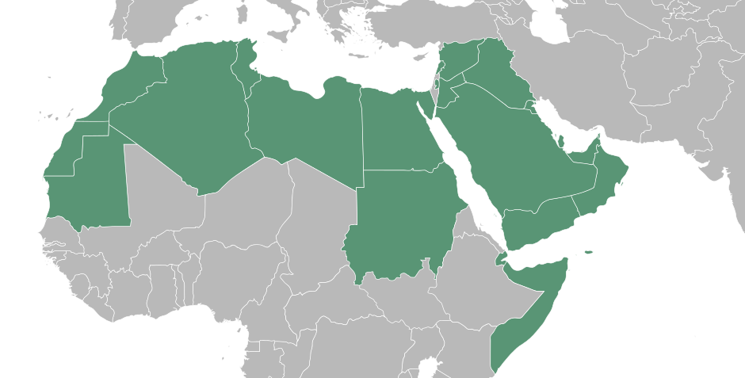
Egypt
Map showing State(s) and neighboring States

Population: 92,000,000

GDP per capita: 3,418 Egyptian pounds

Estimated national R&D expenditure (% of GDP): 3 per cent

Number of research universities: 70 universities and 70 research institutions.

Summary of national patent information network (for example patent libraries, technology and innovation support centers):

Major local industries: Textiles, chemical material, pharmaceutical, food, mining

Major trading partner States: EU, Arab countries, Africa, Latin America. Egypt is a trade member in the Aghadir Agreement and Common Market for Eastern and Southern Africa.

4 – Profile of Patent Applications
Number of national applications received – by technical field

Year  Technical Field | 2016 | 2015 | 2014 | 2013 | 2012
Mechanical | 430 | 424 | 428 | 414 | 436
Electrical/electronic | 422 | 412 | 423 | 407 | 430
Civil | 42 | 40 | 45 | 35 | 48
Textile | 33 | 34 | 32 | 29 | 38
Chemistry | 390 | 393 | 388 | 383 | 399
Physics | 145 | 136 | 141 | 131 | 153
Agriculture | 156 | 154 | 150 | 149 | 158
Pharmaceutical | 410 | 408 | 400 | 403 | 414
Medicine | 32 | 34 | 31 | 32 | 36
Biotech | 83 | 52 | 85 | 49 | 71
Total | 2,143 | 2,087 | 2,123 | 2,032 | 2,183

Number of national applications received – by route
Year  Route | 2016 | 2015 | 2014 | 2013 | 2012
National first filing/internal priority | 901 | 713 | 746 | 651 | 681
Paris priority | 59 | 63 | 47 | 64 | 70
PCT national phase entry | 1,183 | 1,311 | 1,330 | 1,317 | 1,432

Number of international applications received as RO
Year  Technical Field | 2016 | 2015 | 2014 | 2013 | 2012
Mechanical | 19+6(SA) | 23+6(SA)+1(SD) | 30+4(IB) | 24 | 18
Electrical/electronic | 9+6(SA) | 8+4(SA) | 3+2(IB) | 5 | 15
Chemistry | 11+3 (SA) | 16 | 9 | 12 | 3
Biotech | 1 | 2 | 1 | 1 | -
Total | 55 | 60 | 49 | 42 | 36

Main Offices/States in which priority is claimed from national applications:
USPTO, EPO, JPO, SIPO, KIPO

5 – Search and Examination Capacity
Employees qualified to carry out search and examination for both phases, the national / international phase:
EGPO started with 16 technical examiners and has expanded to reach now 130 technical examiners. They cover all required technical fields

Technical field | Number of examiners
Mechanical | 8
Electrical/electronic | 9
Civil | 2
Textile | 3
Chemistry | 10
Physics | 4
Agriculture | 4
Pharmaceutical | 74
Medicine | 5
Biotech | 11
Total | 130

All technical examiners are bachelor degree holders. About 30 per cent of them hold postgraduate qualifications, 17 out of them having master degree and 30 PHD.

EGPO support about 10 persons per year for IP master and we have now more than 54 degree on IP.

Examination Division:

Director: oversees the duties of its staff and the division
Supervisor[s]: signs actions made by 5 or more examiners and check the quality of reports.
Examiner[s]: conduct search and examination procedures

Language(s) in which national applications may be filed and processed: Arabic.

Language(s) in which International applications may be filed and processed: Arabic and English

Other languages in which large numbers of examiners are proficient: English. Smaller numbers are also proficient in other languages, such as French.

Services available to assist search or understanding of prior art in other languages: The search tools used by examiners at the Egyptian Patent Office allow searching of most of the patent and non-patent literature in the English language, either through arrangements such as family matching or machine translation of the documents provided by the search websites themselves e.g. PATENTSCOPE. Also examiners have access to human translators on request as the Egyptian patent office has a department specialized in translation services to more than one languages.

Qualification and Ongoing Training of Examiners:
The Office places great emphasis on continued training and organizes courses such as languages (English and French), computer skills, training of trainers, customer services, supervision skills, archiving systems, modern documentation systems, administrative system development, auditing and development of governmental affairs, as well as specialized on-the-job training in relation to subjects specific to examiners’ work. The Office also supports around 10 staff per year pursuing intellectual property diplomas and the Office now has more than 54 staff with degrees in intellectual property.

The Office also works together with other Organizations, including the World Intellectual Property Organization, the European Patent Office and the Swedish Patent and Registration Office to offer its examiners training courses outside the Office. Staff may also benefit from the experience of the Office’s participation in a variety of international conferences and meetings at WIPO and elsewhere.

Access to the minimum documentation for search purposes:
(X) Full access

According to Rule 34 under the PCT Regulations, the Office has access to the full PCT minimum documentation through a variety of systems, which are selected according to the needs of the particular international application, as set out below.

Search systems:
National databases used by examiners in the search phase

Office | Kind of Document | Publication Year
WIPO | Impact Rule 87  Pamphlets | 2002.12~
 |  | 1978~
EPO | DocB | 1974~
 | Espace-A | 1978-1999
 |  | 1975~
 | Espace-B | 1980-1999
 |  | 1980~
 | Espace-world | 1978-2002.11
USPTO | Granted patent | 1975~
 |  | 1976~
 | Published patent | 2001.3~
JPO | Bibliographic data | 1975-1998
 | Published patent  And utility models | 1975-1992
 |  | 1993~
 | Granted patents  And utility models | 1986-1993
 |  | 1994~
 | Japanese Patent  Abstract | 1975~
 | Japanese Patent  Abstract | 1976~
SIPO | Published patent  Granted patents  English abstracts | 1985~
KIPO | Bibliographic data | 1947~
 | Abstract data | 1947~
 | Granted Patents | 1947-1998
 |  | 1979~
 | KPA (Korean Patent Abstract) | 1979~

All examiners have access to commercial databases, which provide access to the full patents part of the PCT minimum documentation as well as most of the non-patent literature and a very wide range of documentation beyond the minimum:

Some of them provide access to core patent collections, Asian translated patent collections and scientific literature collections; others provides access to chemical structure databases and biological sequences databases; and others provides access to content from universities and research centers, including theses and scientific books.

Examiners also have access to other databases, including the Indian Traditional Knowledge Database, the Egyptian Knowledge Bank (a national system which provides access to a wide range of scientific publications from around the world) and the Egyptian Universities Library (which provides access to major scientific periodicals and journals).

For collections extending beyond the PCT minimum documentation which are only available in paper, CD or microfilm format, the Office has invested in new storage and retrieval systems to maximize the efficiency of access to information.

Average time taken for national patent processing

Indicator | Measured from | Time (months)
To search | Filing | 12 months
To first examination | Filing | 16 months
To grant | Filing | 39 months

National backlogs

Measure | Number of applications
All pending applications | 8,810
Applications awaiting search (where relevant fees paid) | 5,340
Applications awaiting first examination (where relevant fees paid) | 3,470

6 – Quality Management
The Egyptian Patent Office has a quality management system in line with the requirements of Chapter 21 of the International Search and Preliminary Examination Guidelines and is committed to maintaining and enhancing its position in relation to the quality of products and services provided. Its annual reports on this system can be found on the WIPO website at: http://www.wipo.int/pct/en/quality/authorities.html

One of the key tasks under way to improve the Office’s quality management system is the establishment of a new quality management manual for patent examination, better bringing together the information needed to understand and use the quality management processes relevant to the search and examination systems. The Office is also keen to accept feedback from its users about its products and services. Such feedback can be given by letter, fax, email, over the telephone or in person.

EGPO‘s international receiving office uses the e-PCT system to send the international application and the ISR/IPER to IB.

EGPO prepared templates to help examiners filling in the written opinion reports.

Organization (for Quality Management)
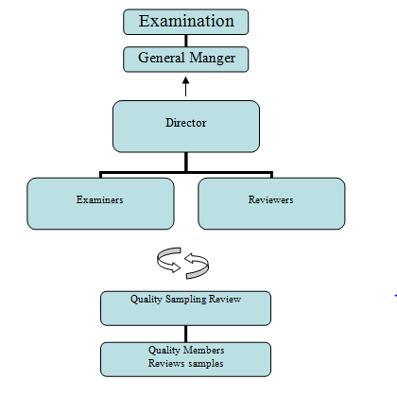

Quality Management by Examination Division
– Reviewers sign action made by Examiners of each technical field group
– Director oversees the duties of Reviewers and Examiners
– Random sampling from first office action cases issued checked by General Manger of Technical Examination Department

Quality Sampling Review
In National Applications
– Random sampling from approved application and rejected application every month (sampling ratio 5 per cent from both)
In International Applications
– All international applications are subject to quality review

Quality sampling review committee (QSR) flow chart
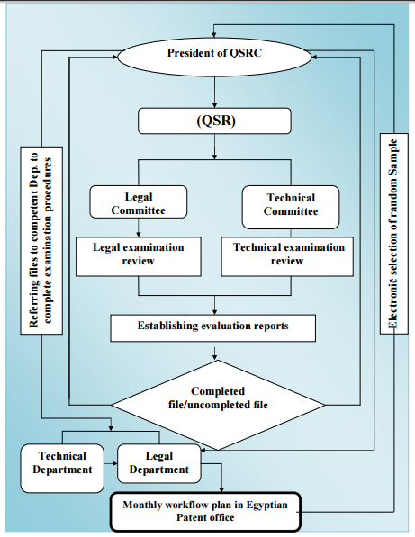

7 – Other
The fourth pillar of the Egyptian vision "2030" objective is:
A creative and innovative society producing science, technology and knowledge, within a comprehensive system ensuring the developmental value of knowledge and innovation using their outputs to face challenges and meet national objectives, so Academy of Scientific Research and Technology (ASRT) developed policy to achieve Egypt goal. ASRT developed TICO to support creativity and innovation.

Support Innovation & Technology
To activate the role of scientific research, and connect it with industry, agricultural& services in a relationship based on trust for the purpose of finding solutions for problems and issues related to the demands (Demand & Delivery). To support innovation and technology in the areas having priority, according to the national vision, down to entrepreneurship by developing the business for existing firms, (Spin off), and establish small and medium projects. All of that were the main motives behind the initiative of the Academy of Scientific Research and Technology (ASRT) to create a network consists of specialized offices aiming to support innovation, technology transfer and commercialization (TICO) in industry, agriculture & services communities. This network includes:
– Technology Transfer Office, TTO
– Grant and International Cooperation Office , GICO
– Technology Innovation Support Center , TIS

Office facilities renewal:
The Office has made major investments in improving its infrastructure to provide an efficient and productive working environment for its staff. This includes:

(a) Lighting, air-conditioning, furniture and buildings facilities;

(b) Effective new IT infrastructure, both at the examiner’s desk and in the data center, to ensure a reliable, effective and secure service for administrative and search systems; and

(c) Improved IT systems to ensure effective electronic support for administrative and search and examination functions.

Automation of the Office’s main functions relating to the PCT is largely based on services provided by WIPO, such as IPAS (Industrial Property Automation System) and ePCT, ensuring effective communications with WIPO and adherence with WIPO standards.

Training for examiners from other offices:
The Egyptian Patent Office has signed a memorandum of understanding with WIPO to act as a training center for offices from other Arab Offices. Training under this program has occurred since 2002, covering around 67 trainees from Sudan, Libya, Algeria, Palestine, Jordan, Djibouti, Qatar, Kuwait and Bahrain. The Office’s activity and experience as an International Searching and Preliminary Examining Authority enhances its ability to provide this form of service and it is hoped to provide further services of this type in the future.

8 – Assessment by other Authorities
Not relevant to extension of appointments.

[End of Annex and of document]

