E
pct/MIA/21/19
ORIGINAL: English only
DATE: January 29, 2014

Meeting of International Authorities
Under the Patent Cooperation Treaty (PCT)

Twenty-First Session
Tel Aviv, February 11 to 13, 2014

PCT 3.0

Document submitted by the Korean Intellectual Property Office

SUMMARY
- The present document concerns the proposals made by the Korean Intellectual Property Office (KIPO) in pursuit of an improved Patent Cooperation Treaty (PCT) System.

Background
- Continued development and improvement of the PCT system has been the subject of discussion in many international fora including the PCT Meeting of International Authorities (MIA) and PCT Working Group meetings.
- Taking on-going discussions into consideration, KIPO proposes to discuss the following items that focus on improving quality of service provided by International Authorities (IAs) and receiving Offices (ROs) through facilitation of work sharing.
- With the help of modern information and telecommunication technologies, an unprecedented level of information-sharing has been made possible. Taking such new opportunities, it is proposed by KIPO that the focus of PCT improvement should be now on facilitation of work sharing, disclosure of information, and mutual understanding and communication through the following group of proposals titled “PCT 3.0”.

OPPORTUNITIES FOR APPLICANT COMMENTS ON THE WOISA
- In order to grant the applicant an opportunity to comment on the written opinion of the International Searching Authority (WOISA), the PCT Assembly, at its thirty-first session, concluded an agreement in October 2001 (see paragraph 47 of document PCT/A/31/10):
“47. The Assembly agreed that no special provision should be included in the Regulations to enable the applicant to comment on the written opinion of the International Searching Authority. Any formal response to the written opinion of the International Searching Authority would need to be submitted to the International Preliminary Examining Authority under Article 34 as part of the Chapter II procedure, that is, by requesting international preliminary examination. Under the Chapter I procedure, the applicant could, however, submit comments on an informal basis to the International Bureau. Such informal comments would be sent by the International Bureau to all designated Offices and made publicly available, as would be, under proposed new Rule 44ter, the report resulting from the written opinion of the International Searching Authority. Designated Offices would be free to require a translation of such comments.”
In other words, the applicant can make informal comments on the WOISA, which would be sent to designated Offices by the International Bureau (IB).
- However, such comments are on an informal basis, and such opportunity has not been fully utilized. For instance, only 28 comments were made for international search reports provided by KIPO during 2013, which constitutes only 0.10 per cent of all search reports. Furthermore, ISAs cannot utilize the comments made by applicants as they are not provided with the comments. It is also noteworthy that at the sixth session of the PCT WG meeting, the importance of applicants’ comments on a negative written opinion at the international stage was pointed out by some ISAs (document PCT/WG/6/16).
- Therefore, KIPO proposes that a new regulation should be introduced to ensure that the applicant has an opportunity to officially comment on the WOISA. Specifically, the IB should be able to receive the applicant’s comments on the WOISA and transmit them to ISAs. Considering already established electronic systems, it is expected that transmission of the comments would not cause too much additional burden to the IB.
- To avoid unnecessary extra burden or workload, it shall not be made mandatory for applicant to submit comments or for the examiner to respond to the comments.
- The anticipated benefits are: applicants will be given an official opportunity to respond to the WOISA before entering the national phase, and ISAs will be able to receive feedback on their search results and to enhance their search quality. Designated Offices will also be able to improve their quality of examination by considering both the applicant’s comments and the international search report.

STANDARD IMAGE FORMATS FOR PCT APPLICATIONS
- When filing a PCT application electronically, drawings, figures, equations/other illustrations, or scanned documents are presented in the form of electronic image files. In accordance with section 3.1.3 of PCT Administrative Instructions Annex F (PCT/AI/ANF/5), an RO can select one between Tagged Image File Format (TIFF) and JPEG File Interchange Format (JFIF) as its accepted image format.
- TIFF is an image format developed for scanning, faxing, word processing and optical character recognition. It means that in the current PCT filing system, only black and white image, compressed by TIFF V6.0 with Group 4 compression legislated in 1992, is allowed. In this regard, TIFF shows excellent results both in image quality and file size, when it comes to compression of character-coded document format or drawings, as shown in Table 1 below.
<Table 1 TIFF compression>
 | 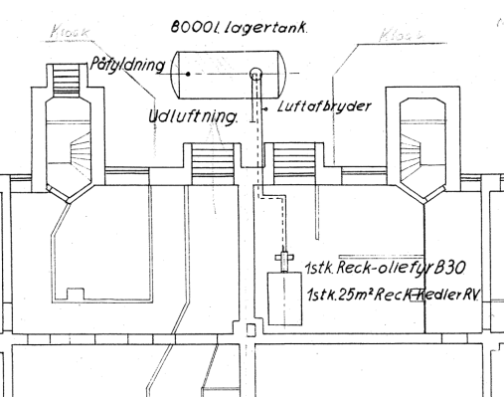
Original drawing  (300dpi, 167*131.3 mm, 2,992 Kbyte) | TIFF compressed drawing  (300dpi, 167*131.3 mm, 25 Kbyte)

- On the other hand, JFIF is the most widely used file format for JPEG compression image, and as shown in Table 2 below, it shows better results than TIFF when it comes to image quality of figures.
<Table 2 TIFF and JFIF comparison>
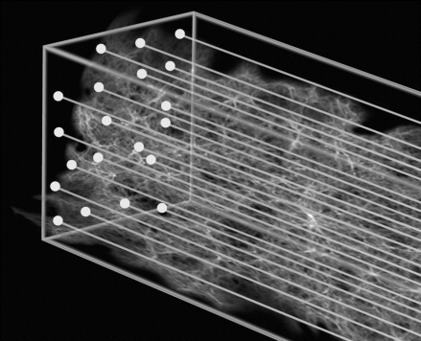 |  |  |  | 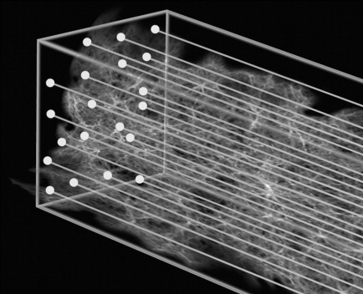
Original  (300dpi, 108*88mm, 1,873Kbyte) |  | TIFF  (300dpi, 108*88mm, 74Kbyte) |  | JFIF  (300dpi, 108*88mm, 111Kbye)
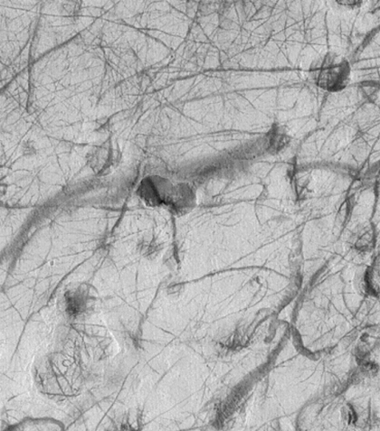 | 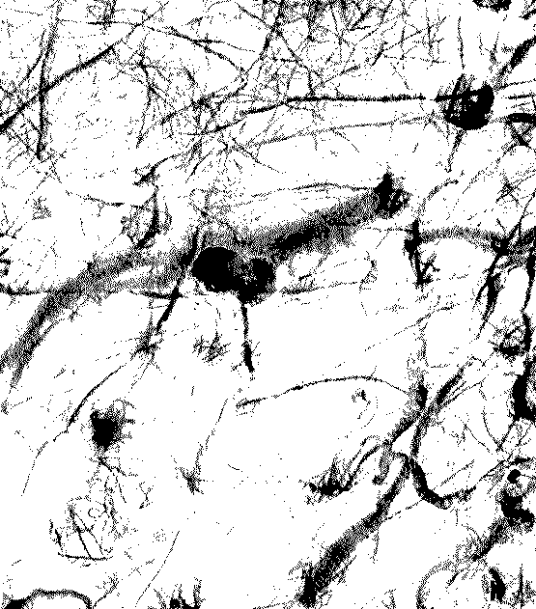 |  | 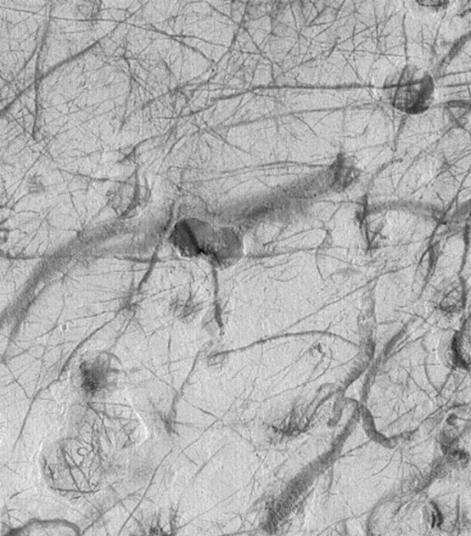
Original  (300dpi, 555*631mm, 1,052Kbyte) | TIFF  (300dpi, 555*631mm, 32Kbyte) |  | JFIF  (300dpi, 108*88mm, 77Kbyte)

- As shown in Table 2, TIFF compression is the possible cause of the unintended decrease in image quality and therefore, if an RO allows only TIFF format, the applicant may have to submit a correction to provide a clearer image. Furthermore, the low quality of image may lead to difficulty in understanding the invention and possibly an incomprehensive PCT publication document.
- It is also true that there are many offices that accept JPEG images in the process of their domestic patent or utility model application. However, when TIFF file is the only option an applicant can take in PCT application, making additional efforts to convert JPEG images into TIFF format is unavoidable.
- It is therefore KIPO’s proposal that ROs and the IB should allow the applicant to file in both TIFF and JFIF format in order for the quality of international search and PCT publications to be ensured.
- It is understood by KIPO that in order to accept JFIF format, each Office may have to revise related provisions and/or bear necessary costs for system upgrades. Any efforts to share experiences of Offices that is already receiving image files in both formats are welcomed.

Facilitation of wOrk sharing among offices
- As many offices are trying to reduce examination pendency period of their domestic applications, it is expected that in 2015, the pendency period of many offices will fall below 10 to 11 months. Since PCT international search is usually completed within 16 months from the priority date, it is likely that there will be more applications with an office action already issued at the time of PCT international search.
- However, under the current procedure, there is no official way for the ISA to receive search results produced by the Office that already conducted an Office Action (in many cases, the Office is the RO). Therefore, KIPO proposes to establish between ROs and ISAs a work-sharing program in which an RO, if available at the time of transmitting a search copy to the ISA, submits the copy of search or examination results of the family domestic application to the ISA.

collaborative search
- KIPO also proposes to consider possibility of officially introducing collaborative search into the PCT system. PCT collaborative search pilot programs jointly conducted by KIPO, the European Patent Office (EPO) and the United States Patent and Trademark Office (USPTO) showed that quality of PCT international search can be dramatically improved by work sharing among ISAs.

Collaboration TO ENHANCE QUALITY OF PATENT CLASSIFICATION
- Many Offices extensively use the International Patent Classification (IPC) for prior art search, statistical analysis, etc. However, despite its importance, discussions on collaboration for patent classification have not been active.
- Currently, ISAs assign an IPC code to each PCT application transmitted by an RO, in accordance with PCT Rule 43.3. Under the current PCT system, ISAs do not share information on the IPC code of an earlier family domestic application which is likely to have been issued by the RO. The lack of communication often results in duplicated work for classification. Therefore, KIPO would like to propose to establish a mechanism to share the IPC code between ISA and ROs in order to enhance efficiency and accuracy in classifying PCT applications.
- If available, an RO should share the IPC code of an application that claims priority with the ISA at the time of transmitting a search copy.

recommendations on non-patent literature citations
- As mentioned in paragraph 21 of Annex in document PCT/WG/6/8, WIPO Standard ST.14 contains no recommendations on how to cite non-patent literature in languages other than the language of an international search report.
“21. As a matter independent of the alignment with ISO 690:2010, the International Bureau has suggested that the recommendations for citing patent documents (including abstracts) should be reviewed in addition to the non-patent literature question. At present, ST.14 contains no recommendations on how to cite documents in languages other than the language of the document (search report) in which they are cited. It would therefore be useful to have guidance on when to use translations or transliterations of details, such as authors’ names or titles of documents whether this should be done in all cases, only when there is an official translation into the other language, or whether both the original and the translation should be provided. Moreover, if a translation or transliteration of a name or title is provided, there is the question of how it should be indicated that it is a translation/transliteration.”
- For example, where the second sheet of an international search report (PCT/ISA/210) is established in English, with non-patent literature in Korean being attached, the title and the author’s name in Korean are either translated into English, or maintained as it is. Recommendations on how non-patent literatures should be cited are absent, causing confusion to the examiners of an ISA and the applicants.
- Where the non-patent literature is in one of PCT international publication languages and the author’s name and document title are laid open in English, it is recommended to list each item in parallel with their English equivalent, arranged in accordance with WIPO Standard ST.14.
- Where the non-patent literature is in one of the PCT international publication languages but the author’s name or document title are not available in English, the information may be recorded in the only language available.
- Where the non-patent literature is not in one of the PCT international publication languages, it should be translated into English.
- Moreover, it would be desirable to initiate discussion on possible ways for the IB to provide translation service e.g. through machine translation, for the prior art cited in the international search reports.

FUTURE PLANS
- KIPO plans to present revised proposals, reflecting opinions of other IAs, at the upcoming sessions of the PCT Working Group.
- The Meeting is invited to consider and comment on the proposals set out in this document.

[End of document]

