E
pct/mia/22/16
ORIGINAL: English only
DATE: December 15, 2014

Meeting of International Authorities
under the Patent Cooperation Treaty (PCT)

Twenty-Second Session
Tokyo, February 4 to 6, 2015

Missing IPC Classes from International Patent Applications

Document prepared by the International Bureau

Introduction
- This document discusses the issue of international patent applications that are published without having been classified by the International Searching Authority (ISA) using the International Patent Classification (IPC) system and thus without an IPC symbol. This issue was the subject of Circular C. PCT 1425, dated October 2, 2014, sent to International Authorities and reproduced in the Annex to this document.

Discussion of Responses to Circular
- Eight International Authorities responded to the Circular and provided comments on some of the situations where an international application is published without an IPC class. The late receipt of the search copy from the receiving Office (RO) and resulting delay in establishment of the international search report were generally considered as the main cause of publication of an international patent application without an IPC class. To reduce delays in the receipt of the search copy arising from the applicant initially selecting an International Searching Authority not competent for the application, one Authority indicated that it had introduced a default International Searching Authority if the applicant did not respond to an invitation sent by this Authority in its capacity as a receiving Office to nominate another International Searching Authority within a given time frame (see document PCT/WG/7/22 and paragraphs 356 to 360 of document PCT/WG/7/30).

eSearchCopy
- While a number of circumstances that could result in the late receipt of a search copy are beyond the control of ROs, ISAs and the International Bureau, such as delays arising from late payment of fees, the responses to the Circular acknowledged that the implementation of the eSearchCopy service to transmit search copies electronically by the International Bureau between ROs and ISAs could minimize the impact of at least those delays attributable to mailing and handling of paper documents. A wide take-up of the eSearchCopy service between interested RO/ISA pairs could therefore reduce the numbers of cases published without IPC codes. Further details of eSearchCopy are described in document PCT/WG/7/8, and an update of its implementation is provided in document PCT/MIA/22/2.

Separate transmission of IPC codes from the international search report
- When it is not possible for the ISA to establish the international search report in time for international publication of the application, the ISA can perform a separate classification of the application by IPC codes and send these to the International Bureau before publication. Although this may add to the time spent by an examiner on the application, users will benefit by being able to retrieve an application from a technology search as of the publication date.
- An effective procedure for communicating the IPC codes to the International Bureau on an international application before establishing the international search report requires applications to be identified where the international search report is unlikely to be ready in time for international publication. As one Authority pointed out in its response, this requires one of two mechanisms to be in place. Either, the International Searching Authority needs to have a system to identify applications where the international search report is likely to miss the deadline for completion of preparations for international publication. Or, the International Bureau could send reminders to International Searching Authorities for IPC codes to be communicated (whether separately or as part of the international search report if this can be made available in time for publication) on particular cases close to publication where international search reports have not yet been received.
- If there is sufficient interest from International Authorities, the International Bureau is willing to explore solutions that could be introduced to remind International Searching Authorities of the applications with missing IPC codes shortly before publication is due and to facilitate Authorities in sending these IPC codes to the International Bureau. One option in this regard could be to develop ePCT to add an interactive feature for the International Searching Authority to insert classification codes after receiving a prompt from the International Bureau at a given time before the due date for international publication. Another possibility could be to use PCT-EDI (Electronic Data Interchange) to communicate between the International Bureau and International Searching Authority the application numbers requiring classification and the IPC codes applied. In this case, the International Bureau is willing to discuss technical formats and requirements with International Authorities interested in this option. International Authorities are therefore invited to indicate their likely use of either of these options to receive reminders to insert classification codes and send them to the International Bureau.
- International Authorities are invited to:
(i) comment on the issues set out in Circular C. PCT 1425, reproduced in the Annex to this document;
(ii) note the potential contribution of the eSearchCopy service for reducing numbers of applications published without IPC codes, as outlined in paragraph 3, above; and
(ii) discuss possibilities for sending IPC codes to the International Bureau on applications in time for international publication, as outlined in paragraphs 4 to 6, above, and indicate their potential interest for using ePCT or PCT-EDI as technical solutions in this regard.

[Annex follows]

Missing IPC Classes from International Patent Applications

(reproduced from Circular C. PCT 1425, dated October 2, 2014)

C. PCT 1425 | October 2, 2014

Madam,
Sir,

Missing IPC classes from international patent applications

This Circular is addressed to your Office in its capacity as an International Searching and Preliminary Examining Authority under the Patent Cooperation Treaty (PCT).

This Circular discusses the subject of international applications that are published without having been classified by the International Searching Authority under the International Patent Classification (IPC) and thus without an IPC symbol.

The issue of missing IPC symbols was brought to the attention of the International Bureau by the Secretary General of the Patent Documentation Group (PDG) in a letter dated March 20, 2014, who suggested that the International Bureau take up the matter with International Authorities, noting the importance of the issue, as even an “apparently ‘small’ amount of 2 per cent of documents with missing IPC classes will lead to the loss of a significant number of potentially highly relevant patent documents”.

According to an analysis of the International Bureau, over 5,500 international applications were published in 2013 without an IPC classification. This represents about 2.9 per cent of all published international patent applications. Although there has been a marked improvement in this figure over recent years, it remains large enough to be a significant problem for users of published patent information. The percentage of cases with this problem also varies considerably between different International Searching Authorities and between fields of technology as represented by the IPC classification eventually given.

To illustrate, the Annex to this Circular presents several graphs on international applications published in 2013 without an IPC classification. The raw data used to produce these graphs can be accessed on the PCT Quality Subgroup forum at https://www3.wipo.int/confluence/display/pctqualitysubgroup/Missing+IPC+classes+from+international+patent+applications. This is a snapshot of information taken in September 2014 from live databases. You may freely use the information for analysis within your Office, but as the data may contain minor errors, the information should not be distributed more widely or republished at this stage. However, these errors should not affect the conclusions from any analysis.
./.
/...

A number of different situations can result in an international patent application being published without an IPC classification. Some are outside the direct control of the International Searching Authority, such as late delivery of the search copy. Others are more closely associated with the Authority, such as backlogs in particular technical fields. Some Authorities appear to suffer particularly from difficult processes, such as delays caused by nomination of an alternative International Searching Authority when the original Authority is found not to be competent; these issues may also deserve further investigation for their effects in other areas, including on the timeliness of establishment of international search reports. Difficulties may also exist in identifying applications where an international search report is unlikely to be available in time for international publication and communicating an IPC classification to the International Bureau for these applications at an earlier stage than the international search report.

The International Bureau does not hold enough data to reliably identify the causes of problems in specific cases, but initial analysis suggests that these vary in their relevance between different Authorities. International Authorities which have a significant number or proportion of their international applications published without an IPC classification are invited to study the information in the Annex to this Circular and the raw data on the Quality Subgroup forum to identify the root causes of the problems with a view to solving the underlying problem where possible, or alternatively reinforcing the existing arrangements for delivery of IPC codes on demand for cases close to publication where the international search report has not yet been established.

The International Bureau invites comments from all International Authorities on the problems with applying IPC classes in time for international publication and possible remedies. Comments should be addressed to the PCT Business Development Division, email: pctbdd@wipo.int, by November 19, 2014. Such comments may either be general, in which case they may be shared with other International Authorities on the Quality Subgroup forum, or else form the basis for individual or collective efforts to resolve specific problems. Any comments received by that date will be taken into account in preparing a further paper for the Meeting of International Authorities, envisaged to take place in early 2015. However, ongoing comments will remain welcome after that date whenever difficulties in transmitting IPC symbols to the International Bureau are encountered by International Searching Authorities, and can also be sent to this email address.

Yours sincerely,

James Pooley
Deputy Director General

Enclosure: Annex International applications published without an IPC classification in 2013
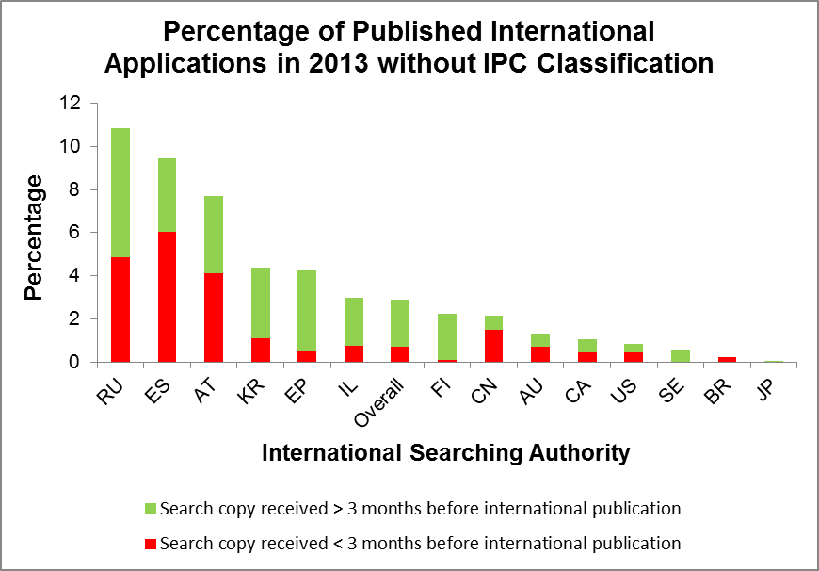

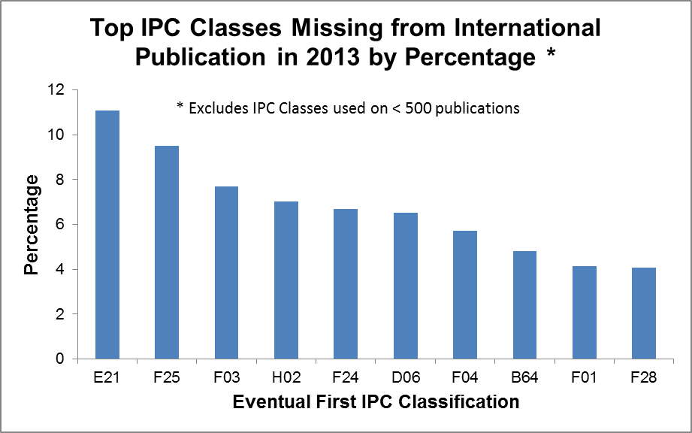

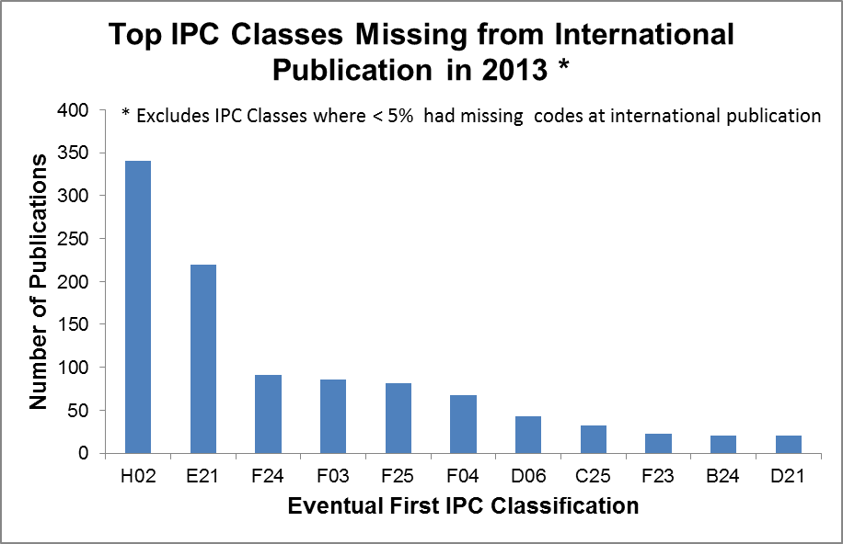

Distribution of Receiving Offices for International Applications published without an IPC Classification in 2013 by International Searching Authority*

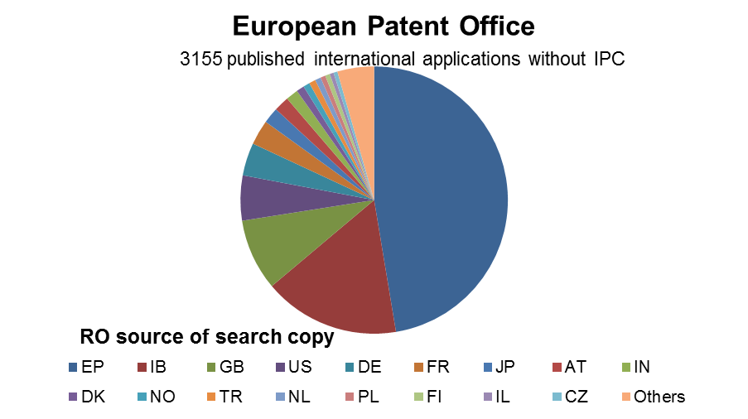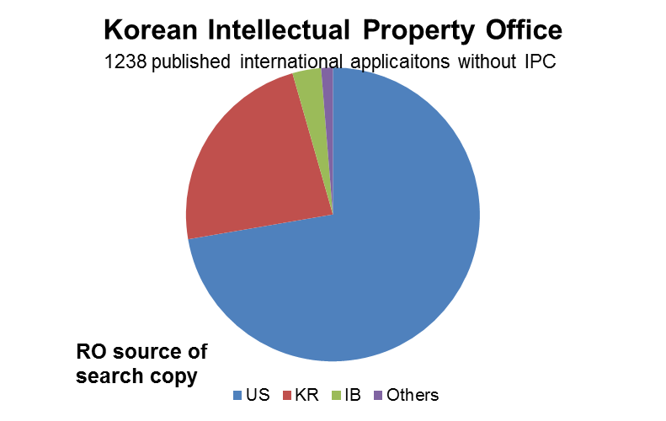

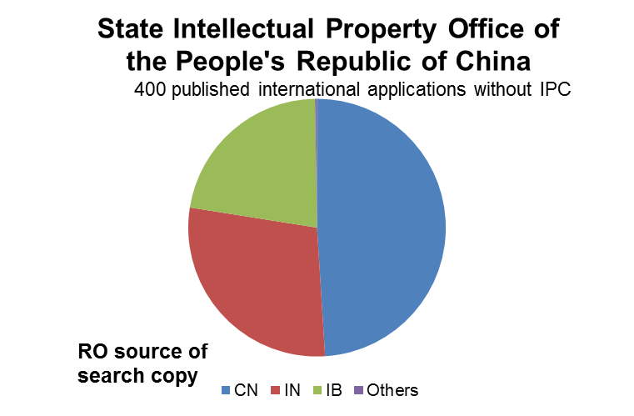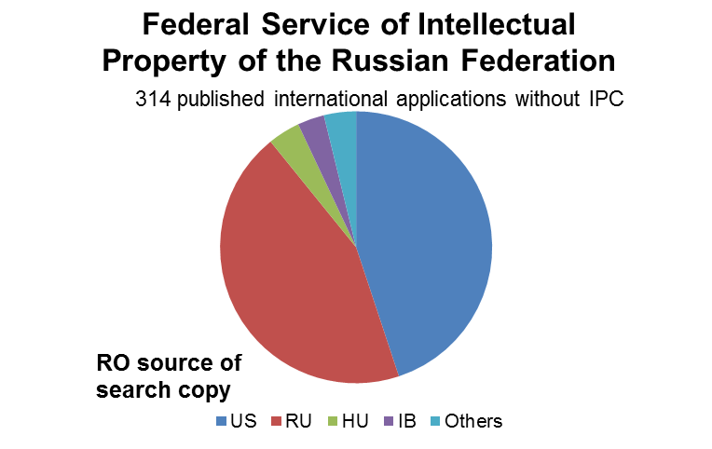

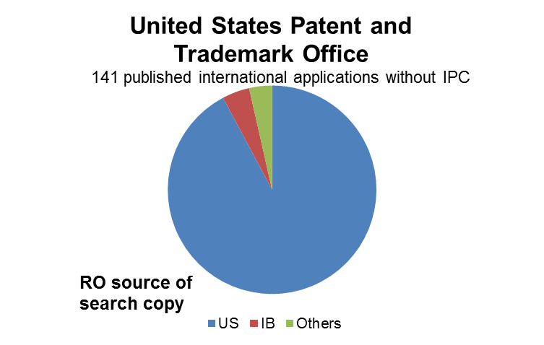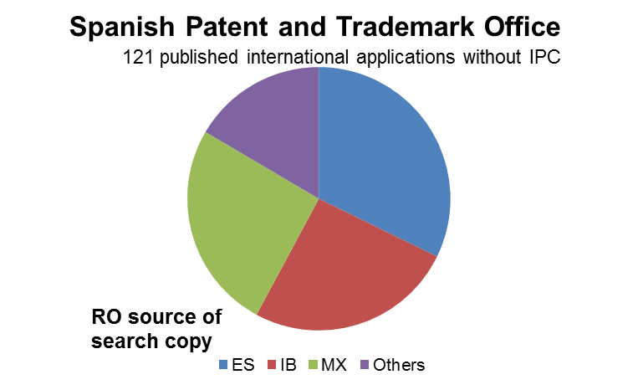

* International Search Authorities only shown where more than 100 international applications were published without an IPC symbol

[End of Annex and of document]

