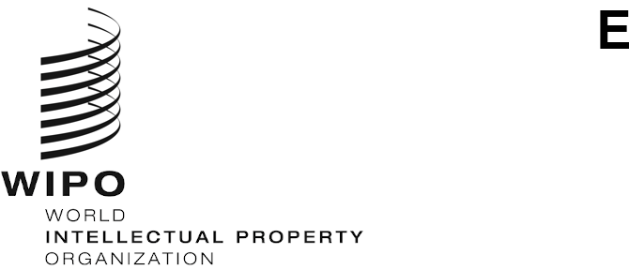

PCT/MIA/31/2

ORIGINAL: ENGLISH Only

DATE: JULY 31, 2024

# Meeting of International Authorities under the Patent Cooperation Treaty (PCT)

**Thirty-First Session**

**Beijing, October 16 and 17, 2024**

Citation of Non-Written Disclosures

*Document prepared by the International Bureau*

# Summary

1. This document discusses the implementation of the changes to the definition of relevant prior art for international search and preliminary examination to enter into force on January 1, 2026. In relation to the legal provisions, the International Bureau proposes to discuss the modifications needed to the PCT International Search and Preliminary Examination Guidelines through the PCT Quality Subgroup electronic forum and does not foresee any requirements to change the forms. The document also proposes discussions between Authorities on practices in citing non‑written disclosures and sets out initial steps for extending the document upload facilities that the International Bureau offers for written documents to other formats.

# Background

1. The PCT Assembly, at its fifty‑sixth session from July 9 to 17, 2024, adopted amendments to Rules 33 to 64 as set out in Annex IV of document PCT/A/56/2 to broaden the definition of relevant prior art for international search and preliminary examination to include non‑written disclosures. These amendments will enter into force on January 1, 2026, and will apply to any international application where the international search report or declaration under Article 17(2)(a) is established on or after that date.
2. This document discusses the implementation of the changes to the definition of the minimum documentation. This covers modifications to the legal texts including the forms, and the practical aspects of citing non‑written disclosures and their storage.

# Modifications to LegaL Texts

## Administrative Instructions under the PCT (including Forms)

1. In view of potential changes to IT systems at International Searching and Preliminary Examining Authorities, the International Bureau proposes to prioritize discussions on any modifications to the forms that might be needed to implement the amended definition of prior art.

### International Search Report and Supplementary International Search Report

1. The categories of cited documents are defined in the international search report (Form PCT/ISA/210 (second sheet)), the international‑type search report (Form PCT/ISA/201 (second sheet)), the communication relating to the results of the partial international search (Annex to Form PCT/ISA/206 (first sheet)) and the supplementary international search report (PCT/SISA/501 (second sheet)). The definitions of cited documents in these forms closely follow the wording for the citation categories listed in paragraph 20 of [WIPO Standard ST.14 – Recommendation for the Inclusion of References Cited in Patent Documents](https://www.wipo.int/export/sites/www/standards/en/pdf/03-14-01.pdf). While the term “document” is used for the citation categories in paragraph 20 of ST.14, this paragraph begins by referring to paragraph 9 of the Standard, which recommends that “industrial property offices should include in their granted patents and in their patent applications all relevant references cited in the course of search or examination procedure”. The subsequent paragraphs in ST.14 provide recommendations on how to cite relevant references, with paragraph 15 giving details on how an electronic document should be identified. Video, audio and multimedia citations are among the examples in this paragraph of electronic documents retrieved from the Internet.
2. The term “document” in WIPO Standard ST.14 therefore covers relevant references beyond a narrow definition of a written document containing text and drawings. This can encompass video, audio and multimedia representations that could be relevant to a patent application or granted patent. From this understanding, the International Bureau does not believe that any modifications are required to the international search report, supplementary international search report or similar forms listing the categories of cited documents to cite non‑written disclosures as being of particular relevance to an international patent application.

### Written Opinion and International Preliminary Report on Patentability

1. After January 1, 2026, non-written disclosures will be considered in the reasoned statement on whether a claim appears to satisfy the criteria of novelty and inventive step in Box No. V of the Written Opinion of the International Searching Authority (Form PCT/ISA/237), the Written Opinion of the International Preliminary Examining Authority (Form PCT/ISA/408) and the International Preliminary Examination Report on Patentability (Chapter II) (Form PCT/IPEA/409). However, the requirement remains unchanged in Rule 64.2 to call attention in the manner provided for under Rule 70.9 to non‑written disclosures that are made available to the public before the relevant date where the date of the non‑written disclosure is indicated in a written disclosure which has been made available to the public on or after the relevant date; the amendments to Rule 64.2 only delete the text that excludes such non‑written disclosures from being considered as part of the prior art.
2. As the practice of calling to attention non‑written disclosures in the manner provided under Rules 43*bis*.1 and 70.9 will remain after January 1, 2026, examiners will continue to complete item 2 of Box No. VI in the Written Opinion and International Preliminary Report on Patentability, reproduced in the Annex to this document. Moreover, no other modifications to these forms would appear necessary to implement the amendments to Rules 33 and 64.

### Conclusion

1. In the view of the International Bureau, no modifications to the forms are required to apply the definition of relevant prior art for international search and preliminary examination. International Authorities are invited to consider if any such modifications are necessary, and either confirm that the forms can remain unchanged after January 1, 2026, or indicate any modifications that are deemed to be essential for implementation by this date. In the latter situation, the International Bureau would propose modifications shortly after the Meeting with a view to promulgation by the end of 2024 or in early 2025.
2. For main body of the Administrative Instructions, the International Bureau does not see modifications that would be needed for the change to the definition of relevant prior art.

## PCT International Search and Preliminary Examination Guidelines

1. The PCT International Search and Preliminary Examination Guidelines (“the Guidelines”) will be the main legal text requiring modifications before the new definition of relevant prior art enters into force. This exercise is likely to benefit from technical input of examiners with experience of performing international search and preliminary examination. The International Bureau therefore proposes to discuss proposed modifications informally over the PCT Quality Subgroup electronic forum with a view to agreeing necessary modifications by the end of July 2025. Following consensus on the modifications to the Guidelines, the International Bureau would send Circulars as the formal consultation on the modifications and promulgation of the changes to take effect on January 1, 2026.

# Practical Matters

## Citation of Non‑Written Disclosures

1. Beyond the legal provisions, examiners will be required to cite non‑written disclosures in the international search report and in the reasoned statement of the written opinion. This will not be new to examiners with experience of citing these disclosures in national or regional search reports. However, it will be useful to provide guidance on the citation of non‑written disclosures that could include further examples to help International Authorities follow consistent practices, for example, in providing relevant dates for online videos (date of upload, date of filming of disclosure if it takes place in public, and date of retrieval from the Internet), in indicating pertinent parts of a video by timestamp links, and in tagging non­‑written disclosures in XML reports. There may also be a need to clarify how citation category “O” should be used in international search reports.
2. Work on the practical citation of disclosures is linked to modifications of the Guidelines, and the International Bureau proposes that discussions on the PCT Quality Subgroup electronic forum should take place alongside and feed into the discussions on modifications to the Guidelines. While the International Bureau does not see any need to modify WIPO Standard ST.14 to bring the new definition of relevant prior art into force, if International Authorities consider during this work that the outcome from these discussions would enhance the recommendations in the Standard, a proposal to modify WIPO Standard ST.14 could be made to the Committee on WIPO Standards at any time.

## Storage of Non‑Written Disclosures

1. The other practical matter is how Authorities should store non‑written disclosures retrieved from the Internet for future use, even if the online content has been changed. Discussions have taken place in this subject on the Quality Subgroup electronic forum, and the Meeting discussed the creation of a central repository at its thirtieth session in November 2023 (see paragraphs 10 to 16 of document PCT/MIA/30/5 and paragraphs 22 to 27 of the Summary by the Chair, document PCT/MIA/30/10).
2. International Authorities that have shared practices on the electronic forum discussed creating screenshots for conversion into a PDF file to resemble the format of a document and facilitate storage. In addition to storing screenshots, some Authorities have explored storing recordings of video and audio disclosures for their own use, whether on internal servers or external platforms. By January 1, 2026, all Authorities should have practices in place for internal storage of online non‑written citations. The International Bureau therefore encourages further sharing on practices that could help achieve this goal.
3. A central repository could facilitate the storage and retrieval of non‑written disclosures in any file format, but this could be developed after the new provisions enter into force. The International Bureau already provides the possibility for International Authorities to upload copies of cited documents in pdf form into the application file. Access rights to these documents is limited to the applicant and designated Offices covering use where the Authority has the right to provide copies for such purposes. As indicated in paragraph 11 of document PCT/MIA/30/5, it is technically straightforward to extend this facility to other disclosure formats, but the main issue is assessing likely costs of hosting and distributing the citations based on expected volumes of data. As a first step, the International Bureau will shortly be requesting Authorities to provide estimated volumes of data that would be required to host citations in international search reports in the Quality Subgroup electronic forum. Where an Office only stores recordings from videos and related disclosures in its national work, this estimate could be made considering volumes from these searches and the share of its overall search work performed in its capacity as an International Searching Authority. The International Bureau will update International Authorities on this work at the Meeting.
4. *The Meeting is invited to:*
   * 1. *determine if any modifications to the forms are required to implement the revised definition of relevant prior art after January 1, 2026, as discussed in paragraphs 5 to 10, above;*
     2. *comment on the proposed procedure for modifying the PCT International Search and Preliminary Examination Guidelines in paragraph 11, above; and*
     3. *comment on the issues relating to the citation of non‑written disclosures and their storage, discussed in paragraphs 13 to 16, above, as well as the procedures proposed for further discussion.*

[Annex follows]

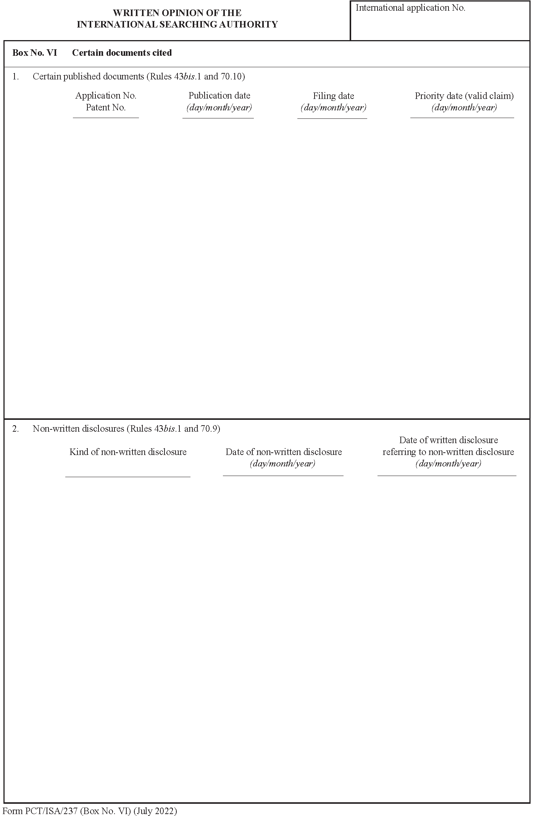

[End of Annex and of document]