E
PCT/WG/10/21
ORIGINAL: English
DATE: April 27, 2017

Patent Cooperation Treaty (PCT)
Working Group

Tenth Session
Geneva, May 8 to 12, 2017

PCT Online Services

Document prepared by the International Bureau

Summary
- Development of PCT online services since the last session of the Working Group has focused mainly on:
  - consolidation and improvements to back-end services for reliability, easier maintenance and supporting new services which are expected to become available over the coming months; and
  - preparation of a new “look and feel” for the ePCT browser-based service, which was made available for live use March 29, 2017.
- The use of several services by Offices has increased significantly, especially for eSearchCopy, which is the subject of a separate document (see document PCT/WG/10/22).
- Suggested priorities for future work include: (i) move towards delivery of international search reports and written opinions in XML format; (ii) improve services for preparing, filing and processing applications in XML format; (iii) ensure that applicants can upload documents to receiving Offices and International Authorities; (iv) ensure that key documents from the International Authority are available online; and (v) evaluate eSearchCopy as a means for receiving search copies in a consistent electronic format from all associated receiving Offices; (vi) allow receiving Offices to make ex officio corrections and (vii) improve workflow processes within ePCT, inter alia to make receiving Office processing more intuitive and efficient.

General
- PCT online services aim to support efficient and effective administration of the PCT System for all parties, including applicants and national Offices in their various roles, as well as third parties. The PCT System is inherently distributed, which brings challenges in ensuring a consistent service.
  - At present, 118 Offices act as receiving Offices. Twenty-two Offices are operational as International Searching and Preliminary Examining Authorities across the 10 publication languages. These Offices vary enormously in size and in capacity to support local IT services.
  - Even though around 70 per cent of applications have the same Office acting as both receiving Office and International Searching Authority, which in many cases has its own systems allowing the applicant to interact with the Office electronically, this leaves over 60,000 applications per year where these Offices are different. Even where those Offices are the same, the applicant may need to interact with the International Bureau.
  - Information needs to be provided to designated Offices of or acting for 152 Contracting States, as well as to patent information users interested in the applications, whether for their technical content or for their legal status. Users should be able to access information consistently irrespective of where the international application was filed and searched.
- National Offices and the International Bureau need to work together closely to ensure that their processing tools exchange documents and data in consistent formats and that their applicants are able to use online services, even (and especially) if they are located in a different country and do not have an account set up with the Office’s national systems. ePCT offers a variety of interfaces and hosted services for both applicants and Offices, aimed at ensuring that the system is accessible to all applicants. The International Bureau runs a number of background services aimed at allowing Offices with different levels of automation to interface effectively with PCT services whether they use ePCT browser-based services or not.

Latest Release of ePCT
- The version of ePCT released on March 29, 2017, includes two major features:
  - A new “look and feel” for the interface, which seeks to make the ePCT environment easier and more consistent for users.
  - A new identity management system offers easier secure login for users of the browser-based system and opens new opportunities for machine-to-machine services.

Look and Feel
- The new version of ePCT concentrates on better and more consistent presentation of the information, including validation messages. This should improve the quality of data at the point of entry. The business functions which it provides have only very minor changes from the previous version, which means that it has been possible to maintain the old version running in parallel while it is confirmed that user needs are met. Some example screens for applicant and Office users are shown below.
Figure 1: New ePCT Login screen, offering the possibility to access old ePCT version, ePCT in Demo mode and to select preferred language.
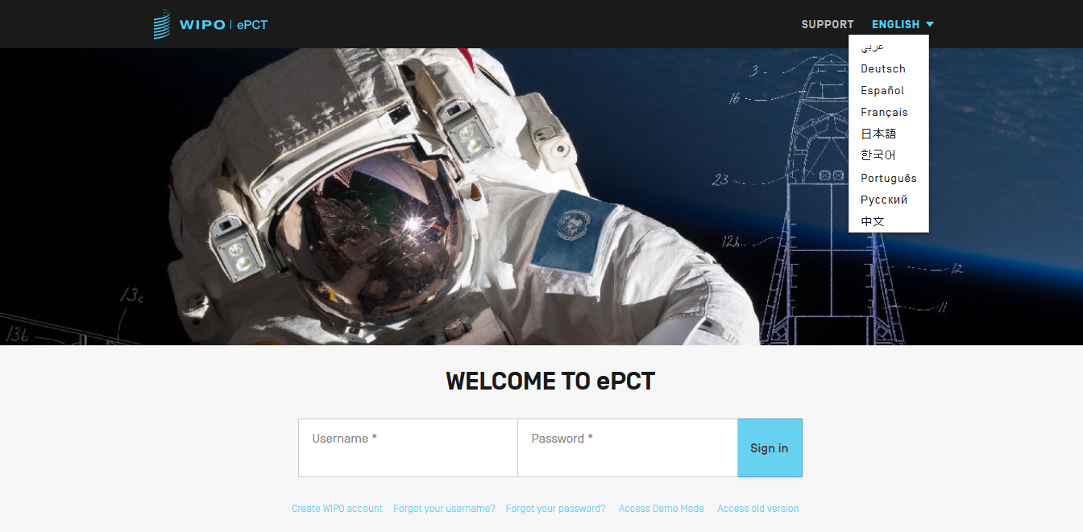
Figure 2: An example of validation messages, showing three different levels of warning
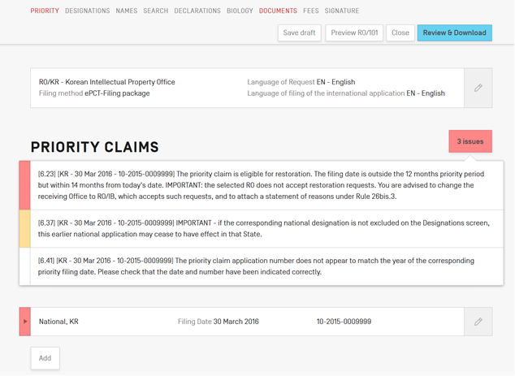
Figure 3: Part of an action to request a change of name and address for an application with both Latin and non-Latin details. The interface language can be chosen independently of the language of filing. Validation messages can be shown at the specific relevant field.
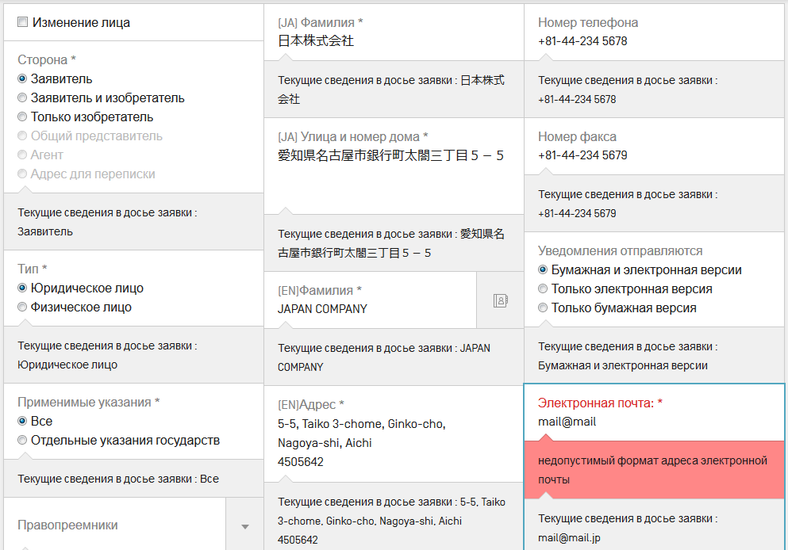
Figure 4: ePCT Office information: To assist formalities examination, Office users can see a wide range of validation messages equivalent to those provided for the applicant in ePCT-Filing.
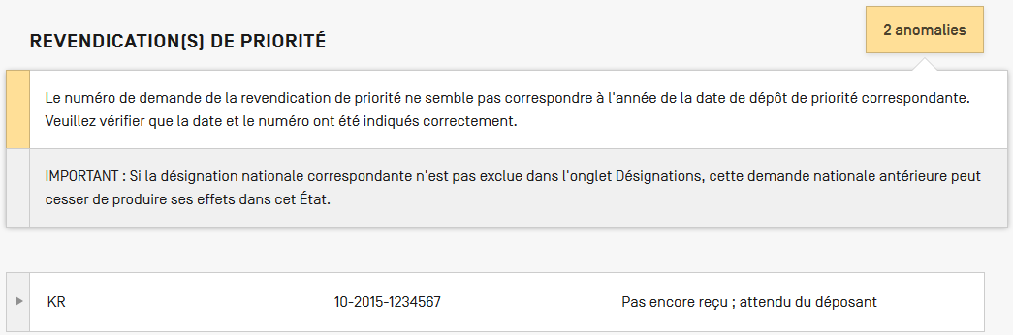

Identity Management
- While a number of improvements to security and services have been introduced behind the scenes, the obvious change in the identity management system is in usability of the secure browser interface. In previous versions of ePCT, most services have required two factor authentication for user access, using the same digital certificates used with PCT-SAFE. However, users find managing these certificates difficult and in recent years they have been by far the largest reason for calls to the PCT eServices Helpdesk.
- The new service allows users to choose one or more strong authentication methods. In addition to traditional digital certificates, users can choose one-time passwords generated by standard apps or else sent by a text message (SMS). While ePCT users can choose the option best suited to their needs, the International Bureau recommends that users select two different strong authentication methods, which allows flexibility for use in different situations, as well as easier recovery from events such as loss or theft of a phone used for the authentication procedures.
- The registration procedure for the new authentication factors is much easier than that for digital certificates and does not require manual confirmation by the International Bureau (though other security steps still apply to Office users before their accounts can be enabled for access to the system). It can therefore be completed immediately by the user and has lower running costs for the International Bureau compared to digital certificates.

Use of ePCT Browser-Based Services
- At the time of writing, the ePCT browser-based service is open to users from 72 Offices: 69 in their capacity as receiving Office, 22 in their capacity as International Searching and Preliminary Examining Authority and 21 in their role as designated Office. The use of the service varies from:
  - the primary processing tool for international phase and some national phase entry functions; through
  - back-office support to view the International Bureau’s file for cases where there appears to be a problem with processing, following up applicant enquiries and transmitting documents which are particularly urgent or which cannot be handled automatically through batch transfers set up using local IT systems; to
  - review and evaluation of options.
- It should be noted that use of ePCT by applicants and by Offices is essentially independent. Although some of the services for applicants can only be enabled with the cooperation of the national Offices concerned, where documents and data need to be processed by national Offices, Offices generally have the choice of delivery through the ePCT browser-based service or as batches of documents through PCT-EDI.

ePCT-Filing
- ePCT now allows for filing to 45 receiving Offices. Thirty-two of these Offices use a server that is hosted for the Office by the International Bureau, nine host a server locally to which filings are made directly, and four use packages provided for download by the applicant and separate upload to a browser-based service hosted by the receiving Office.
- ePCT-Filing now accounts for over 60 per cent of applications to the receiving Office of the International Bureau and a large majority of applications to many of the other participating Offices, especially those which either did not previously offer electronic filing, or where it was implemented and promoted so as to highlight its benefits over previous arrangements.

ePCT Subsequently-Filed Documents
- Documents which applicants need to submit after filing can be uploaded by applicants through ePCT to 48 Offices, including 46 in their role as receiving Office (including most, but not all, of those Offices which accept ePCT-Filings), 13 in their role as International Searching or Preliminary Examining Authority, as well as to the International Bureau. The service recognizes the time-zone of the headquarters of the relevant Office and time stamps the documents accordingly. This arrangement is particularly important for applicants using receiving Offices which do not have their own national systems for accepting international phase documents, or else who file the international application with one Office as receiving Office but nominate a different Office as International Searching Authority.
- In order to get the best out of such online communications with applicants, it is also important that all applicants – especially those who are not located in the same country as the International Searching Authority – are able to receive key communications in electronic form. Receiving Offices and International Authorities are therefore encouraged to electronically transmit key documents to the International Bureau, even when they are not required to do so by the Administrative Instructions. If transmitted with the appropriate document codes, these documents can be made immediately available to the applicant without any manual processing by the International Bureau.

eSearchCopy
- The eSearchCopy service is working well and increasingly being used for transmission of search copies in cases where different Offices act as the receiving Office and the International Searching Authority. It can offer significant reductions in cost and, where an Office has several partners, complexity for receiving Offices and International Searching Authorities. Further details are set out in document PCT/WG/10/22.

Forms Transmitted Between the International Bureau and Offices
- For Offices which do not wish to use PCT-EDI for document transmission, international phase Forms can be sent using ePCT from the International Bureau to Offices in their role as receiving Office or International Searching and Preliminary Examining Authority. A notification is sent to indicate that a new document is available and the Office downloads it through the browser interface.
- This arrangement is presently used by 42 Offices. It was designed primarily for use by small to medium-sized receiving Offices which either use ePCT as their main processing tool, or else do not have a business case to fully automate communications between their systems and those of the International Bureau. However, it is also used by seven International Authorities. Moreover, with the development of web services, it is hoped that International Authorities will progressively implement services to move most document transmissions away from batch-based services to near real time communications.

Next Steps for ePCT
- Workflow and Fee Information – In addition to a wide range of improvements for applicants, work is under way on improving the Office functions, most notably in relation to workflow management and fee information handling for Offices using ePCT as a main processing tool, aiming to make the system more intuitive and efficient.
- Payments – Another barrier to greater use of ePCT services is the handling of payments (credit card payments can presently only be accepted for international applications filed at or for services provided by the International Bureau). Work is under way to improve mechanisms for transfer of fees between Offices: a new pilot of “netting” arrangements for the exchange of international filing fees and search fees is expected to begin soon (see document PCT/WG/10/6). It is hoped that this will later also enable arrangements for the International Bureau to collect fees on behalf of national Offices and to reconcile the balances on a monthly basis with fees collected by the national Office and due to the International Bureau.
- Web Services – At present, the browser-based ePCT services offer Offices the ability to use common services and data with the International Bureau, allowing significant cost savings and the certainty of real time consistency in data. The new identity management system, referred to in paragraphs 8 to 10, above, supports the deployment of secure web services, allowing real time exchange of documents and data with Offices using their own IT systems for international phase processing, as well as for offering improved services to designated Offices following national phase entry. A number of test services are being validated.
- Reporting and Metrics – It is desired to provide improved management reports for national Offices in their roles as receiving Office and International Searching and Preliminary Examining Authorities, highlighting current performance against targets and cases which fall outside expected parameters (such as search copies not delivered within specified times from the filing date or priority date). It is likely that the browser-based ePCT service will be the medium for on-demand services giving access to sensitive information, complementing or improving on the reports currently available. Comments are welcome on whether Offices would like information “pushed” to them and, if so, what information should be sent with what frequency or on what triggers.

Use of XML
- The fact that the bibliographic data from the request form has, for some years, been available in XML for a large majority of international applications has helped to transform the work of the International Bureau, reducing costs and eliminating the risk of transcription errors. Many of the further improvements to the PCT system which Offices and users would like to see are dependent on applicants and Offices delivering more information in machine-processable formats, the preferred one of which for most cases being XML. Interests include:
  - greater “self-service” by applicants;
  - improved validity checks for actions prior to Forms and letters being formally transmitted by Offices and applicants;
  - reduction of costs;
  - reduction of transcription errors relating to post-filing processes;
  - avoiding errors or unnecessary costs due to delays in receipt and data entry of key information such as withdrawals and changes of name and address;
  - language-independent information allowing views to be created in many different languages on demand;
  - the ability to provide better services to applicants and Offices, such as by customizing forms and interfaces in line with the current status of the international application or providing links to cited documents and related applications;
  - improved patent information concerning the substance of patent applications; and
  - improved information on which to base metrics concerning processing.
- XML standards have also long been available for the application body and many other international phase documents and transactions. In recent years, efforts have been made to prepare DTDs for all remaining RO, ISA and IPEA forms. Also, for some years, XML has been prepared and made available for almost all Forms issued by the International Bureau. However, while a few national and regional Offices have been working to move Forms into XML format, with the exception of XML application bodies filed with receiving Offices which do not permit the use of PDF, relatively little use has been made of XML beyond the request.
- Recently, however, interest in XML has been renewed at some national Offices and work is under way in several areas. The International Bureau supports this work but, with limited capacity and a need to exchange information between many national Offices, it is desirable to prioritize work so as to get high quality results in areas which can make a practical difference. To be useful, it is essential that XML information is accurate and provided at the earliest stage possible in formats which are fully consistent between different Offices performing equivalent tasks.
- The main focus of current activities is around the application body (notably in converting Office Open XML (“docx”) files to Annex F XML format) and the international search reports and written opinions (which are currently being sent in XML format by four International Searching Authorities). However, in principle, many other interactions could be usefully automated if standard XML was exchanged between Offices. The International Bureau would therefore welcome comments on areas of work which should be given priority. This may include proposals for improvements to processing arrangements which would radically change or even eliminate some of the Forms as they exist today, rather than simply moving to an XML-based format for generating and transmitting Forms directly equivalent to the traditional paper ones.

Other Issues

National Phase Entry
- At its forty-seventh session in October 2015, the PCT Assembly approved amendments to PCT Rule 95, requiring designated Offices to transmit timely information concerning national phase entries, national publications and grants of international applications from July 1, 2017. This should greatly improve the quality and completeness of the information concerning national phase entry provided in ePCT and PATENTSCOPE, as well as in bulk form to Offices and patent information providers. This will also potentially allow for the deployment of more targeted services such as notifying designated Offices of events which occur after national phase entry (such as late receipt of international preliminary examination reports), or the availability through WIPO-CASE of new national search reports from other Offices.
- Work on the proposed pilot for national phase entry assisted by ePCT (see document PCT/WG/9/24) was put on hold during the implementation of the new “look and feel”, but it is intended to contact interested Offices shortly with a view to restarting this process.

Rule Changes
- Some changes, notably to the request form, will be made to ePCT and PCT-SAFE to support the other Rule changes coming into force in July 2017. Related changes, at least to DTDs and stylesheets, will be required by some national Office systems.

Color Drawings
- The International Bureau recently issued Circular C. PCT 1505, proposing some minor technical changes to the XML specifications for the request and application body which would be required to implement concerning the “interim solution” (see paragraphs 11 to 15 of document PCT/WG/9/19). If the changes are found acceptable, it is hoped to make the interim solution available for international applications filed on or after October 1, 2017. Work on a more complete solution is currently focusing on whether work relating to import and processing of docx files can simultaneously resolve some of the technical issues concerning processing color drawings.

Sequence Listings
- The International Bureau in its role administering the PCT is assisting in the development of software to create, validate and use sequence listings according to WIPO Standard ST.26, which is expected to be integrated into the PCT in the future (see documents CWS/5/6 and CWS/5/7).

conclusion
- PCT online services are now relatively mature and can be used for functions performed by any Office, whether or not it has its own local IT services for international phase processing. In particular, ePCT can help International Authorities to offer a high level of service to applicants irrespective of their residence and whether they have accounts with the International Authority’s national IT systems.
- The services provided to applicants and Offices through the browser-based ePCT system use the same underlying services as the processing done internally by the International Bureau. To achieve the best results for the PCT System, Offices need to use consistent tools for their international phase work and the timely exchange of documents and data, where possible in well-standardized XML formats. The International Bureau is ready to work with all Offices towards more effective and consistent use of online services in the processing of international applications.
- The Working Group is invited:
(i) to note the developments in PCT online services;
(ii) to comment on the proposed priorities for further work; and
(iii) to identify other issues which should be given priority in PCT online services.

[End of document]

The DTDs are not formally included in Annex F, but are available on the WIPO website at: http://www.wipo.int/pct-safe/en/resources

