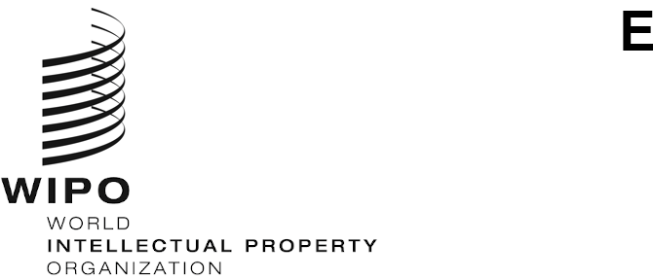
PCT/WG/16/2
ORIGINAL: English
DATE: December 15, 2022

Patent Cooperation Treaty (PCT) Working Group

Sixteenth Session

Geneva, February 6 to 8, 2023

Languages of Communication for the International Bureau
Document prepared by the International Bureau

Summary
- The International Bureau wishes to improve its services by expanding the languages of communication with applicants and national Offices to any of the 10 languages of international publication, instead of only in English or French as at present.
- This will require the development of new IT systems and an evolution in the distribution of language skills at the International Bureau. Consequently, it cannot be achieved in a single step. It is proposed to amend Rule 92.2(e) in a manner similar to a previous amendment to Rule 92.2(d), allowing the extension of languages used for letters and notifications being sent to the applicant and any national Office to be regulated by modification of the Administrative Instructions. This will allow the International Bureau to extend the languages used at a manageable rate by targeting straightforward and high value areas first.

Background
- With effect from July 1, 2016, Rule 92.2(d) was amended to allow for the possibility to extend the languages in which the applicant may write to the International Bureau beyond English and French to other PCT languages of publication, as may be permitted by the Administrative Instructions. As of that date, Section 104(c) of the Administrative Instructions allows applicants to send communications to the International Bureau in English, French or the language of publication if ePCT is used for the purpose. The provision also allows the Director General to issue decisions to extend the languages of correspondence for applicants using other means of communication, or to expand on the permitted languages for a given international application.
- At present, Rule 92.2(e) requires the International Bureau to respond to applicants or to any national Office in English or French, though some informal communications are, in fact, made in other languages familiar to both the formalities examiner at the International Bureau and the addressee.
- The International Bureau has staff able to work with all of the languages of publication and is seeking to extend its capacity in different languages, taking into account the changing distribution of languages in international applications. Furthermore, various PCT forms can already be prepared in any of the languages of publication, as appropriate, both in ePCT and through other means of communication and systems. Further developments related to XML, stylesheets and machine translation would also facilitate the International Bureau's capacity to provide these services more generally.

Proposal
- The Annex contains a proposal to amend Rule 92.2(e) to allow the extension of languages used by the International Bureau to communicate with applicants and Offices, regulated through the Administrative Instructions.
- A likely first area for such expansion would be to allow the sending of invitations to correct defects in formalities if the proposal in document PCT/WG/16/3 is accepted. In the longer term, it is intended to develop systems to allow the transmission of most IB forms in the language of publication.
- It is important that third parties and designated Offices are able to understand the outcomes of the International Bureau's work, as well as the initial recipient of a form. It should be noted that all IB forms are already prepared using XML. This provides a good basis for development to ensure either that forms can be prepared in bilingual form (language of publication plus English), or else that a system can be provided similar to that in PATENTSCOPE for XML search reports and written opinions. In that system, the XML is used to create views of the content in any of the 10 languages of publication, using the appropriate language stylesheet to display the content for checkboxes and boilerplate text, with machine translation of free text.
- The Working Group is invited to consider the proposed amendment to the Regulations in the Annex to this document.
[Annex follows]
Proposed Amendments to the PCT Regulations

Table of Contents

Rule 92 Correspondence 2
92.1 [No change] 2
92.2 Languages 2
92.3 and 92.4 [No change] 2

Rule 92
Correspondence

92.1 [No change]

92.2 Languages
(a) [No change]
(b) [No change]
(c) [Remains deleted]
(d) [No change] Any letter from the applicant to the International Bureau shall be in English, French or any other language of publication as may be permitted by the Administrative Instructions.
(e) Any letter or notification from the International Bureau to the applicant or to any national Office shall be in English, or French or any other language of publication as may be permitted by the Administrative Instructions.

92.3 and 92.4 [No change]
[End of Annex and of document]

Proposed additions and deletions are indicated, respectively, by underlining and striking through the text concerned.

