E
intellectual property
corporation of malaysia
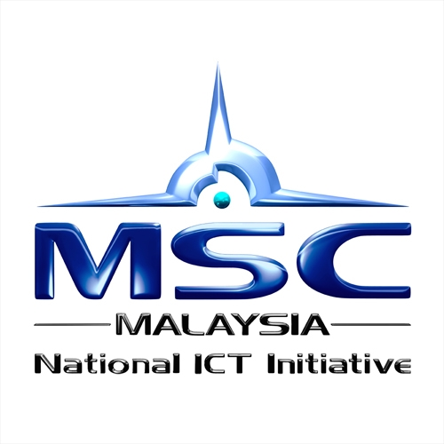 MULTIMEDIA DEVELOPOMENT
CORPORATION
training of trainers program
WIPO/smes/KUL/11/INF/1 PROV.
OriGINAL: English
DATE: DECEMBER 27, 2010
WIPO TRAINING OF TRAINERS PROGRAM ON EFFECTIVE INTELLECTUAL PROPERTY ASSET MANAGEMENT BY SMALL AND MEDIUM-SIZED ENTERPRISES (SMEs)
Organized by
the World Intellectual Property Organization (WIPO),
Multimedia Development Corporation (MDeC) and
the Intellectual Property Corporation of Malaysia (MyIPO)

MSC Malaysia Innovation Centre, Cyberjaya, Malaysia,
February 21 to 25, 2011
PROVISIONAL PROGRAM
prepared by the international bureau of WIPO (amended by MDeC)

Monday, February 21, 2011

10. – 10.15 | Opening Ceremony: Representatives of MDeC, MYIPO and WIPO
10.15 – 11.15 | Introduction to the World Intellectual Property Organization (WIPO) and its Small and Medium-sized Enterprises (SMEs) Division; Overview of Intellectual Property (IP) and the Role of Effective IP Asset Management in Enhancing the Competitiveness of SMEs
 | Speaker: Mr. Guriqbal Singh Jaiya, Director, Small and Medium-sized Enterprises Division, WIPO, Geneva, Switzerland
 | Resources: Module One of IP PANORAMA multimedia toolkit
11.15 – 11.30 | Tea/Coffee Break
11.30 – 12.45 | “Making a Mark” – The Importance of Trademarks in Establishing a Distinct Identity in the Marketplace
 | Speaker: Ms. Chew Kherk Ying, Senior Partner, Messrs Wong & Partners
 | Resources: Module Two of IP PANORAMA multimedia toolkit
 | “Making a Mark”
12.45 – 13.45 | Lunch Break
13.45 – 15.00 | “Looking Good” – The Appeal of Designs in Getting Noticed by the Customer
 | Speaker: Ms. Chew Kherk Ying
 | Resources: Module Two of IP PANORAMA multimedia tookit
 | “Looking Good”
15.00 – 15.15 | Tea/Coffee Break
15.15 – 14.30 | “Inventing the Future” – The Importance of Inventive and Innovative Activity in Maintaining Competitiveness
Speaker: Mr. P. Kandiah, Senior IP Consultant, KASS
International Sdn. Bhd.

 | Resources: Module Three of IP PANORAMA
 | “Inventing the Future”
Tuesday, February 22, 2011

10.00 – 11.15 | “In Confidence” – Putting in Place a Trade Secret Protection Program “
 | Speaker: Mr. Anil Sinha, Counsellor, SMEs Division, WIPO
 | Resources: Module Four of IP PANORAMA
 | “In Confidence”
11.15 – 11.30 | Tea/Coffee Break
11.30 – 12.45 | Creative Expression” - Benefiting from your Copyright and Using the Copyright Works of Others
Speaker: Mr. Deepak Pillai, Senior Partner,
Messrs. Haryati Deepak
 | Resources: Module Five of IP PANORAMA
 | Creative Expression
12.45 – 13.45 | Lunch Break
13.45 – 15.00 | Collective Marketing: Adding Value through Geographical Indications, Certification Marks and Collective Marks
 | Speaker: Mr. Anil Sinha
15.00 – 15.15 | Tea/Coffee Break
15.15 – 16.30 | IP Law and Administration in Malaysia
 | Speaker: Representative from MyIPO
Wednesday, February 23, 2011

10.00 – 11.15 | Intellectual Property in the Digital Economy
 | Speaker: Mr. Deepak Pillai
 | Resources: Module Eight of IP PANORAMA
11.15 – 11.30 | Tea/Coffee Break
11.30 – 12.45 | Intellectual Property Issues in International Business
 | Speaker: Mr. Anil Sinha
 | Resources: Module Nine of IP PANORAMA
12.45 – 13.45 | Lunch Break
13.45 – 15.00 | Shaping Business Strategy Through Competitive Intelligence – Strategic Use of Intellectual Property Information
 | Speaker: Mr. P. Kandiah
Resources: Module Six of IP PANORAMA
http://osint.pbworks.com/f/Fahey_2007.pdf
15.00 – 15.15 | Tea/Coffee Break
15.15 – 16.30 | Exploiting Intellectual Property Assets; Overview of Licensing, Franchising and Merchandising
Speaker: Ms. Wong Jin Nee, Senior Partner,
Messrs. Wong Jin Nee & Teo
 | Resources: Modules Seven and Twelve of IP PANORAMA
Thursday, February 24, 2011

10.00 – 11.15 | IP and Finance: Accounting and Valuation of IP Assets and IP-based Financing
 | Speaker: Mr. Guriqbal Singh Jaiya
 | Resources: Module Eleven of IP PANORAMA
11.15 – 11.30 | Tea/Coffee Break
11.30 – 12.45 | Enforcing Intellectual Property Rights in Malaysia
Speaker: Mr. Teo Bong Kwang, Senior Partner,
Messrs. Wong Jin Nee & Teo
12.45 – 13.45 | Lunch Break
13.45 – 15.00 | Role of IP Management in Effective Government -University/Research Institute-Industry Relations
Speakers: Mr. Guriqbal Singh Jaiya
A representative of from a Malaysian University/Research Institute
15.00 – 15.15 | Tea/Coffee Break
15.15 – 16.30 | IP Asset Management: IP Audit and IP Due Diligence
 | Speaker: P. Kandiah
 | Resources: Module Ten of IP PANORAMA

Friday, February 25, 2011

10.00 – 11.15 | Presentation of Case Studies or Group Exercise based on a case study or a business scenario : Effective Use of Intellectual Property Assets by SMEs in their Business Strategies
 | Speaker: Ms. Wong Jin Nee, Senior Partner, Messrs Wong Jin Nee & Teo
11.15 – 11.30 | Tea/Coffee Break
11.30 – 12.45 | Current and Proposed IP Information, Teaching/Training, Advice and Consulting Services for entrepreneurs and SMEs in Malaysia
 | Speaker: Representatives from MyIPO, MDeC and SMECorp
12.45 – 14.15 | Lunch Break
14.15 – 15.30 | Round Table Discussion: Creating a Tool Box of Support Services: Basic IP Services to be Provided by SME Support Institutions in Malaysia
 | Moderator: Mr. Guriqbal Singh Jaiya
 | Discussants: Representative(s) of MyIPO, SMECorp, MDeC, Local IP Consultants and Mr. Sinha
15.30 – 15.45 | Tea/Coffee Break
15.45 – 17.00 | Written Test (open book) for Evaluation of Participants
17.00– 17.30 | Summing up and Closing Ceremony

[End of document]

