E
workshop
WIPO/IPTK/GE/19/INF/3
ORIGINAL: ENGLISH
DATE: November 12, 2019

Practical Workshop on Intellectual Property for Women Entrepreneurs from Indigenous Peoples and Local Communities

organized by
the World Intellectual Property Organization (WIPO)

in cooperation with
the International Labour Organization (ILO),

the International Trade Centre (ITC),

and
the International Trademark Association (INTA)

Geneva, Switzerland, November 11 to 15, 2019

GENERAL INFORMATION FOR PARTICIPANTS

prepared by the International Bureau of WIPO

ORGANIZATION OF THE WORKSHOP AND RELATED ACTIVITIES

Organizers

The Practical Workshop on Intellectual Property for Women Entrepreneurs from Indigenous Peoples and Local Communities (the Practical Workshop) is being organized by the World Intellectual Property Organization (WIPO), in cooperation with the International Labour Organization (ILO), and the International Trademark Association (INTA). The Practical Workshop is offered in the context of the Project-Based Training and Mentoring Program on Intellectual Property for Women Entrepreneurs from Indigenous Peoples and Local Communities (the Program).

Venue and dates

The Practical Workshop will be held in Geneva, Switzerland, from November 11 to 15, 2019, at the following venue:

WIPO Headquarters
34, chemin des Colombettes
1211 Geneva 20, Switzerland
Tel: +41 22 338 91 11

Reception

A reception will be hosted by WIPO in the evening of November 11, 2019 at WIPO Headquarters.

Working languages

The working languages for the Practical Workshop will be English, Russian and Spanish.

LOGISTICS

Hotel accommodation

Rooms have been booked and payed for by WIPO for invited participants at the following hotel:

Drake Longchamp Hotel Geneva
7, rue Butini
1202 Geneva
Tel: +41 22 716 48 48
Website: http://www.hdlge.ch

Breakfast is included. Additional expenses, such as laundry and mini-bar, are to be covered by the participants.

Local transportation from the airport to the hotel

Urban buses: Participants arriving at Geneva Airport can obtain a free public transport ticket valid for an 80-minute journey around Geneva. The ticket machine is located in the luggage retrieval hall, just before going through customs.

From the airport, buses 5 and 28 stop at “Nations”. From there, tram line 15 stops at “Butini”, which is located within a two minute walking distance from the hotel.

Taxis: Taxis are available outside the airport. Fares between the airport and the city range from CHF 35 to 45, depending on traffic.

Local transportation from the hotel to WIPO

Participants staying in a Geneva hotel can obtain a personal and non-transferable Geneva Transport Card from the hotel reception free of charge. The card is valid for the entire duration of their stay and allows free access to trams, buses, trains and yellow taxi-boats.

Tram stop “Butini” is located within a 2 minutes walking distance from the hotel. From there, tram line 15 stops at “Nations”, a short walking distance from WIPO.

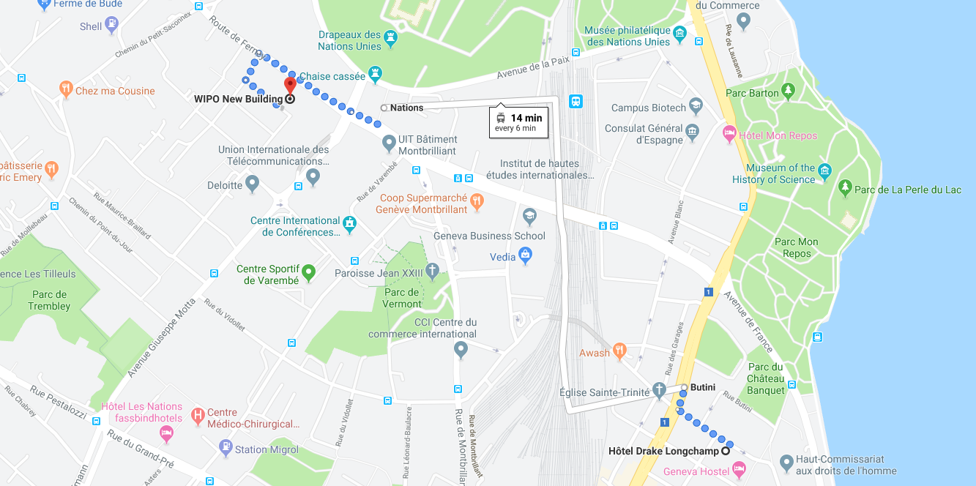

Collection of WIPO badges

In order to access the WIPO campus, you will need to collect your WIPO official badge at the WIPO Access Center, which is located in the WIPO AB Building.

MISCELLANEOUS INFORMATION

Meals

Tea and coffee will be available free of charge during morning and afternoon coffee breaks.

Lunch expenses will be covered by the Daily Subsistence Allowance (DSA) participants will receive upon arrival. Tables will be booked for participants in the WIPO NB cafeteria. The cafeteria offers a large variety of dishes, including vegetarian and take-out options. There are also a number of restaurants located within walking distance offering a wide range of cuisines (Chinese, French, Italian, Japanese, Thai, etc.).

Wireless internet (WIFI)

A free wireless Internet connection (identified as: WIPOwifi4CONF) is available in WIPO meeting rooms and public areas (lobbies/foyer, cafeterias/lounge and Library). The access code will be provided to participants upon arrival.

Medical emergencies

For medical conditions of a less serious character, there is a Medical Unit at WIPO Headquarters. The Unit is accessible from the corridor on the ground floor of the WIPO GBI Building (right side of the lobby of the WIPO AB Building).

For emergency assistance required while outside of WIPO’s Headquarters, participants may go to:

Centre Médical Servette
Avenue de Luserna 17
1203 Geneva
Tel: +41 22 795 25 25
Open from Monday to Friday 8.30 a.m. to 6 p.m. and Saturday 9 a.m. to 1 p.m.

Hôpital Cantonal de Genève
24 rue Micheli-du-Crest
1205 Geneva
Tel: +41 22 372 33 11
Open 24/7

Ambulance and medical emergency: call 144

Climate
Average daytime temperatures in November range between 2°C (35.6°F) to 9°C (48.2°F). There might be some rainfall.

Local time

The local time for Geneva is UTC +1 hour.

Currency

Geneva’s local currency is the Swiss franc (CHF), whose exchange rate is currently similar to the euro (EUR or €) and the United States dollar (USD or $) (almost equal in parity in May 2019). There are currency exchange counters in the arrival area at Geneva airport, in hotels and bank offices.

Electricity

The voltage in Switzerland is 230V/50Hz. Switzerland uses type C (2-pin) and Type J (3-pin) plugs.

Bank and ATM location

The closest bank branch to WIPO is the UBS Vermont-Nations Branch, located on 17bis chemin Louis Dunant. Opening hours: Monday 10 a.m. to 5.30 p.m. and Tuesday to Friday 9.00 a.m. to 5.30 p.m. (Cash dispenser (ATM) 24/7)).

A cash dispenser (ATM) is also available on the ground floor of the WIPO GBI Building (right side of the lobby of the WIPO AB Building). These ATMs can dispense Swiss francs and euros, using internationally recognized credit and debit cards.

Useful websites

General tourist information
https://www.geneve.com/

Transport
http://www.tpg.ch/en/web/site-international

Weather
https://www.meteo-geneve.ch./

Safety and security
https://www.cagi.ch/en/practical-info/health-and-security.php

Map of WIPO campus

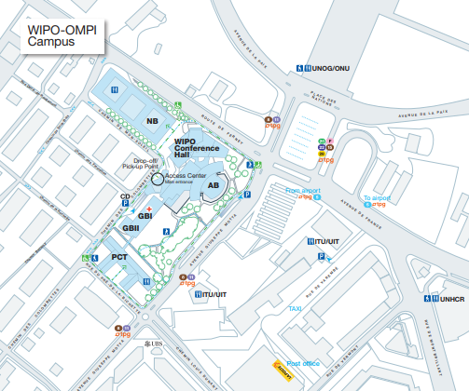

CONTACT PERSONS

As to the overall organization of the Practical Workshop, the following persons can be contacted for inquiries:

Ms. Daphne Zografos Johnsson  Legal Officer  Traditional Knowledge Division, WIPO  Tel: +41 22 338 91 13  E-mail: daphne.zografos@wipo.int | Ms. Rebecka Forsgren  WIPO Indigenous Fellow  Traditional Knowledge Division, WIPO  Tel: +41 22 338 80 06  E-mail: rebecka.forsgren@wipo.int
Ms. Carla Bengoa Rojas  Consultant  Traditional Knowledge Division, WIPO  Tel: +41 22 338 89 11  E-mail: carla.bengoa@wipo.int | Ms. Martine Coppola  Administrative Assistant  Traditional Knowledge Division, WIPO  Tel: +41 22 338 81 41  E-mail: martine.coppola@wipo.int

[End of document]

