Business Model Canvas Tool Description

In this document we will explain how to develop a Business Model Canvas (BMC). The BMC provides an outline of how the product or service, as a stand-alone revenue center, makes money or, in the case of a non-profit entity, meets the designated mission in a financially sustainable way. It is like an outline of a business plan for a one product or service company. In New Product Development (NPD) it can be used to orient the design team to the context in which the product or service will be sold (or provided) and deployed. In the remainder of this document, we will use the term good to refer to either a product or service.

## What is the Business Model Canvas Tool?

In NPD, the Business Model Canvas (BMC) Tool can be used at any stage during the NPD process to help you visualize your good from a business perspective, evaluate whether it seems to be a viable revenue and profit generator, and confirm there is a viable business opportunity for the product or service being considered or developed. The BMC Tool guides you through a process for gathering information developed using other tools from the Toolkit, and arranging the information in nine boxes that represent different fundamental business components which, taken together, provide a one-page “snapshot” of the business prospects for the good you are developing. The information in a BMC can be used as an outline for drafting a formal business plan document with financial projections and an action roadmap for 1-3 years into the future.

The Business Model Canvas is discussed in the WIPO publication *Using Inventions in the Public Domain: A Guide for Inventors and Entrepreneurs* (2020), in section 7 of Module III, “Drafting a business model canvas”. This publication summarizes how the BMC model works as follows (page 49): “A business model canvas focuses on the synergy between the nine components listed below:

– Key partners who contribute to making your business a success.

– Key activities that are carried out to implement the business model and create value.

– Key resources that are needed to create value and are integral to the business model.

– Value proposition that is being offered as products which create value for the customers.

– Customer relationships that are key in generating demand.

– Channels of distribution that are used to take products to customers/end-users.

– Customer segments that comprise buyers that can be categorized.

– Cost structure that results from understanding the business model.

– Revenue streams that distinguish and define pricing models that help in value capture.”

The BMC Tool helps you identify the fundamental components of a successful business model for your NPD project. Customer-focused components are: customer segments, value proposition, customer relationships, channels, and revenue streams. Components focused on what is necessary to build customer relations and generate revenues by delivering the value proposition are: key activities, key resources, key partners, and cost structure.

Here, we show how to use the BMC Tool at the beginning of the Design stage (see Figure 1 below). However, because a BMC can be generated using existing information that only needs to be updated, it can be used at any stage of the NPD process when you want to check the viability of your business model.

When used at the beginning of the Design stage, the BMC summarizes findings from prior stages and gate reviews in your NPD project. In the Idea and Screen stages, you used the following tools from the Toolkit: Project Charter, Action Plan, Voice of the Customer, Competitive Advantage, Freedom to Operate Value Chain; and SWOT Analysis. The information and insights you gained from using these tools will be used as inputs for the preliminary BMC Tool. As design proceeds and a design is developed, the BMC should be revised as necessary to ensure it is aligned with the final design.

As you prepare to move into the Development stage where you enter the depths of the “Valley of Death”, a completed BMC helps you remain focused. The term “Valley of Death” is used to drive home the fact that in the Development stage, costs of NPD start to rise rapidly yet risk remains relatively high until the technical viability of the product or service has been validated in the Test stage. The BMC provides a map so that once the formal design project is initiated, design and development remain focused on meeting customer and end-user needs, attaining competitive advantage, and generating an attractive gross profit. (Gross profit is net revenues minus the cost of goods sold. In a non-profit institution, gross profit is sometimes called gross net assets. We will discuss these concepts further in the Net Present Value Tool.)

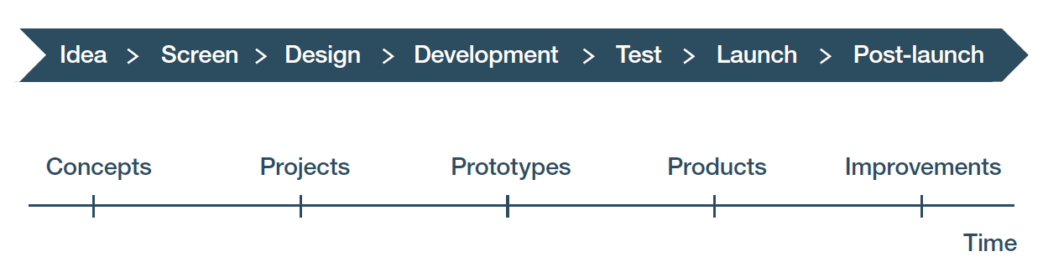

cv

cv

Figure 1: Stages and gates. The green arrow depicts the Business Model Canvas Tool being used before entering the Design stage, and the red arrow indicates that the BMC should be completed as early as possible before making decisions about the design. A second BMC should be done near the end of the Design stage, as indicated by the second set of arrows.

Next, we will discuss how to use the BMC Tool, and how to interpret and apply what you learn from a completed BMC. We will also discuss how information in a BMC can be used to address three main types of risk that apply to NPD.

In *The Wide Lens[1],* Ron Adner describes three main types of risk that apply to NPD. Execution risk refers to the ability of your organization or company to actually conduct NPD. Adoption risk refers to whether the intended customer segments will actually buy the good and the intended end-users actually deploy it. Co-innovation risk refers to the ability of vendors, suppliers, and partners to provide what you need as part of your NPD project and to conduct their own NPD if that is necessary to develop consumables or other essential goods needed to effectively deploy your product or service. We will discuss how results from the BMC can be used to address these types of risks below.

Most of the data used in the BMC comes from the workbooks that were already completed in the process of working with previously deployed tools. Note that the process of putting together the BMC forces you to re-examine your prior findings, assumptions, and conclusions. This re-examination is appropriate given that your expenses will start escalating rapidly once design and development has begun. As you re-examine these results, it is typical to seek some additional data and revise the earlier work. This data comes from talking with co-workers, current and potential customers, current and potential partners, other knowledgeable people, web searching. You may also wish to hire one or more consultants or buy reports and other documents not publicly available free of cost.

## How do you enter data in the Business Model Canvas Tool?

Upon opening the tool, the first tab is a spreadsheet containing a blank BMC. There is no data in this tool when you begin. All the data is entered by the user. Almost all the work is done on this tab. As you work with this tool, it may be necessary to resize some cells to fit in what you wish to write. The “Notes and references” tab is for additional data you may need, things to follow-up on, and sources for web-based data or analytical methods.

Figure 2 below shows a completed BMC for the Biofuels Example.



Figure 2: The Business Model Canvas tab of the Business Model Canvas Tool workbook for the Biofuels Example.

Recall that the approach to NPD in this Toolkit is based on meeting the needs of customers and end-users. For this reason, begin with the upper right rectangle entitled **Customer segments**. Customer segments are the groups of people to whom you are selling *this* product or service, product or service family, or product or service line. These are the people with whom you currently have, or will build, customer relationships. They share a set of common socio-economic characteristics, such as age, income, education, location, occupation, skills, and the like. Influencing their behavior is critical for product or service success.

Customer segments are listed in the corresponding location as shown in Figure 4 below from the BMC Tool workbook for the Biofuels Example. Note that the completed example has five bullet points. There is no fixed number of entries, and you should make as many or as few entries as appropriate to describe the customer segments for your product or service. (This is true for all the items in the BMC Tool workbook.)

Customer segments for the BMC come from your Project Charter in the section entitled “Targeted customers segments and why they will use it”. Figure 3 below shows the relevant information in the Project Charter Tool workbook for the Biofuels Example.



Figure 3: Targeted customer segments in the Project Charter Tool workbook for the Biofuels Example

Note that as you move through your earlier research and results, you may decide to modify your list of customer segments. If that is done, revise your Project Charter as you prepare your BMC. In the Biofuels Example, military bases were added to the BMC based on an interview with an expert, found in the Voice of the Customer Tool workbook.

While the Project Charter is the primary data source, other previously used tools may also give insights. For example, the SWOT analysis for the Biofuels Example includes next generation research and development (R&D) and licensing the products of that R&D to keep the product competitive in the market in the future. Accordingly, in the final version of the BMC for the Biofuels Example, a military bases and licensees were added to the BMC customer segments.

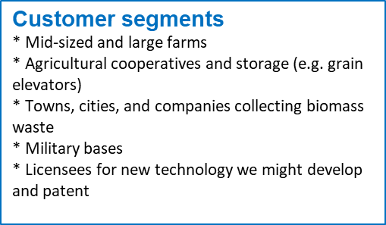

Figure 4: Customer segments from the BMC Tool workbook for the Biofuels Example.

Next, go to the central rectangle entitled **Value proposition**. A value proposition is a brief statement as to why the customer or end-user would acquire and deploy the product or service. It is usually a few sentences and never more than a short paragraph. It explains what core benefits the product or service provides and why its tangible and augmented features and its price provide a competitive advantage sufficient to drive buying and adoption. A persuasive value proposition is useful for addressing adoption risk.

The value proposition is developed from data contained in the Voice of the Customer Tool workbook on the Customer requirements tab. There you find entries for the performance, ease-of-use, price, and other criteria that drive buying behavior and are the basis for the metrics for the Competitive Advantage Tool. These criteria reflect the tangible and augmented features that customers and end-users believe will provide the core benefit they are seeking from products or services like the one(s) you are developing. Figure 5 below shows data from the Customer requirements tab of the Voice of the Customer Tool workbook for the Biofuels Example. Before entering the requirements, make sure they are consistent with supplemental market research conducted via web searching and/or other means.



Figure 5: Customer requirements tab in the Voice of the Customer Tool workbook for the Biofuels Example

Read through these criteria in the customer requirements tab and extract the ones that you think will drive buying behavior. Select no more than four or five criteria, as socio-psychological research indicates people cannot hold more than four or five criteria in their minds at any time. Give preference to the ones with the highest average importance. These should align with the Customer requirements found on the Design specifications tab of the Voice of the Customer Tool workbook (see Figure 6 below) as well as with the requirements found on the Inputs tab of the Competitive Advantage Tool workbook (see Figure 7 below).



Figure 6: Design specifications tab of the Voice of the Customer Tool workbook for the Biofuels Example.



Figure 7: Inputs tab of the Competitive Advantage Tool workbook for the Biofuels Example.

It is important to realize that the results from using other tools in the NPD Toolkit are only data sources. You still have to think about whether you have captured everything that would be critical for a value proposition for your product or service.

The benefit of brainstorming about additional critical elements of the value proposition component is illustrated by Figure 8 below, showing the value proposition from the BMC Tool workbook for the Biofuels Example.

Energy independence does not show up in the tables from the Voice of the Customer workbook shown in Figures 5, 6, and 7, because it is not a feature nor was it a core benefit they identified. But energy independence was added to the value proposition component in the BMC for the Biofuels Example because energy independence is sought by many governments, and there are government grants and tax incentives associated with that objective. Post-pandemic fuel cost spikes make energy independence more important for heavy consumers of diesel. If the interviews were done before the pandemic, the importance of this factor as a way to mitigate costs would not have been captured because it was not an issue for diesel users. Similarly, an entry stating that the product is domestically produced and supported was also added, even though that was not found in the interview data. Assuming there is discussion about supporting domestic economic growth in the print and social media in the country, adding domestic production and support to the value proposition brings an emotive dimension to support the other core benefits stated in the interviews.

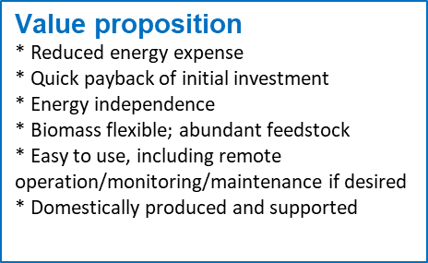

Figure 8: Value proposition from the BMC Tool workbook for the Biofuels Example.

As an aside, whenever major natural, socio-economic, or political events occur than can affect what your customers or end-users want or desire, it is prudent to go and do a second round with the Voice of the Customer Tool.

Now that you know whom you are targeting and why they should want your product or service, you can examine what kind of relationship you want with them.

**Customer relationships** are how you will interact with your customers. For purposes of the BMC, customer relationships involve much more than past buying behavior; they also include your entity’s and your personnel’s reputation in the market as well as the reputations and relationships of your key partners to the extent relevant. Relationships go beyond purchasing to include experiences with training, financing, maintenance and repair, obtaining parts and consumables, and so on. Do you foresee one-time transactional relationships or long-term ones involving repeated sales and/or support contracts? Do you foresee having significant person-to-person involvement with customers or will you primarily or fully interact through on-line shops, automated help desks, and other such digital means? These customer relationships underlie your company’s or organization’s goodwill and brand loyalty. They are a critical component of adoption risk.

The data for developing the Customer relationships component of the BMC comes from the results of using the SWOT Analysis Tool. Figure 9 below shows the analysis of the 4Ps (Product, Price, Place, and Promotion) in the “Analysis of intersections” tab of the SWOT Analysis Tool workbook for the Biofuels Example.



Figure 9: 4Ps found in the “Analysis of intersections” tab of the SWOT Analysis Tool workbook for the Biofuels Example.

Note that the results entered in the “Analysis of intersections” tab after using the SWOT Analysis Tool usually do not specify desired relationships that should be listed in the BMC, although it probably implies what they should be. These desired relationships are derived from further analysis and interpretation of the SWOT analysis results, to identify relationships that will help your NPD project succeed. Using game theory for clarification, in an infinitely repeating game all the players have an incentive to collaborate and cooperate as they know they are in a long-term relationship. To contrast, in a single play game, the incentive is to maximize your own benefits since you will not work with the other players again. In this stage of NPD of the biofuel mini-refinery example, the goal is to build long-term positive relationships which, in turn, will contribute to goodwill and word-of-mouth promotion of the product, stimulating additional sales. Figure 10 below, shows the Customer relationships component in the BMC Tool workbook for the Biofuels Example, listing the types of relationships that would help this project succeed.

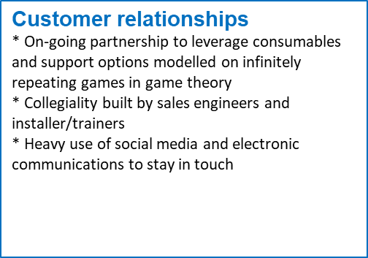

Figure 10: Customer relationships in the BMC Tool workbook based on the “Analysis of intersections” tab from the SWOT Tool workbook for the Biofuels example.

Next, look at the **Channels** used to reach the customer segments. Channels are the literal, physical ways you will send messages to your customer segments and how you will sell to them. Advertising and sales are not channels. A trade magazine, a catalog, a wholesaler, a sales representative, or a retail outlet are channels. So is a trucking firm, a postal system, email, a telephone, or an air express delivery company. The choice of channels can be a factor in adoption risk because you have to use channels that reach your intended customer segments in a way that will facilitate decisions to buy and deploy your product or service.

The data for preparing this item comes from interviews with experts and end-users, as well as web searching. Figure 11 shows a portion of an interview for the Biofuels Example collected using the Voice of the Customer Tool, where the interviewee suggested channels for reaching customers such as trade meetings (trade associations) and the trade press.



Figure 11: Interview data suggesting channels to use to reach customers from the “Customer interview 2” tab in the Voice of the Customer Tool workbook for the Biofuels Example.

Channels identified for the Biofuels Example are shown in Figure 12 below. Note that the interviewee quoted in Figure 11 mentioned trade meetings (trade associations) and the trade press, and these were listed in the channels component of the BMC for this project (see Figure 12 below). Further analysis suggested that in order to be mentioned or featured in articles in the trade press written by relevant experts, they need something to write about. This in turn suggested additional channels such as beta testing with respected opinion leaders and participating in demonstrations of the product or service (demos) sponsored by agencies seeking to introduce innovative agricultural and waste management technology. In view of including military bases as a customer segment (see Figure 4 above), military bases may also provide early adopters who can then write articles in suitable channels.

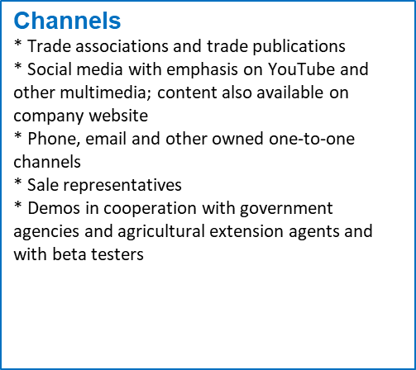

Figure 12: Channels in the BMC Tool workbook for the Biofuels Example

The final customer-focused component in the BMC Tool is the **Revenue streams** component. Revenue streams are the sources of income generated by selling or leveraging the product or service. They are very sensitive to adoption risk, because if that risk is not managed, then the product or service is not bought and there are no revenue streams.

Always remember that sales are not necessarily the only revenue stream. Licensing, service, interest on financing, sales of extended warranties, sales of parts and consumables, and training are examples of additional revenue streams. Where your product or service allows others to be bundled with it, sales of those additional products may also generate commissions. Be aware that bundling has its own risks, as a problem with a bundled product or service could reflect negatively on your own product or service in the eyes of your customers or end-users.

Revenue streams are also suggested by your results after using the SWOT Analysis Tool. The revenue streams must be realistic given the customer segments you have identified, the relationships you will build with them, the channels you will use to reach them, and your value proposition. Note that for the BMC Tool you do not have to estimate the revenues themselves, only identify where they will come from. That said, by this time you should have an idea as to pricing from the Voice of the Customer Tool interviews and your web research. You should also have a rough estimate of the market size from using the Project Charter Tool and some ideas about likely market penetration from using the SWOT Analysis Tool. So, making an initial rough estimate of revenues is reasonably straightforward and should be included if you have it. A more rigorous estimate will be made when using the Net Present Value Tool.

Figure 13 below shows the Revenue streams component from the BMC Tool workbook for the Biofuels Example, indicating that multiple, distinct revenue streams will be pursued for this project.

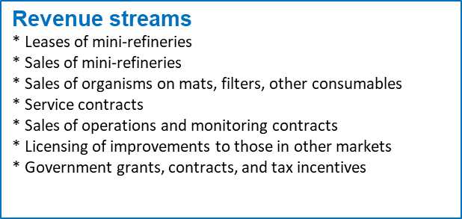

Figure 13: Revenue streams from the BMC Tool workbook for the Biofuels Example.

The last four components of the BMC Tool address what is necessary to build the customer relationships and generate revenues by delivering the value proposition. These components are: key activities; key resources; key partners; and cost structure.

Begin with the **Key activities** needed to make the prior items a reality. Key activities are the ones that you need to develop, make, support, sell, and sustain the product or service once it is commercially introduced. Key activities may also involve developing capabilities and capacities in your vendors and other organizations important for your and your customers’ supply chains. The inability to perform these key activities directly can be considered an execution risk while the inability to perform them through partners can be considered a co-innovation risk. Key activities may also show where you can intervene to address adoption risk, as when training is required for end-users.

Your starting point for locating data about key activities is your Action Plan. Figure 14 is from the Action Plan Tool workbook for the Biofuels Example at the “Action plan framework” tab.



Figure 14: From the “Action plan framework” tab of the Action Plan Tool workbook for the Biofuels Example

Also examine your SWOT analysis (see Figure 9 above) to ensure you are not missing something critical in your Action Plan. If you are, revise it.

Always remember that the BMC is an outline of the business plan for the product or service, and the bullet points under the key activities component in the BMC are categories of what must be done to realize that business plan. They are what is needed for the overall success of the product or service, not just successful NPD. This is illustrated in Figure 15 below, showing the Key activities component in the BMC Tool workbook for the Biofuels Example.

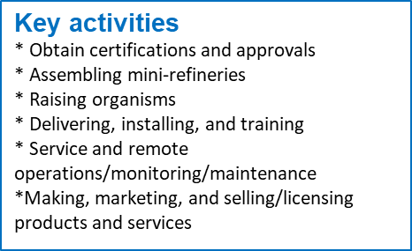

Figure 15: Key activities from the BMC Tool workbook for the Biofuels Example.

Next, examine what **Key resources** are needed to perform the key activities in a manner that maintains customer relationships and delivers the value proposition. Key resources are whatever is essential to conduct the key activities. These resources include labor, capital, facilities, and other items included in the cost of goods sold or overhead on an income statement. The costs include payments to key partners. They may also include tangible or intangible assets on a balance sheet. Intellectual property and goodwill are examples of intangible assets. Facilities are an example of tangible assets. Current assets provide the capital and inventory needed for NPD. Note that if you are using a public domain technology, the relevant patent(s) likely are a critical intangible asset. Lack of key resources can be considered an execution risk.

To identify key resources, begin by re-examining your Value Chain Tool results. Pay special attention to risks associated with the current value chain. Figure 16 shows the “Service and support” tab of the Value Chain Tool workbook for the Biofuels Example. Figure 17 shows details from the “Solutions” tab of the Value Chain Tool workbook for the Biofuels Example.



Figure 16: “Services and support” tab of the Value Chain Tool workbook for the Biofuels Example



Figure 17: Detail from the “Solutions” tab of the Value Chain Tool workbook for the Biofuels Example.

As you work through your value chain, consider what should be performed in-house and what should be done by partners, as this will be needed to complete the key partners component in the BMC Tool. As always, when examining tools used in early stages of NPD, you may discover that you need to revise previous tools as a result of this exercise.

In the Key resources component of the BMC, you provide a high-level synopsis of what is needed to complete the key activities with the desired outcomes. Figure 18 below shows the Key resources in the BMC Tool workbook for the Biofuels Example, with a comprehensive list of resources that must be secured.

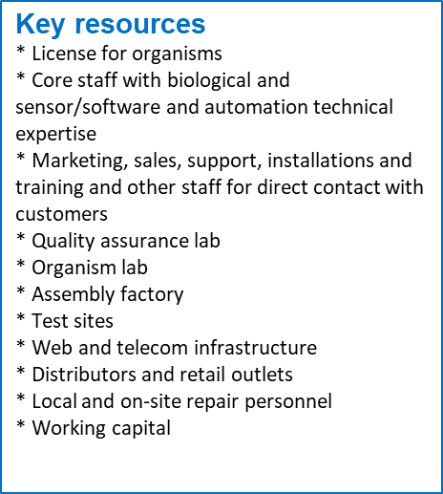

Figure 18: Key resources from the BMC Tool workbook for the Biofuels Example.

**Key partners** are the vendors, suppliers, contractors, consultants, and licensors that you use to supplement your internal capabilities and resources to develop, make, sell, distribute, and support the product or service. In addition to vendors, suppliers, contractors, manufacturers and the like, are those who make consumables and spare parts as well as those who conduct maintenance, repair, training, and other support services. What makes them key partners is that they are essential for creating and providing the tangible or augmented features of the product or service. Key partners can be involved in one or many of the design specifications that provide technical approaches to those features. Key partners are critical for addressing co-innovation risk.

Even if you use a public domain technology, you likely need key partners. For example, perhaps you need access to know-how in order to adapt the technology to use it in your product or service. It is also possible that you may need to license an underlying patent for a patented invention related to your product or service. Or you may want to partner with a research entity to develop a different solution, or design around a patented invention.

Key partners can be important for addressing adoption risk. For example, marketing and sales outlets as well as maintenance and repair contractors or independent repair shops may have crucial roles as key partners to promote or support your product or service. Trainers may also be involved as key partners.

Where consultants are used, such as a designer, they can help address execution risk by contributing special skills that may be needed to enable your organization or company to actually conduct NPD as planned.

Key partners have been identified as a supplemental activity when examining key resources. They provide the resources, capabilities, and skills you are lacking to implement NPD and utilize your value chain. They may also be identified after doing the SWOT Analysis. At this time, you should also consider downstream generations of this product or service, or related ones. If your long-term plan includes downstream generations (portfolio development), then key partners may include entities that can develop those for you or in cooperation with you.

Key partners for the Biofuels Example are shown in Figure 19 below. Key Partners for this project include a source for the organisms used in the mini-refineries, equipment vendors, consultants, delivery services, government agencies, financial partners, and research partners. For downstream generations of the product/service, key partners include research partners that can continue to improve organisms and equipment for the mini-refineries. In an actual BMC you would ideally be able to list the specific partners you will be using.

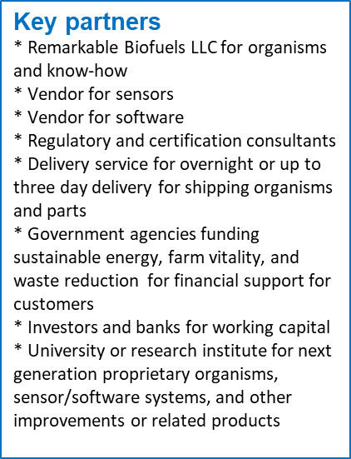

Figure 19: Key partners from the BMC Tool workbook for the Biofuels Example.

The final component of the BMC Tool is the **Cost structure**. It presents the financial implications of how the key activities are performed. The cost structure reflects both the product and the business or industry for which it is being developed as well as the number of customers in the market and how they will buy or receive the product.

Cost structure both drives and reflects your cost of goods sold and overhead. Costs are the actual expenditures, while cost structure is the relation of these expenses, that is, the percentages of groups of bins for the various line items account for in the total costs.

Some costs are fixed and must be paid regardless of how many units are produced or sold. For example, the factory where the units are assembled has to be obtained regardless of whether one unit is made or 200. Of course, there is always some range in the number of units. If 200,000 were to be made, additional investment in facilities would be needed. When examining fixed costs, see where it is feasible to achieve economies of scale (many identical units with the same equipment that only has to be acquired once), economies of scope (many different units made with the same equipment acquired once), or network economies (ability to add additional units to infrastructure at no additional costs up to some limit). Software is an example, where many users can download the same program.

Fixed costs can be leveraged where they can provide economies of scale, economies of scope, or network economies. Whether that can be done depends on the nature of the business, the industry it is in, the products or services being sold, and how rapidly production can be scaled, as well as how quickly sales increase.

Variable costs fluctuate in correspondence to the number of units made or sold. An example may be labor for a delivery service, where you have to hire more people around holidays associated with gift giving but these only need to be temporary workers because when the holiday passes the demand for delivery services will drop. The inventory of required labor to produce the product or service is a variable cost. Depending on the training required and the labor market, even full-time workers can be a variable cost, especially when you can hire more as volume increases, or, depending on labor laws, lay off workers as volumes fall. Of course, this is always within some range, since it does not make sense to be constantly hiring and firing people as volumes shift with seasonal demand, for example.

Semi-variable costs fall between variable and fixed costs. For example, if you buy storage in the cloud for data, you usually buy a fixed number of gigabytes or terabytes. You may not use all that storage at first. But the company selling the storage only sells it in fixed increments. This cloud storage model represents a semi-variable cost. At some point, if you need more storage you will have to buy it. Semi-variable costs are where network economies may come into play. A network economy means you can add additional units without an additional cost, up to some cap. Network economies exist where the next unit added does not increase costs. These are often seen in telecommunications, when more cell phones are added to an existing network for little or no additional cost. However, at some point the capacity of the cell tower and equipment to handle a volume of calls is exceeded, the network economy ends, and a new tower or better equipment or new way of maximizing bandwidth use is required, which establishes a new maximum number of calls for the system’s network economy.

Often, semi-variable costs are lumped with variable costs. For example, attendees at an in-person event can be added as long as the room capacity is not exceeded, but food and beverage costs for the event usually are not amenable to network economies because when attendees are added more food and beverages are needed. The exception is when a minimum order must be placed, which sets a fixed price of a certain amount. Until that minimum is reached there can be a network economy as people are added.

Sunk costs are those made regardless of whether any units are made or sold. NPD is a sunk cost. So is a factory built for a product that never sells. Once equipment is purchased, it can be treated as a sunk cost. If an item such as a piece of equipment can be depreciated or amortized, the associated costs may be able to be treated as fixed or variable.

Cost structures typically involve looking at the fixed, variable, and semi-variable costs and the ratio between them. Sunk costs are usually not considered. Cost structure is determined by calculating the mix of fixed, variable, and sunk costs, and the line items included in each. Typically, these costs are aggregated into categories such as operations, marketing, sales, support, and other liabilities. They could also be aggregated into categories reflecting your value chain. The ratio of these categories as part of the overall costs of making, selling, distributing, and supporting the product, product line, or product family is the cost structure. By value-engineering the value chain and leveraging your assets (which includes the goodwill and brand loyalty resulting from customer relationships), you create a more favorable cost structure for generating profit, as that will reflect reducing the costs of the various line items. For example, for an existing company greater goodwill and brand loyalty reduces marketing costs. For any company, use of public domain technology may reduce operations costs. An advantageous, value-engineered cost structure can reduce execution risk.

The ratio between these is calculated by estimating the expenses within each category of the cost structure. By examining the value chain and looking at the costs associated with it, it is possible to identify these expenses. This activity requires a level of analysis that usually has not previously been done by this stage of NPD, but for the purposes of the BMC it can be an initial estimate based on the experience of staff. If there is insufficient expertise to make an educated guess in-house, consultants can be brought in who have solid experience in the industry. These results will be useful when using the Net Present Value Tool, where a more detailed examination of costs will need to be made.

With the revenue and cost structure estimates, you can also calculate the relationship between cost of goods sold and sales, which is called cost of goods sold ratio or cost of sales to revenues ratio.

The two ratios, the cost structure ratio and the cost of sales to revenues ratio are used to compare the prospects of your product or service with those of other similar products or services. It can also be used to compare products and services being considered for an NPD portfolio. If you know these ratios for other goods or business units and their gross profit (net revenues minus costs of goods sold), you can tell if this product or service should be more profitable or less profitable than those it is benchmarked against. Such ratio analysis is a good tool for checking the efficiency of a business or business unit. Typically, the comparison data is provided by experts in that industry or found through examining the financial disclosures of companies focused on making the same or related goods. Such financial disclosures are sometimes found in government filings or in reports to shareholders for publicly traded companies.

Collecting the background data necessary to complete the cost structure is tedious, unfortunately. But it is important because you will need the cost estimates in order to calculate expenses for ensuring you have sufficient resources to complete NPD and bring the product or service to market. You also need them for calculating the net present value of the product or service (see the Net Present Value Tool).

To find your costs, first examine each page of the Value Chain Tool workbook in order to determine the costs and type of costs associated with the activities required during that part of the value chain. See Figure 20 below, from the “Operations” tab of the Value Chain Tool workbook for the Biofuels Example. This tool contains the activities involved in the Primary Activities of Porter’s Value Chain. These are the tasks associated with making the product or service, getting it to customers, and supporting it when there. They do not include research and development, new product development, human resources, and other overhead or general and administrative activities. Those are called Secondary Activities in Porter’s Value Chain. If Porter’s Value Chain is new to you, you can read more about it in Module III of the WIPO publication *Using Inventions in the Public Domain: A Guide for Inventors and Entrepreneurs* (2020), section 2.3 “Value chain analysis in an assessment of a firm’s competitive environment”.



Figure 20: Examples of costs for primary value chain activities are found in the “Operations” tab in the Value Chain Tool workbook for the Biofuels Example.

Next you must estimate and categorize your costs for Porter’s Secondary Value Chain activities. One way to estimate these is to look at publicly available records of similar entities engaged in similar businesses and use those as a working benchmark. Another way is to hire an accountant with experience working with companies, non-profits, or agencies similar to yours engaged in similar or equivalent activities. Hiring an accountant usually makes sense, especially in a start-up or entity that has never done something like this before, because the bins you set up for your expenses will typically be the same ones used as accounts for tracking costs in the bookkeeping of the entity. If you do engage a consultant, it is usually helpful to look at your estimates for the Primary Value Chain activities as well.

The data is then entered in the BMC Tool workbook in the cell labelled Cost structure, as shown in Figure 21 below from the BMC Tool workbook for the Biofuels Example. Note that only the key activities in the value chain are entered into the cell.

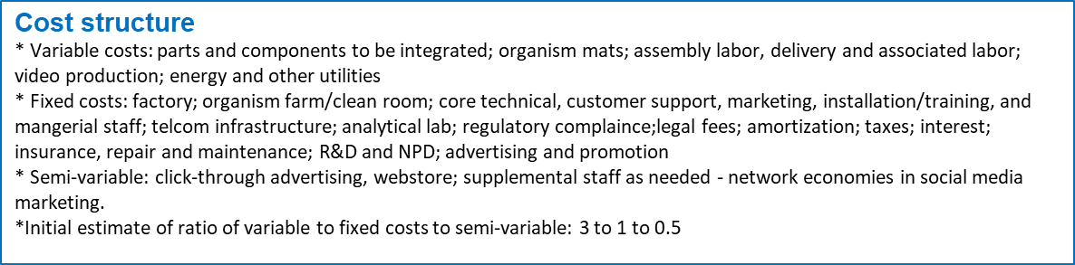

Figure 21: Cost structure from the BMC tab of the BMC Tool workbook for the Biofuels Example.

The cost structure is indicative of the control the entity making the product or service will have over its expenses. In a BMC, the cost structure component has to present the information in a form such that a reviewer of the BMC can see how the revenue streams can be obtained in a way that makes money for the company or meets other financial goals of a governmental or non-profit organization.

## How do you interpret the data in the Business Model Canvas Tool and use it in your NPD process?

Taken together, the cells of a completed BMC Tool provide an outline of how the product or service will generate value for the customers and end-users on the one hand, and for the company or organization developing the product or service and offering it for sale or use on the other. Where it is coherent (i.e. hangs together and makes sense as a whole), the BMC provides a value framework and a point of reference for developing and evaluating designs and conducting development. It does this because the design and development decisions have to cohere with the BMC. If they do not, the likelihood the product or service will fail in the market increases.

Common problems are uncertainty as to whether the right data is in the BMC or if it seems complete enough. One way to gain a feel for whether you have the right data, or enough data, is to view the BMC as a business plan for a one-product or one-service company. Putting on your most skeptical and cynical eyeglasses, ask yourself whether you would invest in it. If you are still not certain, ask a qualified friend or colleague outside your company, non-profit, or agency to review it. Before doing so, it is prudent to have them sign a non-disclosure agreement (NDA) because at this point you are still in NPD for a product or service which may qualify for intellectual property protection, and you want to guard against prior public disclosure or unauthorized use of information. You may also wish to hire an outside expert as a consultant and if so, have them sign an NDA.

If this BMC review is negative, stop the NPD process. Determine if there is a problem due to lack of sufficient or adequate data, or if the product or service no longer makes sense to develop. If it is a data problem, go back to the tool or tools referenced as the source for the data. Reexamine the data in any relevant tool’s workbook(s) and, if need be, add to or redo them. Then use the BMC Tool to create a new BMC and repeat your review. If it is still negative, you may choose to abandon the NPD initiative until you can seriously rethink and revise it. It is imperative to generate a BMC that makes the NPD initiative seem investment-worthy.

1. Adner R., *The Wide Lens: What Successful Innovators See That Others Miss*, Portfolio; Revised edition (June 25, 2013).