Technology Forecasting Tool Description

The Technology Forecasting Tool is used to examine the technology selected for the preliminary design of a product or service and explore what other options may exist, either today or in a relevant timeframe going forward, that are superior and thus should replace a technology when preparing the final design specifications. This time period is usually set by the period in which the product or service will be produced and sold or provided.

## What is Technology Forecasting?

Technology forecasting requires a clear understanding of the core benefits, tangible features, and intangible features desired by customers and end-users, as these together constitute the first criterion that is used to determine what is, or is not, a superior option for the final design. Another way to think of this first criterion is to ask: what is the performance, cost, and ease of use being sought by your intended customers and end-users? A second criterion asks: what reduces the cost or difficulty of producing, selling, distributing, supporting, and, in general, conducting the activities in the Value Chain? In other words, what drives technology forecasting is the importance of searching for ways to increase the value of your product or service for its customers and end-users, and/or for the entities developing, making, selling, and supporting it.

In the process of technology forecasting, you identify the systems, subsystems, and components to be used in the product or service. In the rest of this document, and in the associated workbook, the term *parts* will be used to encompass all of these.

A good forecast always considers three time periods: near-term, mid-term, and long-term. It identifies the technologies to be used in the product or service design to improve the attractiveness of the product or service to customers and end-users. It recognizes that the time to start thinking about the last step in NPD, post-launch improvements, should be no later than the end of the Screening stage, because you want to ensure that your product or service does not become obsolete as new technology enters the market and your product design does not allow incorporating and integrating the kinds of upgrades necessary to remain competitive.

Through its focus on how options for meeting requirements for core benefits and providing desired tangible features may change over time, technology forecasting is critical for designing a product or service that is likely to have a competitive advantage both upon launch and for the period of time essential for creating the financial returns desired. Without conducting at least one round of technology forecasting, you risk being blind-sided by the emergence of products that incorporate technology which can better satisfy customer and end-user needs.

Technology forecasting is done when entering the Design stage, shortly after initiation of a formal design project. It facilitates determining the systems, subsystems, and components to be included in the design. In other words, it is a tool for identifying the parts out of which the product or service will be made. When diligently done, it requires considering various options for parts and whether the currently preferred option will need to be replaced later in the life of the product or service in order to maintain a competitive advantage.

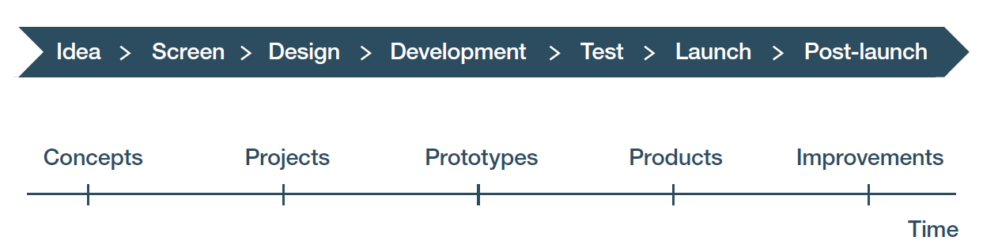

Figure 1: NPD stages and gates. The green arrow depicts the Technology Forecasting Tool being used when entering the Design stage. It is reviewed and revised as needed shortly after the Business Model Canvas Tool is completed in the Design stage. Another process of review and revision is done in the Post-Launch stage in order to assess how to proceed with product or service upgrades and develop new products or services in the product or service line or family.

Technology foresting is done using the product, patent, and research and development (R&D) searching methods used in the Competitive Advantage Tool. If you are unfamiliar with those methods, you should review them before proceeding. When using those methods here, you may not always find a specific deployable technology. This type of result may nonetheless be worth noting and tracking because you are looking for future options which may enable superior competitive advantage. If you do not find anything, that suggests the currently selected technology is a good one to use in your design.

Because this analysis considers future options, be aware you cannot assume that the tangible features, or even the core benefits, sought by customers or end-users are static. Those too may change over time. Additional market research may be needed to confirm whether that is true. The Voice the Customer Tool may provide insights. The methods described there can be adapted to seek further information on current customer and end-user requirements and how they might change.

These points can be illustrated by looking at the example of electric bicycles. Globally, the electric bike (e-bike) market was valued at US$40,312 million in 2019 and is expected to grow to US$118,657 million by the end of this decade. That is a compound annual growth rate (CAGR) of 10.5% over the next 10 years.[1] The market is currently divided between three types of batteries: lead acid, lithium-ion, and other. The cost of the battery is a major factor in the cost of the e-bike, which in turn is a major factor in consumer purchasing.

A better performing less expensive battery would deliver a major competitive advantage. Better performance could be defined by distance per charge, time to charge, and cost to charge. Searching on Electric Battery Roadmap turns up several transportation hits which could be relevant for bicycles. These include a USDRIVE report from September 2017 called Electrochemical Energy Storage Technical Team Roadmap (available from www.energy.gov). USDRIVE is a US Department of Energy led government-industry partnership. USDRIVE is focusing on Li-Sulfur and Li-Air as well as various Li-metal approaches in addition to improvements to Li-ion. The European Union’s EUROBAT also has a battery roadmap called E-MOBILITY BATTERY R&D ROADMAP 2030 (available from www.eurobat.org). In it, they focus on three existing battery technologies (advanced lead-based, lithium-ion and sodium nickel chloride batteries), which they believe have the greatest potential for improvement over the next decade.

For purposes of this illustration, two things are important.

First, the e-bike is a relatively new product for which there was no demand until the combination of aging populations, climate change and air pollution, and technological progress made them feasible. Only when they reached a performance and price threshold did buyers start to switch from traditional bikes or motor scooters to e-bikes. If you looked at customer and end-user needs prior to that threshold being attained, you would have found little interest in battery-power as a tangible feature for a bicycle for local transportation.

Second, the batteries on the market today are not likely to be the best options within the life span of an electric bicycle product line. Further, some of the battery types being developed may not even be in existence today, but they still may be important options so you should include them in your technology forecast. Their inclusion means management may wish to determine who is likely to license them, so they can approach them about licensing or buying these future battery types. The NPD team will probably want to become beta testers of the batteries as a way to determine if they should adopt them in the future. Finally, the team may even consider licensing a new battery technology for the e-bicycle field of use and making it under a sublicense in order to secure a future competitive advantage.

The Technology Forecasting Tool is designed to be used in connection with Module III “Integrating public domain knowledge into product development processes”, section 8, “Screening product concepts,” sub-section 8.5, “Technology intelligence through patents to study evolving technology trends and innovation” of the WIPO publication *Using Inventions in the Public Domain: A Guide for Inventors and Entrepreneurs* (2020). It also supports Module III “FTO Search: Finding sources of information to identify inventions in the public domain and carrying out an FTO search,” section 2, “Preparing for search: Deconstructing the invention” of the WIPO publication *Identifying Inventions in the Public Domain: A Guide for Inventors and Entrepreneurs* (2020).

## How do you enter data in the Technology Forecasting Tool?

Data is entered into the Technology Forecasting Tool and analyzed in three steps. In the first step, you conduct a functional decomposition to identify the systems, subsystems, and components that comprise your product or service. In the second step, you scan the horizon for current and future technologies for those systems, subsystems and components that can provide the tangible functionalities desired by customers and end-users. In the final step, you select which technologies will be incorporated into the product or service design, and which will be stored for future deployment.

### Functional decomposition of the product or service to identify desired functionalities

The first step begins with a functional decomposition of the product or service so you can identify what kinds of technology you are searching for. The framework for doing a functional decomposition is described briefly in connection with the FTO Tool in this NPD Toolkit, and in more detail in Module III “FTO Search: Finding sources of information to identify inventions in the public domain and carrying out an FTO search”, section 2, “Preparing for search: Deconstructing the invention” of the WIPO publication *Identifying Inventions in the Public Domain: A Guide for Inventors and Entrepreneurs* (2020). That framework is graphically depicted in Figure 2 below, reproduced from the guide.

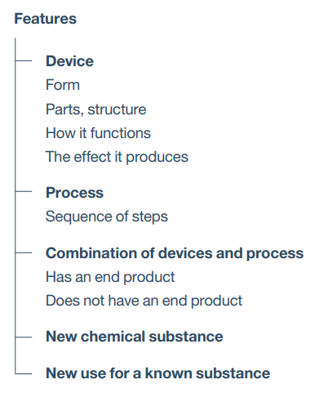

Figure 2: Framework for a functional decomposition.

To develop your functional decomposition, four methods are helpful.

The first method is to search the patent literature for related inventions. This method leverages public domain information in the patent literature.

Both the description of the invention and the drawings in a patent document can provide suggestions for your functional decomposition. Figure 3 below was found by searching the WIPO PATENTSCOPE database using the search string “biofuels from biomass”. Additional drawings and the description are found in the patent document.

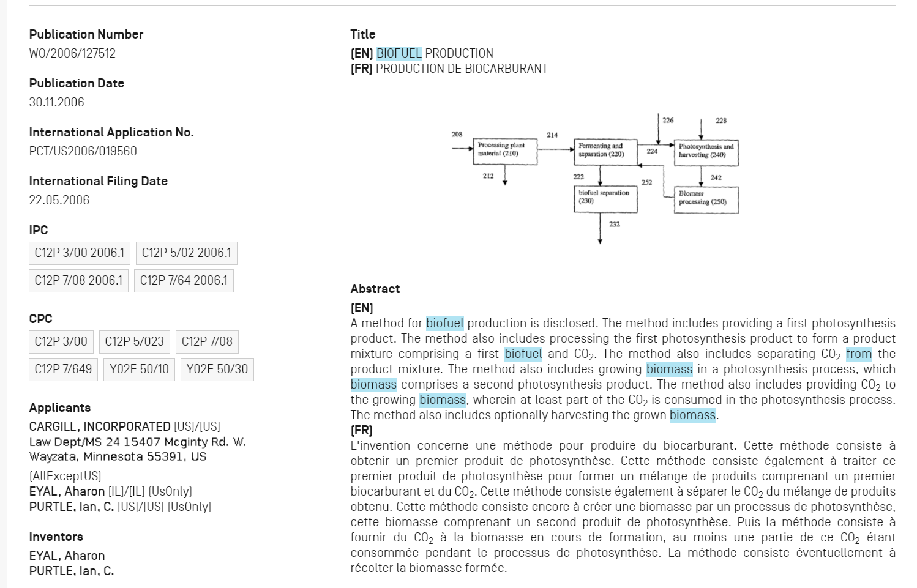

Figure 3: Example of a functional decomposition contained in a patent document on the WIPO PATENTSCOPE database.

The second method is to search for a schematic or diagram of the part of interest. Figure 4 is an example of diagram found on the web by using the search string “biofuel refinery diagram” and then clicking to see images that were retrieved.[2]

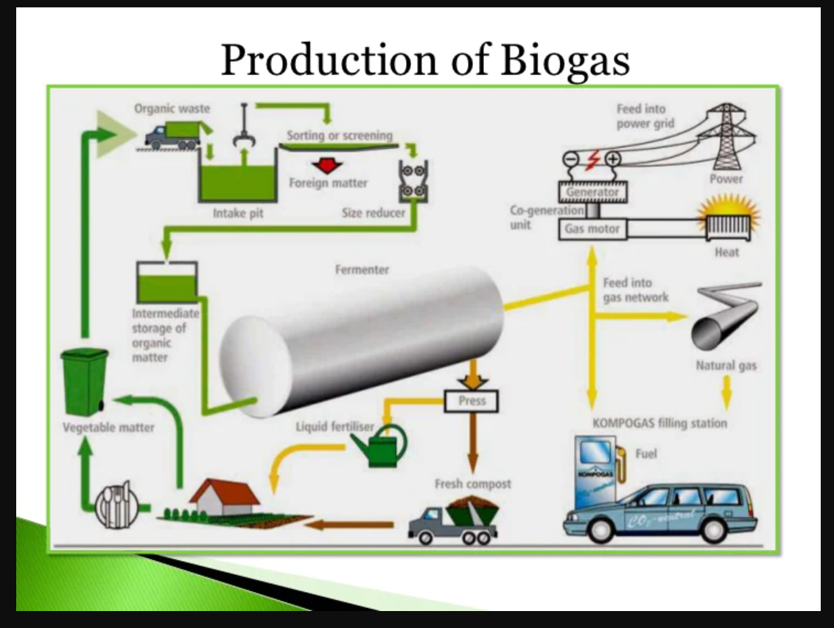

Figure 4: Biofuel refinery diagram found through web searching.

The third method is similar to the second. In this case, you are looking for videos and multimedia presentations. Figure 5 is an example found using the search string “biofuels refinery”. This video explains the one step conversion of waste to biofuels using a microorganism.[3]

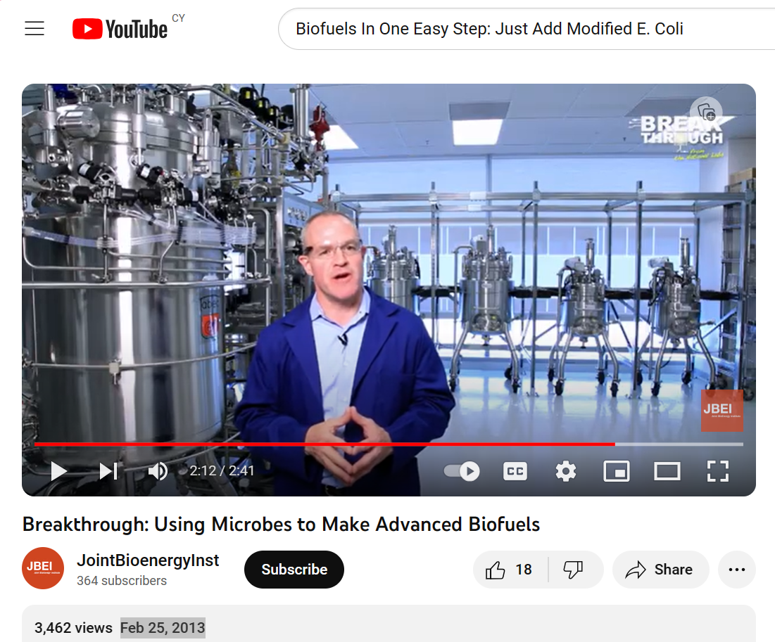

Figure 5: Example of a video found through web searching that can provide suggestions for your functional decomposition.

The fourth method is to look at the websites of biofuels companies for schematics and parts lists. Figure 6 is an example of a biofuel plant from the manufacturer Mectech Process Engineers in India.[4]

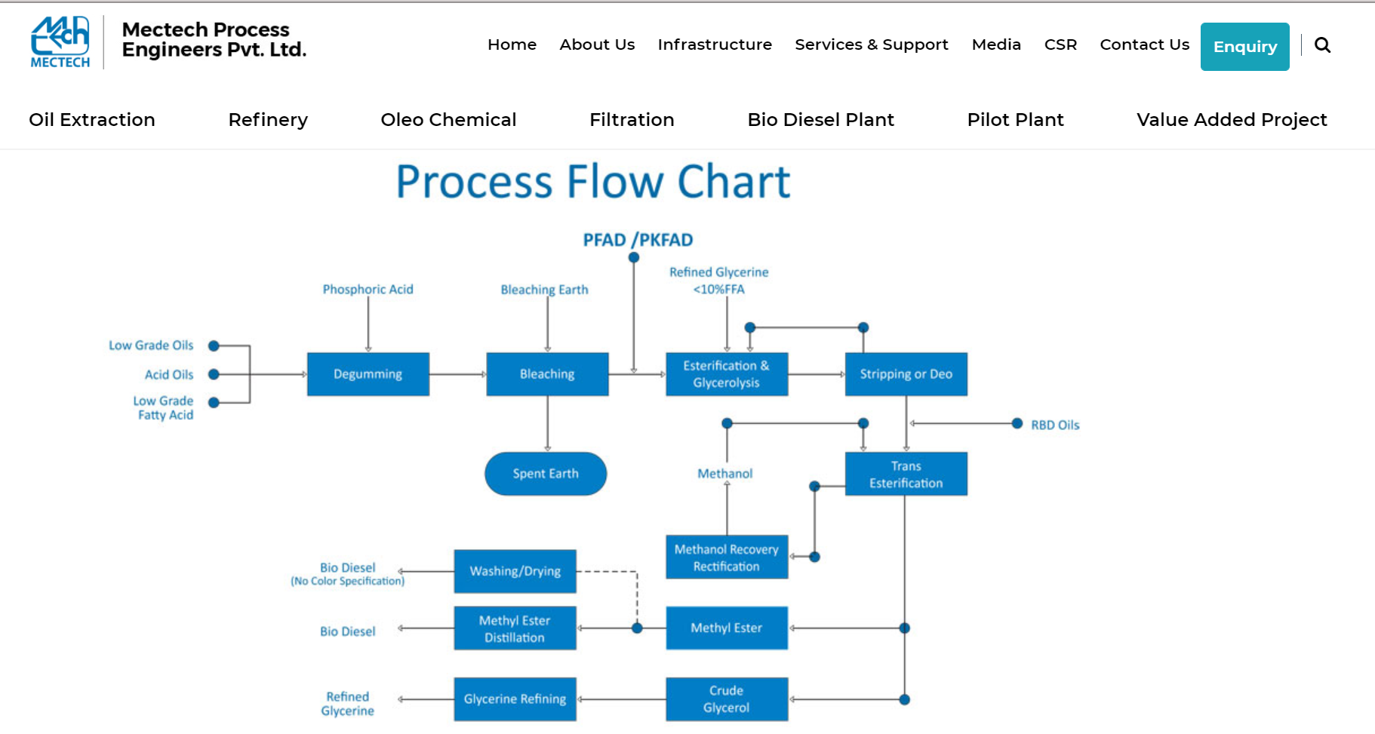

Figure 6: A flow chart that provides a functional decomposition of a vendor’s plant found through web searching.

After viewing several examples, begin developing the functional decomposition of your product. Repeat the process as needed to drill down to systems, subsystems and components. As you develop your functional decomposition, record the results in the first four columns (A, B, C, D) of the matrix provided on the “Forecasting” tab of the Technology Forecasting Tool workbook. During this searching process, you can store the location of web pages and other information on the “Notes and references” tab of the tool.

Figure 7 is an example of functional decomposition of a mini-refinery using the Technology Forecasting Tool for the Biofuels Example.



Figure 7: A part of the functional decomposition of the mini-refinery in the Biofuels Example on the “Forecasting” tab of the Technology Forecasting Tool workbook.

### Search for technological options that can provide desired functionalities

Next search patent databases, the trade press, press releases on innovative research results, and the refereed literature for technological options which can provide the desired functionalities. You are searching on the functionalities that are desired, or the name of the part, or both. Examples of functionality searching that would be relevant to processing biomass to use in the mini-refineries of the Biofuels Example is “grinding cellulosic plants” or “grinding technology” (see Figure 8).

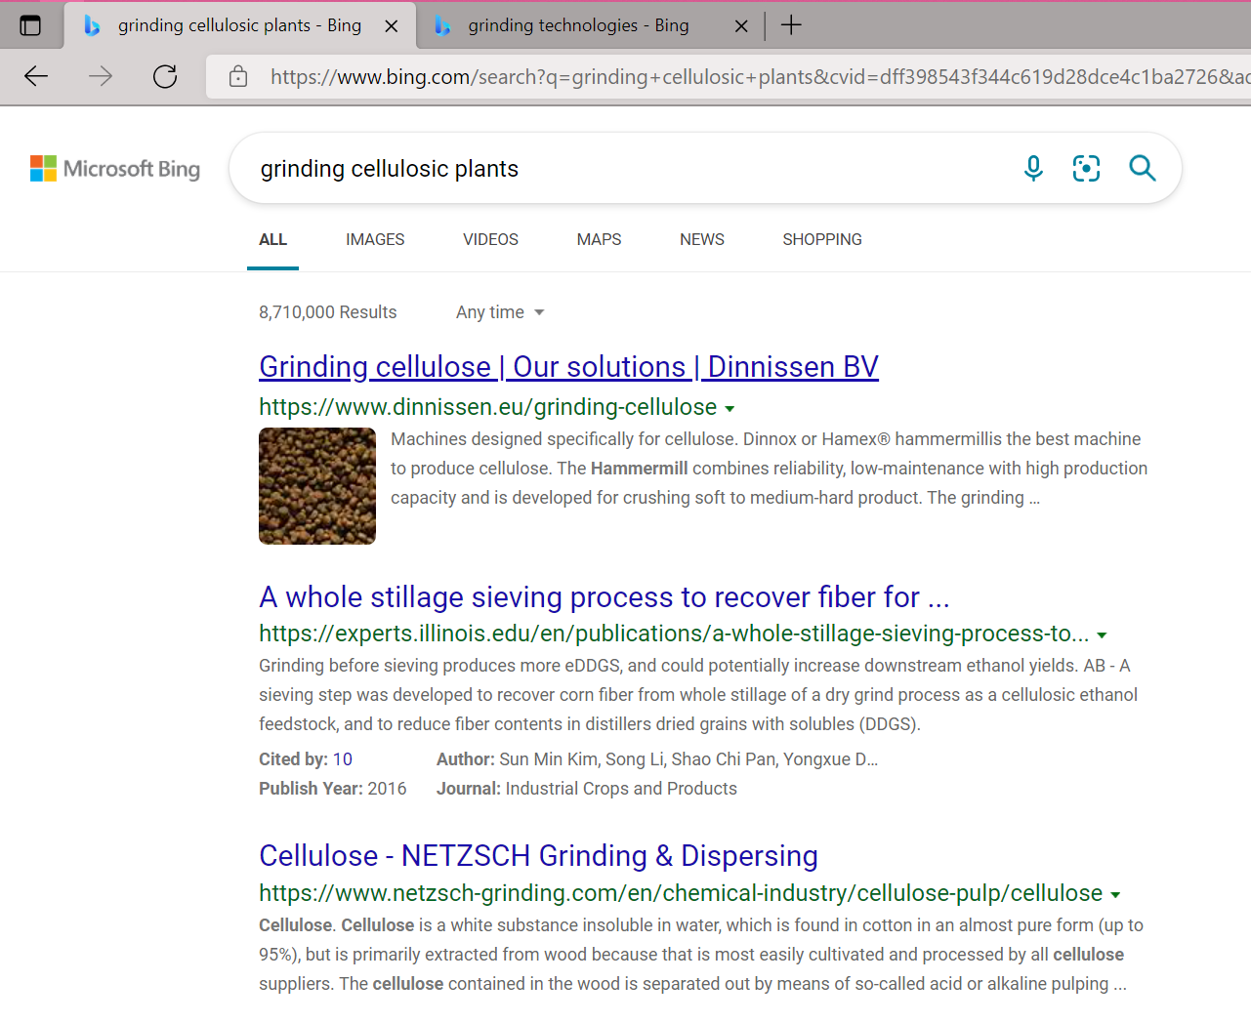

Figure 8: Example of searching by functionality.

In general, start to search using a broader search and then refine it to hone in on the results you seek. The search string “industrial grinder for plants” is a general part-based search. It turned up the non-intuitive result of grinders for cannabis. In the Biofuels Example, a small-scale, low-cost system is being developed so this option is worth exploring to see if it meets the customers’ and end-users’ needs. Broader searches have a higher likelihood of turning up serendipitous results.

By revising the search string to the more precise “industrial grinder for biomass,” more focused technologies and parts are found. Another revision to the string, “innovative grinders for biomass,” returns newer and emerging technological solutions. Adding “low-cost” to the string (“low-cost innovative grinders for biomass”) further hones in on even more interesting results.

Note that the methods that were used for searching used in the Competitive Advantage Tool are similar to the methods being discussed here. The Competitive Advantage Tool can be used concurrently with the Technology Forecasting Tool, if desired, to evaluate various alternatives in order to select the three with the greatest potential for enhancing the competitive advantage for the product you are designing. As before, you can store the location of web pages and other information on the “Notes and references” tab.

When you are ready to enter interesting technological options you have found, move to the second section of the “Forecasting” tab entitled “Technological options for providing the functionality” (columns E, F, G and H). Enter the results from your searches in these columns. Column E is for the technology you anticipate using. The other columns are for recording up to three current or future alternative technologies you might substitute or add.

Figure 9 below provides an example from the Biofuels Example workbook for this tool.



Figure 9: Options for providing the desired functionalities from the Biofuels Example. Note that some columns have been hidden in this example from the workbook for better readability.

For the final step, move to the third section of the “Forecasting” tab entitled “Component, subsystem or system to be used as a part” (columns I, J, K and L). These are where you specify the parts to be used in the design of your product or service and record any notes that would be important to remember for the future. The Competitive Advantage Tool can be used to evaluate options, if you are having trouble deciding which option is best for your design. Use the currently selected technology as the benchmark against which the newly discovered options are evaluated.

Figure 10 illustrates how data for parts options is entered in this section of the “Forecasting” tab for the Biofuels Example.



Figure 10: Parts selection recording in the Technology Forecasting Tool workbook for the Biofuels Example. Note that some columns have been hidden in this example from the workbook for better readability.

## How do you interpret the data from the Technology Forecasting Tool and use it in your NPD process?

The parts options recommended in the tool should be examined in light of value creation both for customers and end-users and for the entities involved in developing, making, selling, and supporting the product or service. Just because a part gives a performance advantage does not mean it should be selected over a substitutable part. For example, the performance advantage may be irrelevant for users. The part may make the product or service too expensive for customers. For example, if someone never rides their e-bike more than 20 miles in a day and recharges it every night, then they may not care if a more expensive battery lets them ride it 50 miles before it needs a recharge. They may prefer a cheaper battery.

Second, as mentioned previously, neither technology nor customer and end-user needs are static. The data needs to be considered in light of the trajectory of needs as well as technology.

Another issue is whether a part which at first glance appears superior hinders plans for future products or services found in the entity’s NPD Portfolio because it cannot be deployed in those future products or services. For example, suppose one battery option for an e-bike needs a special custom-made charging device while the other option uses a commercial off-the-shelf charger. At first glance the one needing only a commercially available charge might seem preferable. But now consider that choice if the former battery requiring a custom-made charging device can carry far more power and would work not only in e-bikes but for tricycles and paddle boats as well, and the company’s NPD Portfolio calls for developing a wide range of land and water electric powered vehicles targeting seniors. Now developing the custom charger seems preferable, so long as it does not make the price for the customer unattractive.

When looking at the data in the Technology Forecasting Tool workbook, realize that it contains, at best, a set of design recommendations that must be considered in light of the Business Model Canvas as well as the entity’s Value Chain and its NPD Portfolio. (There is a separate tool for the NPD Portfolio entitled “Portfolio Construction”.) This consideration is a job for upper management, not the NPD team, unless that team is tasked with developing a product family. Making design recommendations is however always the responsibility of the NPD team.

Once the data entry has been done, you are ready to develop your design specification. A design specification, also called a specification sheet, is simply a document that specifies the design requirements for a specific NPD project. It describes how the product or service will perform for what users, the functional requirements required to provide the desired tangible and augmented features and their functionality, all hardware and software interfaces, operating constraints (including environmental ones), how the product or service will be tested to ensure the specific requirements are meet, configuration settings, and any constraints, assumptions and interdependencies between parts or parts and users. The functional requirements include all relevant dimensions and weights both for the overall product and for its parts, the specific materials of which they are made, the tolerances for any measurements (if relevant), colors for products or services (if relevant), and all performance requirements (such as durability, temperature range, power consumption, and so on). It includes not only hardware but also software, including any software interface functions and capabilities and the code needed to operate the product or conduct the service.

There is no specific tool in this Toolkit for developing a design specification. This is because the best format for a design specification and related documents can vary widely depending on what product or service is being developed, and what works for your company or organization. If you are uncertain what your design specification should look like, the easiest way to determine which format might work for your NPD project is to see what design specifications for similar products or services look like. These are found through web searching for ‘design specification’ or ‘specification sheet’ in relevant technology areas. After you have chosen a format, you are now ready to develop your design specification for the product or service you plan to develop.

Finally, it is wise to simultaneously develop a manufacturing specification (also called a production specification chart), which describes how the product or service will be actually produced, including the equipment and labor necessary to carry out production at each of the steps in the production process, so that identical products or services can be produced at the scales anticipated. The design specification and the manufacturing specification for that product or service will need to cohere in order to support production.

The Technology Forecasting Tool provides confidence that the technology and parts incorporated in the design are likely to be useful for a specifiable period. Including technology forecasting as part of creating a design specification can reduce execution and co-execution risk because you have considered what parts and processes may be the best choice for the product or service you are developing, both now and in the future. Technology forecasting can also reduce adoption risk because your design process has considered consumer and end-user requirements, both now and in the future, which should increase the likelihood of purchase and use. Having this confidence is important, since changing the parts list for the product or service during development can be expensive, and then other aspects of the design may be affected. Since you will be in the so-called “Valley of Death” during the Design stage, where soaring costs can only be justified by reduced risk, anything that increases risk unnecessarily will make it difficult to proceed through the gate to the Development stage. Using the Technology Forecasting Tool, especially when used in combination with other Design-stage tools, should lead to better-informed strategies for optimizing the product or service while mitigating risk, which should make it easier to proceed to the Development stage.

1. Allied Market Research, “Electric Bike Market,” [Electric Bike Market Size, Share, Growth, Analysis 2021 - 2030 (alliedmarketresearch.com)](https://www.alliedmarketresearch.com/electric-bikes-market), 2021, (Accessed September 20, 2021.
2. [biofuel refinery Diagram - Bing images](https://www.bing.com/images/search?view=detailV2&ccid=6UsGqKe3&id=C20CAE344EE3366CA14DF3A4C6E253E8B9FE94B4&thid=OIP.6UsGqKe3prYiXyH23G0aGQHaFj&mediaurl=https%3a%2f%2fimage.slidesharecdn.com%2fvegetableoilandbiofuelindustryautosavedautosavedautosaved-111121075212-phpapp01%2f95%2fvegetable-oil-and-biofuel-industry-autosaved-autosaved-autosaved-32-728.jpg%3fcb%3d1339553675&cdnurl=https%3a%2f%2fth.bing.com%2fth%2fid%2fR.e94b06a8a7b7a6b6225f21f6dc6d1a19%3frik%3dtJT%252buehT4sak8w%26pid%3dImgRaw%26r%3d0&exph=546&expw=728&q=biofuel+refinery+Diagram&simid=607989716540012281&FORM=IRPRST&ck=DE362C2D0094633DE4CB06D37D85B525&selectedIndex=6&ajaxhist=0&ajaxserp=0), accessed September 20, 2021. The image is from Ybanaz, “Vegetable oil and biofuel industry”, November 21, 2011, on Slideshare, [Vegetable oil and biofuel industry [autosaved] [autosaved] [autosaved] (slideshare.net)](https://www.slideshare.net/franz_ryan/vegetable-oil-and-biofuel-industry-autosaved-autosaved-autosaved)
3. “Breakthrough: Using Microbes to Make Advanced Biofuels,   
   JointBioenergyInst, <https://www.youtube.com/watch?v=oFH56nvzYQk>, Feb 25, 2013, viewed, November 5, 2023.
4. Mectech Process Engineers, “Bio Diesel Plant”, [Biodiesel Manufacturing Plant | Biodiesel Plant Suppliers in India (mectech.co.in)](https://www.mectech.co.in/bio-diesel-plant), accessed September 21, 2021.